Chapter 02
Review of Accounting

True / False Questions
1. | The income statement is the major device for measuring the profitability of a firm over a period of time.  True False

2. | The income statement measures the increase in the assets of a firm over a period of time.  True False

3. | Sales minus cost of goods sold is equal to earnings before taxes.  True False

4. | Sales minus cost of goods sold is equal to gross profit.  True False

5. | It is not possible for a company with a high gross profit margin to have a low operating profit.  True False

6. | Operating profit is essentially a measure of how efficient management is in generating revenues and controlling expenses.  True False

7. | Dividing operating profit by shares outstanding produces earnings per share.  True False

8. | Accounting income is based on verifiably completed transactions.  True False

9. | The P/E ratio is strongly related to the past performance of the firm.  True False

10. | When a firm has a sharp drop off in earnings, its P/E ratio may be artificially high.  True False

11. | The P/E ratio provides no indication of investors' expectations about the future of a company.  True False

12. | The real value of a firm is the same from an economic and accounting perspective.  True False

13. | A balance sheet represents the assets, liabilities, and owner's equity of a company at a given point in time.  True False

14. | The investments account includes marketable securities.  True False

15. | The investments account represents a commitment of funds of at least one year or more.  True False

16. | Asset accounts are listed in order of their liquidity.  True False

17. | Accumulated depreciation shows up in the income statement.  True False

18. | Accumulated depreciation should always be equal to the depreciation expense charged in the income statement.  True False

19. | Total assets of a firm are financed with liabilities and stockholders' equity.  True False

20. | Marketable securities are temporary investments of excess cash and are valued at their original purchase price.  True False

21. | Book value per share and market value per share are usually the same dollar amount.  True False

22. | Book value per share is of greater concern to the financial manager than market value per share.  True False

23. | Book value is equal to net worth.  True False

24. | Equity is a measure of the monetary contributions that have been made directly or indirectly on behalf of the owners of the company.  True False

25. | Stockholders' equity is equal to liabilities plus assets.  True False

26. | Stockholders' equity is equal to assets minus liabilities.  True False

27. | Stockholders' equity minus preferred stock is the same thing as what is sometimes called net worth or book value.  True False

28. | Retained earnings shown on the balance sheet represents available cash on hand generated from prior year's earnings but not paid out in dividends.  True False

29. | Preferred stock is excluded from stockholders' equity because it does not have full voting rights.  True False

30. | Retained earnings represent the firm's cumulative earnings since inception, minus dividends and other adjustments.  True False

31. | Balance sheet items are required to be adjusted for inflation.  True False

32. | "Cash flow" consists of illiquid cash equivalents that are difficult to convert to cash within 90 days.  True False

33. | The statement of cash flows helps measure how the changes in a balance sheet were financed between two time periods.  True False

34. | Cash flow is equal to earnings before taxes minus depreciation.  True False

35. | An increase in an asset represents a source of funds.  True False

36. | Assume that two companies both have a net income of $100,000. The firm with the highest depreciation expense will have the highest cash flow, assuming all other adjustments are equal.  True False

37. | An increase in inventory represents a source of funds.  True False

38. | An increase in a liability account represents a source of funds on the cash flow statement.  True False

39. | An increase in accounts receivable represents a reduction in cash flows from operations.  True False

40. | An increase in accounts payable represents a reduction in cash flows from operations.  True False

41. | The purchase of a new factory would reduce the cash flows from investing activities on the statement of cash flows.  True False

42. | The sale of corporate bonds held by the firm as a long-term investment would increase cash flows from investing activities on the statement of cash flows.  True False

43. | Paying dividends to common shareholders will not affect cash flows from financing activities.  True False

44. | The sale of a firm's securities is a source of funds, whereas the payment of dividends is a use of funds.  True False

45. | Depreciation is an accounting entry and does not involve a cash expense.  True False

46. | The use of depreciation is an attempt to allocate the past and future costs of an asset over its useful life.  True False

47. | Free cash flow is equal to cash flow from operating activities plus depreciation.  True False

48. | Free cash flow is equal to cash flow from operating activities minus necessary capital expenditures and normal dividend payments.  True False

49. | The guidelines of the International Accounting Standards Board have been successfully reconciled with the rules of the FASB in the United States as of 2010.  True False

50. | For corporations with low taxable income (less than $100,000), the effective tax rate can be as much as 40%.  True False

51. | Interest expense is deductible before taxes and therefore has an after-tax cost equal to the interest paid times (1 - tax rate).  True False

52. | Federal corporate tax rates have changed several times since 1980.  True False

53. | A $125,000 credit sale could be a part of a firm's cash flow from operations if paid off within the firm's fiscal year.  True False

54. | Preferred stock dividends are paid out before income taxes.  True False

55. | Net working capital is the difference between current assets and current liabilities.  True False

56. | Book value per share is the most important measure of value for a stockholder.  True False

57. | An increase in accounts receivable results in a cash inflow on the statement of cash flows.  True False

58. | A decrease in bonds payable results in a cash outflow on the statement of cash flows.  True False

59. | An increase in accrued expenses results in a cash outflow on the statement of cash flows.  True False

60. | A cash flow statement is considered correct if the net cash flow ties to the ending cash balance.  True False

61. | Although depreciation does not provide cash to the firm directly, the fact that it is tax-deductible can provide cash inflow to the company.  True False

Multiple Choice Questions
62. | Gross profit is equal to
  A. | sales minus cost of goods sold.
  B. | sales minus (selling and administrative expenses).
  C. | sales minus (cost of goods sold and selling and administrative expenses).
  D. | sales minus (cost of goods sold and depreciation expense).

63. | Which of the following is not subtracted in arriving at operating income?
  A. | Interest expense
  B. | Cost of goods sold
  C. | Depreciation
  D. | Selling and administrative expense

64. | Increasing interest expense will have what effect on EBIT?
  A. | Increase it.
  B. | Decrease it.
  C. | It will have no effect.
  D. | There is not enough information to tell.

65. | The residual income of the firm belongs to
  A. | creditors.
  B. | preferred stockholders.
  C. | common stockholders.
  D. | bondholders.

66. | Allen Lumber Company had earnings after taxes of $750,000 in the year 2009 with 300,000 shares outstanding on December 31, 2009. On January 1, 2010, the firm issued 50,000 new shares. Because of the proceeds from these new shares and other operating improvements, 2010 earnings after taxes were 25 percent higher than in 2009. Earnings per share for the year 2010 were
  A. | $2.14.
  B. | $2.68.
  C. | $3.13.
  D. | None of the options.

67. | Consider the following information for Ball Corp.  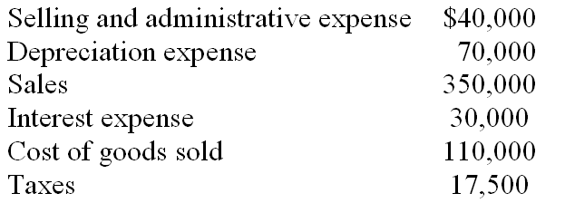  What is the operating profit for Ball Corp.?
  A. | $71,450
  B. | $90,000
  C. | $130,000
  D. | None of the options

68. | Candy Company had sales of $320,000 and cost of goods sold of $112,000. What is the gross profit margin (ratio of gross profit to sales)?
  A. | 55%
  B. | 65%
  C. | 73.3%
  D. | None of the options

69. | Density Farms Inc. had sales of $750,000, cost of goods sold of $200,000, selling and administrative expense of $70,000, and operating profit of $150,000. What was the value of depreciation expense?
  A. | $150,000
  B. | $230,000
  C. | $330,000
  D. | None of the options

70. | Elgin Battery Manufacturers had sales of $1,000,000 in 2009 and their cost of goods sold represented 70 percent of sales. Selling and administrative expenses were 10 percent of sales. Depreciation expense was $100,000 and interest expense for the year was $10,000. The firm's tax rate is 30 percent. What is the dollar amount of taxes paid?
  A. | $30,000
  B. | $117,800
  C. | $27,000
  D. | None of the options

71. | A firm has $1,500,000 in its common stock account and $1,000,000 in its paid-in capital account. The firm issued 100,000 shares of common stock. What was the original issue price if only one stock issue has ever been sold?
  A. | $35 per share
  B. | $25 per share
  C. | $15 per share
  D. | Not enough information to determine

72. | A firm has $4,000,000 in its common stock account and $10,000,000 in its paid-in capital account. The firm issued 1,000,000 shares of common stock. What is the par value of the common stock?
  A. | $40 per share
  B. | $10 per share
  C. | $4 per share
  D. | $14 per share

73. | A firm with earnings per share of $3 and a price-earnings ratio of 20 will have a stock price of
  A. | $60.00.
  B. | $15.00.
  C. | $6.67.
  D. | The market assigns a stock price independent of EPS and the P/E ratio.

74. | Earnings per share is
  A. | operating profit divided by number of shares outstanding.
  B. | net income divided by number of shares outstanding.
  C. | net income divided by stockholders' equity.
  D. | net income minus preferred dividends divided by number of shares outstanding.

75. | Reinvested funds from retained earnings theoretically belong to
  A. | bond holders.
  B. | common stockholders.
  C. | employees.
  D. | All of the options

76. | The firm's price-earnings (P/E) ratio is influenced by its
  A. | capital structure.
  B. | earnings volatility.
  C. | sales, profit margins, and earnings.
  D. | All of the options

77. | When a firm's earnings are falling more rapidly than its stock price, its P/E ratio will
  A. | remain the same.
  B. | go up.
  C. | go down.
  D. | either go up or down.

78. | Which of the following factors do not influence the firm's P/E ratio?
  A. | Past earnings
  B. | Shares outstanding
  C. | Volatility in performance
  D. | None of the options

79. | Which of the following would not be classified as a current asset?
  A. | Marketable securities
  B. | Investments
  C. | Prepaid expenses
  D. | Inventory

80. | An item which may be converted to cash within one year or one operating cycle of the firm is classified as a
  A. | current liability.
  B. | long-term asset.
  C. | current asset.
  D. | long-term liability.

81. | Which of the following would not be included in the balance sheet investment account?
  A. | Stocks of other corporations
  B. | Long-term government bonds
  C. | Marketable securities
  D. | Investments in other corporations

82. | Asset accounts on the balance sheet are listed in order of
  A. | liquidity.
  B. | profitability.
  C. | size.
  D. | importance.

83. | Which of the following is not a primary source of capital to the firm?
  A. | Assets
  B. | Common stock
  C. | Preferred stock
  D. | Bonds

84. | How many of the following balance sheet items are classified as current?  • Retained earnings  • Accounts payable  • Plant and equipment  • Inventory  • Common stock  • Bonds payable  • Accrued wages payable  • Accounts receivable  • Preferred stock
  A. | Three of these items are classified as current.
  B. | Four of these items are classified as current.
  C. | Five of these items are classified as current.
  D. | Six of these items are classified as current.

85. | How many of the following items are found on the balance sheet, rather than the income statement?  • Accounts receivable  • Retained earnings  • Income tax expense  • Accrued expenses  • Cash  • Selling and administrative expenses  • Plant and equipment  • Operating expense  • Marketable securities  • Interest expense
  A. | Three of these items are found on the balance sheet.
  B. | Four of these items are found on the balance sheet.
  C. | Five of these items are found on the balance sheet.
  D. | Six of these items are found on the balance sheet.

86. | How many of the following items are found on the income statement, rather than the balance sheet?  • Sales  • Notes payable (six months)  • Bonds payable, maturity 2001  • Common stock  • Depreciation expense  • Inventories  • Capital in excess of par value  • Net income (earnings after taxes)  • Income tax payable
  A. | Two of these items are found on the income statement.
  B. | Three of these items are found on the income statement.
  C. | Four of these items are found on the income statement.
  D. | Five of these items are found on the income statement.

87. | Which account represents the cumulative earnings of the firm since its formation, minus dividends paid?
  A. | Paid-in capital
  B. | Common stock
  C. | Retained earnings
  D. | Accumulated depreciation

88. | The major limitation of financial statements is
  A. | their complexity.
  B. | their lack of comparability.
  C. | their use of historical cost accounting.
  D. | their lack of detail.

89. | Net worth is equal to stockholders' equity
  A. | plus dividends.
  B. | minus preferred stock.
  C. | plus preferred stock.
  D. | minus liabilities.

90. | Book value is the same as
  A. | stockholders' equity.
  B. | fixed assets minus long-term debt.
  C. | net worth.
  D. | current assets minus current debt.

91. | Total stockholders' equity consists of
  A. | preferred stock and common stock.
  B. | common stock and retained earnings.
  C. | common stock and capital paid in excess of par.
  D. | preferred stock, common stock, capital paid in excess of par, and retained earnings.

92. | The net worth of a firm
  A. | is usually the same as the firm's market value.
  B. | is based on current asset costs.
  C. | is based on current liabilities.
  D. | None of the options

93. | The orientation of book value per share is ________, while the orientation of market value per share is _________.
  A. | short term; long term
  B. | future; historical
  C. | historical; future
  D. | long term; short term

94. | The primary disadvantage of accrual accounting is that
  A. | it does not match revenues and expenses in the period in which they are incurred.
  B. | it does not appropriately measure accounting profit.
  C. | it does not recognize accounts receivable.
  D. | it does not adequately show the actual cash flows of the firm.

95. | The statement of cash flows does not include which of the following sections?
  A. | Cash flows from operating activities
  B. | Cash flows from sales activities
  C. | Cash flows from investing activities
  D. | Cash flows from financing activities

96. | Which of the following is an outflow of cash?
  A. | Profitable operations
  B. | The sale of equipment
  C. | The sale of the company's common stock
  D. | The payment of cash dividends

97. | Which of the following is an inflow of cash?
  A. | Funds spent in normal business operations
  B. | The purchase of a new factory
  C. | The sale of the firm's bonds
  D. | The retirement of the firm's bonds

98. | A statement of cash flows allows a financial analyst to determine
  A. | whether a cash dividend is affordable.
  B. | how increases in asset accounts have been financed.
  C. | whether long-term assets are being financed with long-term or short-term financing.
  D. | All of the options

99. | Which of the following would represent a use of funds and, indirectly, a reduction in cash balances?
  A. | An increase in inventories
  B. | A decrease in marketable securities
  C. | An increase in accounts payable
  D. | The sale of new bonds by the firm

100. | Which of the following would represent a source of funds and, indirectly, an increase in cash balances?
  A. | A reduction in accounts receivable
  B. | The repurchase of shares of the firm's stock
  C. | A decrease in net income
  D. | A reduction in notes payable

101. | A firm's purchase of plant and equipment would be considered a
  A. | use of cash for financing activities.
  B. | use of cash for operating activities.
  C. | source of cash for investment activities.
  D. | use of cash for investment activities.

102. | An increase in investments in long-term securities will
  A. | increase cash flow from investing activities.
  B. | decrease cash flow from investing activities.
  C. | increase cash flow from financing activities.
  D. | decrease cash flow from financing activities.

103. | How many of the following items decrease cash flow in the statement of cash flows?  • Increase in accounts receivable  • Increase in notes payable  • Depreciation expense  • Increase in investments  • Decrease in accounts payable  • Decrease in prepaid expenses  • Dividend payment  • Increase in accrued expenses
  A. | Two of these items decrease cash flow
  B. | Three of these items decrease cash flow
  C. | Four of these items decrease cash flow
  D. | Five of these items decrease cash flow

104. | Depreciation is a source of cash inflow because
  A. | it is a non-cash expense.
  B. | it supplies cash for future asset purchases.
  C. | it is a tax-deductible cash expense.
  D. | it is a taxable expense.

105. | Depreciation tends to
  A. | increase cash flow and decrease income.
  B. | decrease cash flow and increase income.
  C. | affect only cash flow.
  D. | affect only income.

106. | Preferred stock dividends __________ earnings available to common stockholders.
  A. | increase
  B. | decrease
  C. | do not effect
  D. | There is not enough information to determine.

107. | Free cash flow is equal to
  A. | cash flow from operating activities plus capital expenditures, minus dividends.
  B. | cash flow from operating activities plus capital expenditures, plus dividends.
  C. | cash flow from operating activities plus dividends, minus capital expenditures.
  D. | cash flow from operating activities minus capital expenditures, minus dividends.

108. | In the last decade, free cash flow has been associated with special financial activities such as
  A. | leveraged buyouts.
  B. | ESOPs.
  C. | stock options.
  D. | golden parachutes.

109. | Free cash flow is equal to cash flow from operating activities
  A. | plus capital expenditures, minus dividends.
  B. | minus capital expenditures, plus dividends.
  C. | plus capital expenditures, plus dividends.
  D. | minus capital expenditures, minus dividends.

110. | Given the following, what is free cash flow?  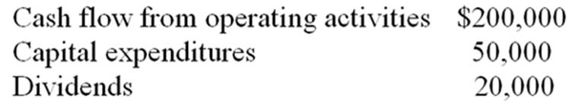
  A. | $150,000
  B. | $270,000
  C. | $180,000
  D. | $130,000

111. | With respect to Finance in Action: Global, which of the following is NOT true:
  A. | International Accounting Standards and United States GAAP are now in full agreement.
  B. | LIFO is forbidden under International Financial Reporting Standards.
  C. | International Financial Reporting Standards are "rules-based."
  D. | Under United States GAAP the method of depreciating long-term assets is at the discretion of the company's management

112. | Assuming a tax rate of 40%, depreciation expenses of $500,000 will
  A. | reduce income by $200,000.
  B. | reduce taxes by $200,000.
  C. | reduce taxes by $500,000.
  D. | have no effect on income or taxes, since depreciation is not a cash expense.

113. | Assuming a tax rate of 40%, the after-tax cost of interest expense of $1,000,000 is
  A. | $1,000,000
  B. | $140,000
  C. | $600,000
  D. | $400,000

114. | Assuming a tax rate of 30%, the after-tax cost of a $100,000 dividend payment is
  A. | $100,000
  B. | $70,000
  C. | $30,000
  D. | None of the options

115. | Farah Snack Co. has earnings after taxes of $150,000. Interest expense for the year was $20,000; preferred dividends paid were $20,000; and common dividends paid were $30,000. Taxes were $22,500. The firm has 100,000 shares of common stock outstanding. Earnings per share on the common stock was
  A. | $1.30.
  B. | $1.10.
  C. | $0.75.
  D. | $0.80.

116. | Gerry Co. has a gross profit of $1,200,000 and $400,000 in depreciation expense. Selling and administrative expense is $250,000. Given that the tax rate is 40 percent, compute the cash flow for Gerry Co.
  A. | $730,000
  B. | $550,000
  C. | $330,000
  D. | None of the options

117. | Hoover Inc. has current assets of $350,000 and fixed assets of $650,000. Current liabilities are $100,000 and long-term liabilities are $250,000. There is $120,000 in preferred stock outstanding and the firm has issued 10,000 shares of common stock. Compute book value (net worth) per share
  A. | $84.00.
  B. | $53.00.
  C. | $75.00.
  D. | None of the options.

118. | The best indication of the operational efficiency of management is
  A. | net income.
  B. | earnings per share.
  C. | earnings before interest and taxes (EBIT).
  D. | gross profit.

119. | Which of the following would indicate an accurate statement of cash flows?
  A. | Net cash flow is equal to marketable securities balance
  B. | Net cash flows from financing activities are equal to the change in stockholder's equity
  C. | Net cash flow is equal to the ending cash balance
  D. | Net cash flow is equal to the change in the cash balance

120. | An increase of $100,000 in inventory would result in a(n)
  A. | Decrease of net cash flow.
  B. | Increase in net cash flow.
  C. | Decrease in marketable securities.
  D. | Increase in bonds payable.

121. | Compute the net increase or decrease in cash flows if Star Corporation had $250,000 in net income, $30,000 in depreciation expense, a decrease of $20,000 in A/R and an increase in bonds payable of $50,000.
  A. | $370,000
  B. | $350,000
  C. | $280,000
  D. | $310,000

122. | One of the primary factors evaluated when a company is pursuing a leveraged buyout is
  A. | Net cash flow.
  B. | Free cash flow.
  C. | Cash flow from financing activities.
  D. | Cash flow from investing activities.

123. | Backdating of options is
  A. | A fair method to award top-performing employees.
  B. | Illegal.
  C. | Not to be reported unless a gain is provided to an employee.
  D. | Considered a gift by tax law.

Matching Questions
124. | Match the following with the questions below:
  1. cash flow from financing | All the assets of the firm minus the liabilities and preferred stock. | ____
  2. marketable securities | A financial statement that indicates what the firm owns or possesses, and how these assets are financed in the form of liabilities or ownership interest. | ____
  3. net worth or book value | Changes accrual-based information from the income statement and balance sheet to cash-based information. | ____
  4. depreciation | The relative convertibility of short-term assets into cash. | ____
  5. cash flows from operations | The levy expressed as a percentage that applies to each new dollar of taxable income. | ____
  6. balance sheet | The multiplier applied to earnings per share to determine the current value of the firm's stock. | ____
  7. free cash flow | The income available to common stockholders divided by the number of common shares outstanding. | ____
  8. earnings per share | A financial statement that measures the profitability of the firm over a period of time. | ____
  9. marginal corporate tax rate | Temporary investments of excess cash. | ____
  10. notes payable | Represents the net cash flow that results from changes in the amount of a firm's long-term assets. | ____
  11. cash flows from investing | The total ownership position of preferred and common stockholders. | ____
  12. historical cost accounting | Traditional method of accounting using original costs minus depreciation. | ____
  13. liquidity | Represents the net cash flow that results from a firm's production and sales activities. | ____
  14. P/E ratio | Short-term signed obligations to banks or other creditors. | ____
  15. income statement | Cash flow that is generated (or reduced) from the sale or repurchase of securities, the payment of cash dividends, and borrowings or repayment of debt. | ____
  16. stockholders' equity | The allocation of the initial cost of an asset over its useful life. | ____
  17. statement of cash flows | Cash flow from operations minus capital expenditures minus dividend payments. | ____

Essay Questions
125. | The following is the December 31, 2010 balance sheet for the Epics Corporation.  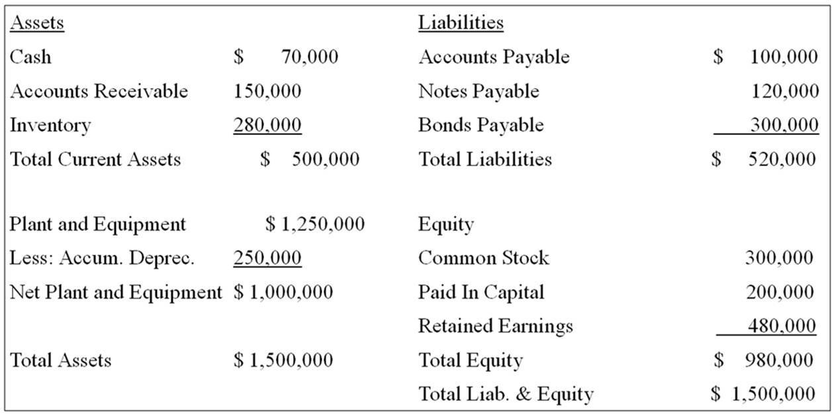  Sales for 2010 were $3,000,000, with the cost of goods sold being 60% of sales. Depreciation expense was 10% of the gross plant and equipment at the beginning of the year. Interest expense was 9% on the notes payable and 11% on the bonds payable. Selling and administrative expenses were $200,000 and the firm's tax rate is 40%. Prepare an income statement.

126. | Given the financial information for the A.E. Neuman Corporation:  (a) Prepare a statement of cash flows for the year ended December 31, 2010.  (b) What is the dividend payout ratio for 2010?  (c) If we increased the dividend payout ratio to 100%, what would happen to retained earnings at year end 2010?  A.E. Neuman Corporation - Year-end Balance Sheets  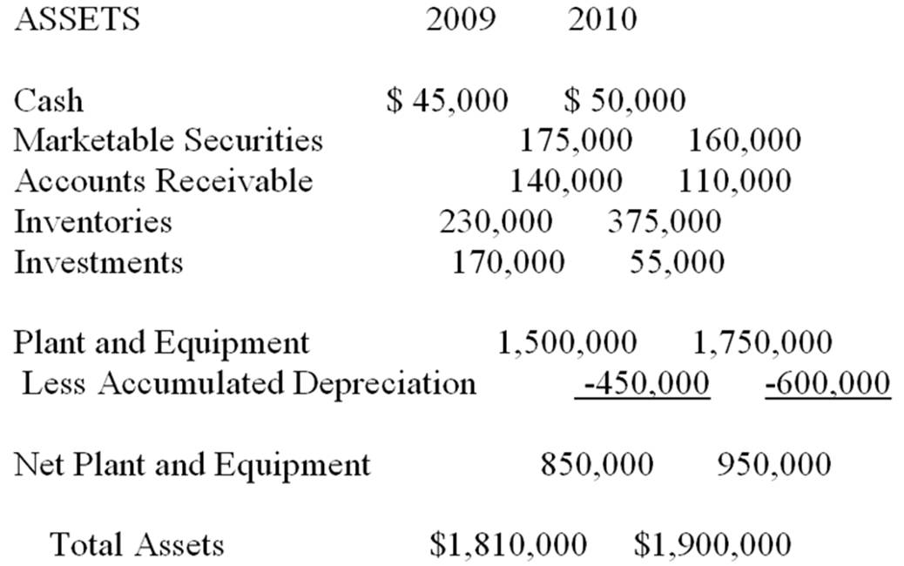  LIABILITIES AND STOCKHOLDERS EQUITY  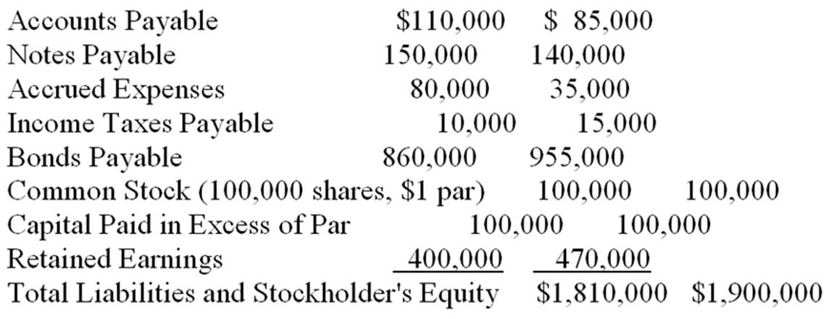  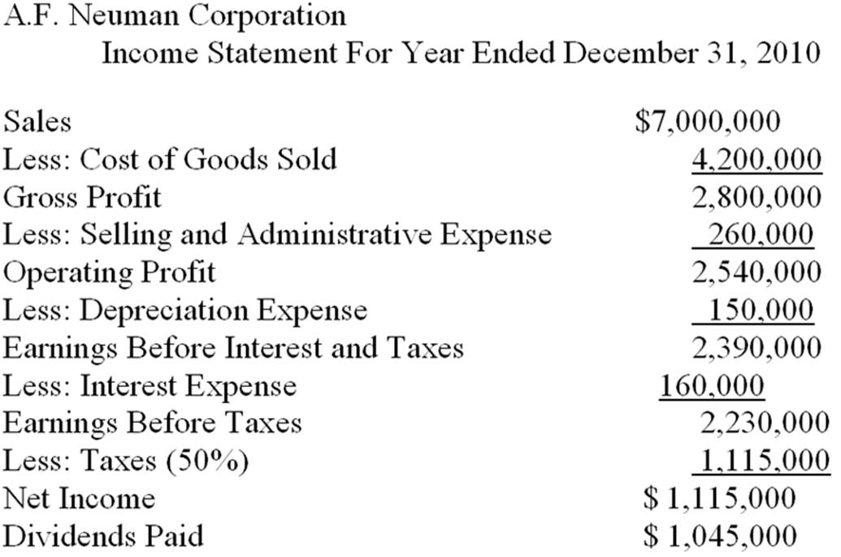

127. | Assume the company has issued 15,000 bonds with a coupon rate of 10% and a face value of $1,000 per bond, and the company has a marginal tax rate of 40%. Calculate the annual after-tax cost of the interest expense.

128. | ElectroWizard Company produces a popular video game called Destructo, which sells for $65. Last year ElectroWizard sold 100,000 Destructo games, each of which costs $10 to produce. ElectroWizard incurred selling and administrative expenses of $200,000 and a depreciation expense of $100,000. In addition, ElectroWizard has a $1,000,000 loan outstanding at 8%. Their tax rate is 40%. There are 400,000 common shares outstanding.  Prepare an income statement for ElectroWizard in good form (include EPS).

129. | Identify each of the following as increasing (+) or decreasing (-) cash flows from operating activities (0), investment activities (I), or financing activities (F). (EXAMPLE: The sale of plant and equipment would increase cash flows from investing activities, and the correct answer would be +I).  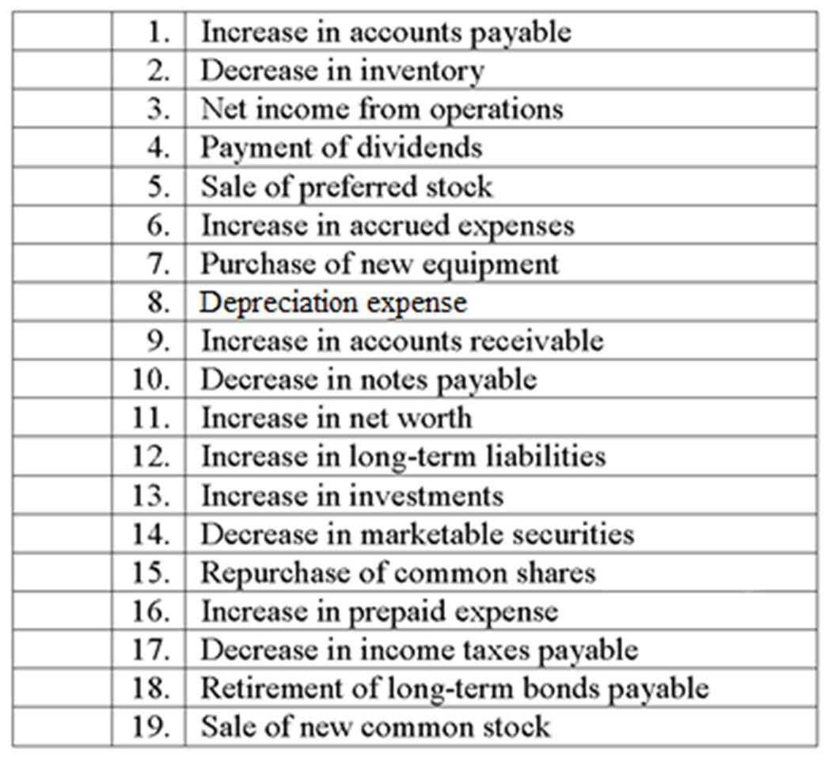

Chapter 02 Review of Accounting Answer Key

True / False Questions
1. | The income statement is the major device for measuring the profitability of a firm over a period of time.  TRUE

AACSB: Analytic
Blooms: Understand
Difficulty: Basic
Learning Objective: 02-01 The income statement measures profitability.

2. | The income statement measures the increase in the assets of a firm over a period of time.  FALSE

AACSB: Analytic
Blooms: Understand
Difficulty: Basic
Learning Objective: 02-01 The income statement measures profitability.

3. | Sales minus cost of goods sold is equal to earnings before taxes.  FALSE

AACSB: Analytic
Blooms: Understand
Difficulty: Basic
Learning Objective: 02-01 The income statement measures profitability.

4. | Sales minus cost of goods sold is equal to gross profit.  TRUE

AACSB: Analytic
Blooms: Understand
Difficulty: Basic
Learning Objective: 02-01 The income statement measures profitability.

5. | It is not possible for a company with a high gross profit margin to have a low operating profit.  FALSE

AACSB: Analytic
Blooms: Understand
Difficulty: Intermediate
Learning Objective: 02-01 The income statement measures profitability.

6. | Operating profit is essentially a measure of how efficient management is in generating revenues and controlling expenses.  TRUE

AACSB: Analytic
Blooms: Understand
Difficulty: Intermediate
Learning Objective: 02-01 The income statement measures profitability.

7. | Dividing operating profit by shares outstanding produces earnings per share.  FALSE

AACSB: Analytic
Blooms: Understand
Difficulty: Intermediate
Learning Objective: 02-01 The income statement measures profitability.

8. | Accounting income is based on verifiably completed transactions.  TRUE

AACSB: Analytic
Blooms: Understand
Difficulty: Basic
Learning Objective: 02-01 The income statement measures profitability.

9. | The P/E ratio is strongly related to the past performance of the firm.  FALSE

AACSB: Analytic
Blooms: Understand
Difficulty: Basic
Learning Objective: 02-02 The price-earnings ratio indicates the relative valuation of earnings.

10. | When a firm has a sharp drop off in earnings, its P/E ratio may be artificially high.  TRUE

AACSB: Analytic
Blooms: Understand
Difficulty: Challenge
Learning Objective: 02-02 The price-earnings ratio indicates the relative valuation of earnings.

11. | The P/E ratio provides no indication of investors' expectations about the future of a company.  FALSE

AACSB: Analytic
Blooms: Understand
Difficulty: Intermediate
Learning Objective: 02-02 The price-earnings ratio indicates the relative valuation of earnings.

12. | The real value of a firm is the same from an economic and accounting perspective.  FALSE

AACSB: Analytic
Blooms: Understand
Difficulty: Intermediate
Learning Objective: 02-03 The balance sheet shows assets and the financing of those assets with debt and equity.

13. | A balance sheet represents the assets, liabilities, and owner's equity of a company at a given point in time.  TRUE

AACSB: Analytic
Blooms: Understand
Difficulty: Intermediate
Learning Objective: 02-03 The balance sheet shows assets and the financing of those assets with debt and equity.

14. | The investments account includes marketable securities.  FALSE

AACSB: Analytic
Blooms: Understand
Difficulty: Intermediate
Learning Objective: 02-03 The balance sheet shows assets and the financing of those assets with debt and equity.

15. | The investments account represents a commitment of funds of at least one year or more.  TRUE

AACSB: Analytic
Blooms: Understand
Difficulty: Basic
Learning Objective: 02-03 The balance sheet shows assets and the financing of those assets with debt and equity.

16. | Asset accounts are listed in order of their liquidity.  TRUE

AACSB: Analytic
Blooms: Understand
Difficulty: Intermediate
Learning Objective: 02-03 The balance sheet shows assets and the financing of those assets with debt and equity.

17. | Accumulated depreciation shows up in the income statement.  FALSE

AACSB: Analytic
Blooms: Understand
Difficulty: Basic
Learning Objective: 02-03 The balance sheet shows assets and the financing of those assets with debt and equity.

18. | Accumulated depreciation should always be equal to the depreciation expense charged in the income statement.  FALSE

AACSB: Analytic
Blooms: Understand
Difficulty: Intermediate
Learning Objective: 02-03 The balance sheet shows assets and the financing of those assets with debt and equity.

19. | Total assets of a firm are financed with liabilities and stockholders' equity.  TRUE

AACSB: Analytic
Blooms: Understand
Difficulty: Basic
Learning Objective: 02-03 The balance sheet shows assets and the financing of those assets with debt and equity.

20. | Marketable securities are temporary investments of excess cash and are valued at their original purchase price.  FALSE

AACSB: Analytic
Blooms: Understand
Difficulty: Intermediate
Learning Objective: 02-03 The balance sheet shows assets and the financing of those assets with debt and equity.

21. | Book value per share and market value per share are usually the same dollar amount.  FALSE

AACSB: Analytic
Blooms: Understand
Difficulty: Basic
Learning Objective: 02-03 The balance sheet shows assets and the financing of those assets with debt and equity.

22. | Book value per share is of greater concern to the financial manager than market value per share.  FALSE

AACSB: Analytic
Blooms: Understand
Difficulty: Basic
Learning Objective: 02-03 The balance sheet shows assets and the financing of those assets with debt and equity.

23. | Book value is equal to net worth.  TRUE

AACSB: Reflective Thinking
Blooms: Remember
Difficulty: Basic
Learning Objective: 02-03 The balance sheet shows assets and the financing of those assets with debt and equity.

24. | Equity is a measure of the monetary contributions that have been made directly or indirectly on behalf of the owners of the company.  TRUE

AACSB: Analytic
Blooms: Understand
Difficulty: Intermediate
Learning Objective: 02-03 The balance sheet shows assets and the financing of those assets with debt and equity.

25. | Stockholders' equity is equal to liabilities plus assets.  FALSE

AACSB: Reflective Thinking
Blooms: Remember
Difficulty: Basic
Learning Objective: 02-03 The balance sheet shows assets and the financing of those assets with debt and equity.

26. | Stockholders' equity is equal to assets minus liabilities.  TRUE

AACSB: Reflective Thinking
Blooms: Remember
Difficulty: Basic
Learning Objective: 02-03 The balance sheet shows assets and the financing of those assets with debt and equity.

27. | Stockholders' equity minus preferred stock is the same thing as what is sometimes called net worth or book value.  TRUE

AACSB: Analytic
Blooms: Understand
Difficulty: Basic
Learning Objective: 02-03 The balance sheet shows assets and the financing of those assets with debt and equity.

28. | Retained earnings shown on the balance sheet represents available cash on hand generated from prior year's earnings but not paid out in dividends.  FALSE

AACSB: Analytic
Blooms: Understand
Difficulty: Intermediate
Learning Objective: 02-03 The balance sheet shows assets and the financing of those assets with debt and equity.

29. | Preferred stock is excluded from stockholders' equity because it does not have full voting rights.  FALSE

AACSB: Analytic
Blooms: Understand
Difficulty: Intermediate
Learning Objective: 02-03 The balance sheet shows assets and the financing of those assets with debt and equity.

30. | Retained earnings represent the firm's cumulative earnings since inception, minus dividends and other adjustments.  TRUE

AACSB: Analytic
Blooms: Understand
Difficulty: Intermediate
Learning Objective: 02-03 The balance sheet shows assets and the financing of those assets with debt and equity.

31. | Balance sheet items are required to be adjusted for inflation.  FALSE

AACSB: Analytic
Blooms: Understand
Difficulty: Intermediate
Learning Objective: 02-03 The balance sheet shows assets and the financing of those assets with debt and equity.

32. | "Cash flow" consists of illiquid cash equivalents that are difficult to convert to cash within 90 days.  FALSE

AACSB: Analytic
Blooms: Understand
Difficulty: Intermediate
Learning Objective: 02-04 The statement of cash flows indicates the change in the cash position of the firm.

33. | The statement of cash flows helps measure how the changes in a balance sheet were financed between two time periods.  TRUE

AACSB: Analytic
Blooms: Understand
Difficulty: Basic
Learning Objective: 02-04 The statement of cash flows indicates the change in the cash position of the firm.

34. | Cash flow is equal to earnings before taxes minus depreciation.  FALSE

AACSB: Analytic
Blooms: Understand
Difficulty: Intermediate
Learning Objective: 02-04 The statement of cash flows indicates the change in the cash position of the firm.

35. | An increase in an asset represents a source of funds.  FALSE

AACSB: Analytic
Blooms: Understand
Difficulty: Intermediate
Learning Objective: 02-04 The statement of cash flows indicates the change in the cash position of the firm.

36. | Assume that two companies both have a net income of $100,000. The firm with the highest depreciation expense will have the highest cash flow, assuming all other adjustments are equal.  TRUE

AACSB: Analytic
Blooms: Understand
Difficulty: Challenge
Learning Objective: 02-04 The statement of cash flows indicates the change in the cash position of the firm.
Learning Objective: 02-05 Depreciation provides a tax reduction benefit that increases cash flow.

37. | An increase in inventory represents a source of funds.  FALSE

AACSB: Analytic
Blooms: Understand
Difficulty: Basic
Learning Objective: 02-04 The statement of cash flows indicates the change in the cash position of the firm.

38. | An increase in a liability account represents a source of funds on the cash flow statement.  TRUE

AACSB: Analytic
Blooms: Understand
Difficulty: Intermediate
Learning Objective: 02-04 The statement of cash flows indicates the change in the cash position of the firm.

39. | An increase in accounts receivable represents a reduction in cash flows from operations.  TRUE

AACSB: Analytic
Blooms: Understand
Difficulty: Challenge
Learning Objective: 02-04 The statement of cash flows indicates the change in the cash position of the firm.

40. | An increase in accounts payable represents a reduction in cash flows from operations.  FALSE

AACSB: Analytic
Blooms: Understand
Difficulty: Challenge
Learning Objective: 02-04 The statement of cash flows indicates the change in the cash position of the firm.

41. | The purchase of a new factory would reduce the cash flows from investing activities on the statement of cash flows.  TRUE

AACSB: Analytic
Blooms: Apply
Difficulty: Intermediate
Learning Objective: 02-04 The statement of cash flows indicates the change in the cash position of the firm.

42. | The sale of corporate bonds held by the firm as a long-term investment would increase cash flows from investing activities on the statement of cash flows.  TRUE

AACSB: Analytic
Blooms: Apply
Difficulty: Intermediate
Learning Objective: 02-04 The statement of cash flows indicates the change in the cash position of the firm.

43. | Paying dividends to common shareholders will not affect cash flows from financing activities.  FALSE

AACSB: Analytic
Blooms: Understand
Difficulty: Intermediate
Learning Objective: 02-04 The statement of cash flows indicates the change in the cash position of the firm.

44. | The sale of a firm's securities is a source of funds, whereas the payment of dividends is a use of funds.  TRUE

AACSB: Analytic
Blooms: Apply
Difficulty: Intermediate
Learning Objective: 02-04 The statement of cash flows indicates the change in the cash position of the firm.

45. | Depreciation is an accounting entry and does not involve a cash expense.  TRUE

AACSB: Analytic
Blooms: Understand
Difficulty: Basic
Learning Objective: 02-04 The statement of cash flows indicates the change in the cash position of the firm.
Learning Objective: 02-05 Depreciation provides a tax reduction benefit that increases cash flow.

46. | The use of depreciation is an attempt to allocate the past and future costs of an asset over its useful life.  FALSE

AACSB: Analytic
Blooms: Understand
Difficulty: Intermediate
Learning Objective: 02-05 Depreciation provides a tax reduction benefit that increases cash flow.

47. | Free cash flow is equal to cash flow from operating activities plus depreciation.  FALSE

AACSB: Reflective Thinking
Blooms: Remember
Difficulty: Intermediate
Learning Objective: 02-04 The statement of cash flows indicates the change in the cash position of the firm.
Learning Objective: 02-05 Depreciation provides a tax reduction benefit that increases cash flow.

48. | Free cash flow is equal to cash flow from operating activities minus necessary capital expenditures and normal dividend payments.  TRUE

AACSB: Reflective Thinking
Blooms: Remember
Difficulty: Intermediate
Learning Objective: 02-04 The statement of cash flows indicates the change in the cash position of the firm.

49. | The guidelines of the International Accounting Standards Board have been successfully reconciled with the rules of the FASB in the United States as of 2010.  FALSE

AACSB: Reflective Thinking
Blooms: Remember
Difficulty: Intermediate
Learning Objective: 02-03 The balance sheet shows assets and the financing of those assets with debt and equity.

50. | For corporations with low taxable income (less than $100,000), the effective tax rate can be as much as 40%.  FALSE

AACSB: Reflective Thinking
Blooms: Remember
Difficulty: Intermediate
Learning Objective: 02-05 Depreciation provides a tax reduction benefit that increases cash flow.

51. | Interest expense is deductible before taxes and therefore has an after-tax cost equal to the interest paid times (1 - tax rate).  TRUE

AACSB: Analytic
Blooms: Understand
Difficulty: Intermediate
Learning Objective: 02-05 Depreciation provides a tax reduction benefit that increases cash flow.

52. | Federal corporate tax rates have changed several times since 1980.  TRUE

AACSB: Analytic
Blooms: Understand
Difficulty: Basic
Learning Objective: 02-05 Depreciation provides a tax reduction benefit that increases cash flow.

53. | A $125,000 credit sale could be a part of a firm's cash flow from operations if paid off within the firm's fiscal year.  TRUE

AACSB: Analytic
Blooms: Apply
Difficulty: Challenge
Learning Objective: 02-04 The statement of cash flows indicates the change in the cash position of the firm.

54. | Preferred stock dividends are paid out before income taxes.  FALSE

AACSB: Analytic
Blooms: Understand
Difficulty: Intermediate
Learning Objective: 02-01 The income statement measures profitability.

55. | Net working capital is the difference between current assets and current liabilities.  TRUE

AACSB: Reflective Thinking
Blooms: Remember
Difficulty: Basic
Learning Objective: 02-01 The income statement measures profitability.

56. | Book value per share is the most important measure of value for a stockholder.  FALSE

AACSB: Analytic
Blooms: Understand
Difficulty: Basic
Learning Objective: 02-01 The income statement measures profitability.

57. | An increase in accounts receivable results in a cash inflow on the statement of cash flows.  FALSE

AACSB: Analytic
Blooms: Understand
Difficulty: Intermediate
Learning Objective: 02-04 The statement of cash flows indicates the change in the cash position of the firm.

58. | A decrease in bonds payable results in a cash outflow on the statement of cash flows.  TRUE

AACSB: Analytic
Blooms: Understand
Difficulty: Intermediate
Learning Objective: 02-04 The statement of cash flows indicates the change in the cash position of the firm.

59. | An increase in accrued expenses results in a cash outflow on the statement of cash flows.  FALSE

AACSB: Analytic
Blooms: Understand
Difficulty: Intermediate
Learning Objective: 02-04 The statement of cash flows indicates the change in the cash position of the firm.

60. | A cash flow statement is considered correct if the net cash flow ties to the ending cash balance.  FALSE

AACSB: Analytic
Blooms: Understand
Difficulty: Intermediate
Learning Objective: 02-04 The statement of cash flows indicates the change in the cash position of the firm.

61. | Although depreciation does not provide cash to the firm directly, the fact that it is tax-deductible can provide cash inflow to the company.  TRUE

AACSB: Analytic
Blooms: Understand
Difficulty: Intermediate
Learning Objective: 02-04 The statement of cash flows indicates the change in the cash position of the firm.

Multiple Choice Questions
62. | Gross profit is equal to
  A. | sales minus cost of goods sold.
  B. | sales minus (selling and administrative expenses).
  C. | sales minus (cost of goods sold and selling and administrative expenses).
  D. | sales minus (cost of goods sold and depreciation expense).

AACSB: Reflective Thinking
Blooms: Remember
Difficulty: Basic
Learning Objective: 02-01 The income statement measures profitability.

63. | Which of the following is not subtracted in arriving at operating income?
  A. | Interest expense
  B. | Cost of goods sold
  C. | Depreciation
  D. | Selling and administrative expense

AACSB: Analytic
Blooms: Apply
Difficulty: Basic
Learning Objective: 02-01 The income statement measures profitability.

64. | Increasing interest expense will have what effect on EBIT?
  A. | Increase it.
  B. | Decrease it.
  C. | It will have no effect.
  D. | There is not enough information to tell.

AACSB: Analytic
Blooms: Understand
Difficulty: Intermediate
Learning Objective: 02-01 The income statement measures profitability.

65. | The residual income of the firm belongs to
  A. | creditors.
  B. | preferred stockholders.
  C. | common stockholders.
  D. | bondholders.

AACSB: Reflective Thinking
Blooms: Remember
Difficulty: Intermediate
Learning Objective: 02-01 The income statement measures profitability.

66. | Allen Lumber Company had earnings after taxes of $750,000 in the year 2009 with 300,000 shares outstanding on December 31, 2009. On January 1, 2010, the firm issued 50,000 new shares. Because of the proceeds from these new shares and other operating improvements, 2010 earnings after taxes were 25 percent higher than in 2009. Earnings per share for the year 2010 were  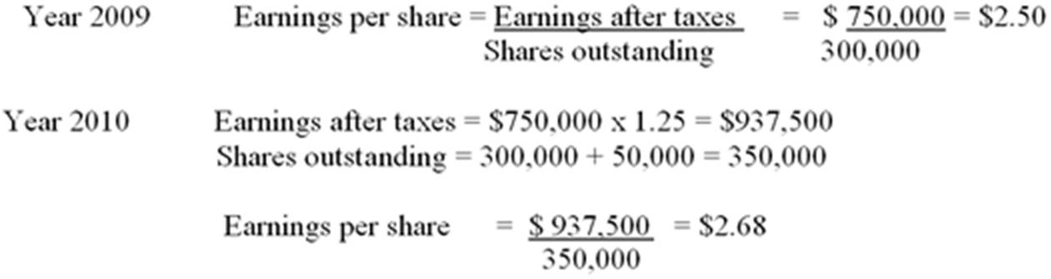
  A. | $2.14.
  B. | $2.68.
  C. | $3.13.
  D. | None of the options.

AACSB: Analytic
Blooms: Apply
Difficulty: Intermediate
Learning Objective: 02-01 The income statement measures profitability.

67. | Consider the following information for Ball Corp.  What is the operating profit for Ball Corp.?  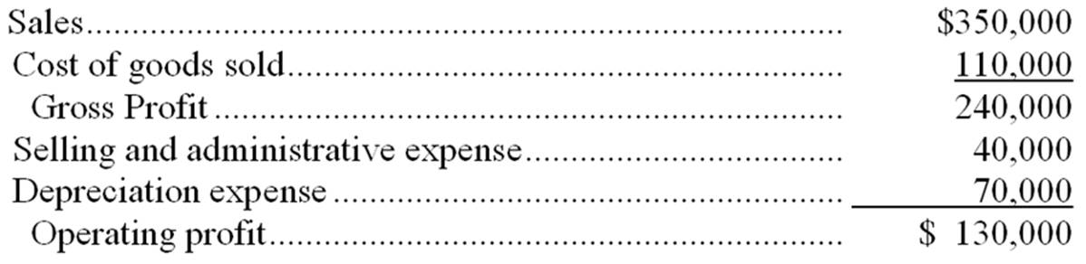
  A. | $71,450
  B. | $90,000
  C. | $130,000
  D. | None of the options

AACSB: Analytic
Blooms: Apply
Difficulty: Intermediate
Learning Objective: 02-01 The income statement measures profitability.

68. | Candy Company had sales of $320,000 and cost of goods sold of $112,000. What is the gross profit margin (ratio of gross profit to sales)?  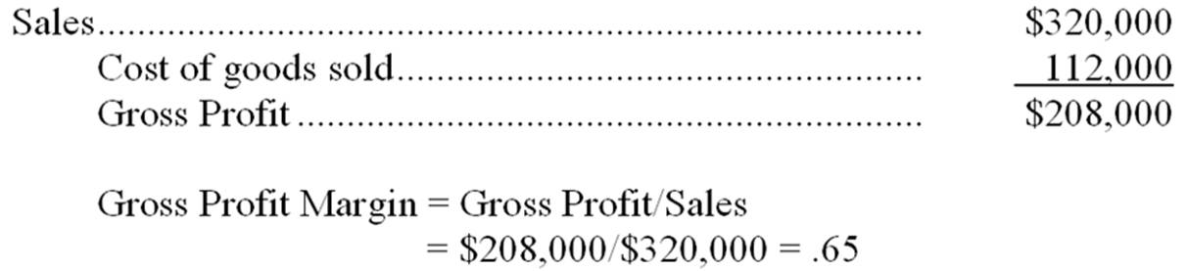
  A. | 55%
  B. | 65%
  C. | 73.3%
  D. | None of the options

AACSB: Analytic
Blooms: Apply
Difficulty: Intermediate
Learning Objective: 02-01 The income statement measures profitability.

69. | Density Farms Inc. had sales of $750,000, cost of goods sold of $200,000, selling and administrative expense of $70,000, and operating profit of $150,000. What was the value of depreciation expense?  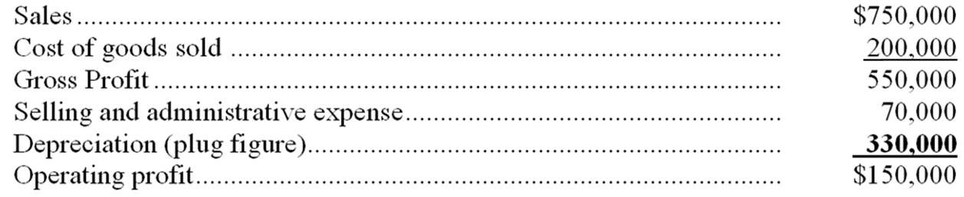
  A. | $150,000
  B. | $230,000
  C. | $330,000
  D. | None of the options

AACSB: Analytic
Blooms: Apply
Difficulty: Intermediate
Learning Objective: 02-01 The income statement measures profitability.

70. | Elgin Battery Manufacturers had sales of $1,000,000 in 2009 and their cost of goods sold represented 70 percent of sales. Selling and administrative expenses were 10 percent of sales. Depreciation expense was $100,000 and interest expense for the year was $10,000. The firm's tax rate is 30 percent. What is the dollar amount of taxes paid?  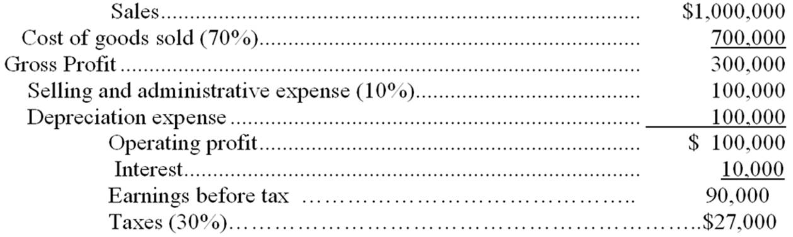
  A. | $30,000
  B. | $117,800
  C. | $27,000
  D. | None of the options

AACSB: Analytic
Blooms: Apply
Difficulty: Intermediate
Learning Objective: 02-01 The income statement measures profitability.

71. | A firm has $1,500,000 in its common stock account and $1,000,000 in its paid-in capital account. The firm issued 100,000 shares of common stock. What was the original issue price if only one stock issue has ever been sold?
  A. | $35 per share
  B. | $25 per share
  C. | $15 per share
  D. | Not enough information to determine

AACSB: Analytic
Blooms: Apply
Difficulty: Intermediate
Learning Objective: 02-01 The income statement measures profitability.

72. | A firm has $4,000,000 in its common stock account and $10,000,000 in its paid-in capital account. The firm issued 1,000,000 shares of common stock. What is the par value of the common stock?  Par value = Common stock/number of shares outstanding = $4,000,000/1,000,000 = $4
  A. | $40 per share
  B. | $10 per share
  C. | $4 per share
  D. | $14 per share

AACSB: Analytic
Blooms: Apply
Difficulty: Intermediate
Learning Objective: 02-01 The income statement measures profitability.

73. | A firm with earnings per share of $3 and a price-earnings ratio of 20 will have a stock price of  Stock price = EPS × P/E ratio = $3 × 20 = $60
  A. | $60.00.
  B. | $15.00.
  C. | $6.67.
  D. | The market assigns a stock price independent of EPS and the P/E ratio.

AACSB: Analytic
Blooms: Apply
Difficulty: Intermediate
Learning Objective: 02-02 The price-earnings ratio indicates the relative valuation of earnings.

74. | Earnings per share is
  A. | operating profit divided by number of shares outstanding.
  B. | net income divided by number of shares outstanding.
  C. | net income divided by stockholders' equity.
  D. | net income minus preferred dividends divided by number of shares outstanding.

AACSB: Reflective Thinking
Blooms: Remember
Difficulty: Intermediate
Learning Objective: 02-01 The income statement measures profitability.

75. | Reinvested funds from retained earnings theoretically belong to
  A. | bond holders.
  B. | common stockholders.
  C. | employees.
  D. | All of the options

AACSB: Analytic
Blooms: Understand
Difficulty: Basic
Learning Objective: 02-01 The income statement measures profitability.

76. | The firm's price-earnings (P/E) ratio is influenced by its
  A. | capital structure.
  B. | earnings volatility.
  C. | sales, profit margins, and earnings.
  D. | All of the options

AACSB: Analytic
Blooms: Understand
Difficulty: Basic
Learning Objective: 02-02 The price-earnings ratio indicates the relative valuation of earnings.

77. | When a firm's earnings are falling more rapidly than its stock price, its P/E ratio will
  A. | remain the same.
  B. | go up.
  C. | go down.
  D. | either go up or down.

AACSB: Analytic
Blooms: Understand
Difficulty: Intermediate
Learning Objective: 02-02 The price-earnings ratio indicates the relative valuation of earnings.

78. | Which of the following factors do not influence the firm's P/E ratio?
  A. | Past earnings
  B. | Shares outstanding
  C. | Volatility in performance
  D. | None of the options

AACSB: Analytic
Blooms: Understand
Difficulty: Intermediate
Learning Objective: 02-02 The price-earnings ratio indicates the relative valuation of earnings.

79. | Which of the following would not be classified as a current asset?
  A. | Marketable securities
  B. | Investments
  C. | Prepaid expenses
  D. | Inventory

AACSB: Reflective Thinking
Blooms: Remember
Difficulty: Basic
Learning Objective: 02-03 The balance sheet shows assets and the financing of those assets with debt and equity.

80. | An item which may be converted to cash within one year or one operating cycle of the firm is classified as a
  A. | current liability.
  B. | long-term asset.
  C. | current asset.
  D. | long-term liability.

AACSB: Reflective Thinking
Blooms: Remember
Difficulty: Basic
Learning Objective: 02-03 The balance sheet shows assets and the financing of those assets with debt and equity.

81. | Which of the following would not be included in the balance sheet investment account?
  A. | Stocks of other corporations
  B. | Long-term government bonds
  C. | Marketable securities
  D. | Investments in other corporations

AACSB: Analytic
Blooms: Understand
Difficulty: Intermediate
Learning Objective: 02-03 The balance sheet shows assets and the financing of those assets with debt and equity.

82. | Asset accounts on the balance sheet are listed in order of
  A. | liquidity.
  B. | profitability.
  C. | size.
  D. | importance.

AACSB: Reflective Thinking
Blooms: Remember
Difficulty: Basic
Learning Objective: 02-03 The balance sheet shows assets and the financing of those assets with debt and equity.

83. | Which of the following is not a primary source of capital to the firm?
  A. | Assets
  B. | Common stock
  C. | Preferred stock
  D. | Bonds

AACSB: Reflective Thinking
Blooms: Remember
Difficulty: Basic
Learning Objective: 02-03 The balance sheet shows assets and the financing of those assets with debt and equity.

84. | How many of the following balance sheet items are classified as current?  • Retained earnings  • Accounts payable  • Plant and equipment  • Inventory  • Common stock  • Bonds payable  • Accrued wages payable  • Accounts receivable  • Preferred stock
  A. | Three of these items are classified as current.
  B. | Four of these items are classified as current.
  C. | Five of these items are classified as current.
  D. | Six of these items are classified as current.

AACSB: Reflective Thinking
Blooms: Remember
Difficulty: Intermediate
Learning Objective: 02-03 The balance sheet shows assets and the financing of those assets with debt and equity.

85. | How many of the following items are found on the balance sheet, rather than the income statement?  • Accounts receivable  • Retained earnings  • Income tax expense  • Accrued expenses  • Cash  • Selling and administrative expenses  • Plant and equipment  • Operating expense  • Marketable securities  • Interest expense
  A. | Three of these items are found on the balance sheet.
  B. | Four of these items are found on the balance sheet.
  C. | Five of these items are found on the balance sheet.
  D. | Six of these items are found on the balance sheet.

AACSB: Reflective Thinking
Blooms: Remember
Difficulty: Intermediate
Learning Objective: 02-03 The balance sheet shows assets and the financing of those assets with debt and equity.

86. | How many of the following items are found on the income statement, rather than the balance sheet?  • Sales  • Notes payable (six months)  • Bonds payable, maturity 2001  • Common stock  • Depreciation expense  • Inventories  • Capital in excess of par value  • Net income (earnings after taxes)  • Income tax payable
  A. | Two of these items are found on the income statement.
  B. | Three of these items are found on the income statement.
  C. | Four of these items are found on the income statement.
  D. | Five of these items are found on the income statement.

AACSB: Reflective Thinking
Blooms: Remember
Difficulty: Intermediate
Learning Objective: 02-03 The balance sheet shows assets and the financing of those assets with debt and equity.

87. | Which account represents the cumulative earnings of the firm since its formation, minus dividends paid?
  A. | Paid-in capital
  B. | Common stock
  C. | Retained earnings
  D. | Accumulated depreciation

AACSB: Reflective Thinking
Blooms: Remember
Difficulty: Basic
Learning Objective: 02-03 The balance sheet shows assets and the financing of those assets with debt and equity.

88. | The major limitation of financial statements is
  A. | their complexity.
  B. | their lack of comparability.
  C. | their use of historical cost accounting.
  D. | their lack of detail.

AACSB: Analytic
Blooms: Understand
Difficulty: Intermediate
Learning Objective: 02-01 The income statement measures profitability.

89. | Net worth is equal to stockholders' equity
  A. | plus dividends.
  B. | minus preferred stock.
  C. | plus preferred stock.
  D. | minus liabilities.

AACSB: Analytic
Blooms: Understand
Difficulty: Intermediate
Learning Objective: 02-03 The balance sheet shows assets and the financing of those assets with debt and equity.

90. | Book value is the same as
  A. | stockholders' equity.
  B. | fixed assets minus long-term debt.
  C. | net worth.
  D. | current assets minus current debt.

AACSB: Analytic
Blooms: Understand
Difficulty: Intermediate
Learning Objective: 02-03 The balance sheet shows assets and the financing of those assets with debt and equity.

91. | Total stockholders' equity consists of
  A. | preferred stock and common stock.
  B. | common stock and retained earnings.
  C. | common stock and capital paid in excess of par.
  D. | preferred stock, common stock, capital paid in excess of par, and retained earnings.

AACSB: Analytic
Blooms: Understand
Difficulty: Intermediate
Learning Objective: 02-03 The balance sheet shows assets and the financing of those assets with debt and equity.

92. | The net worth of a firm
  A. | is usually the same as the firm's market value.
  B. | is based on current asset costs.
  C. | is based on current liabilities.
  D. | None of the options

AACSB: Analytic
Blooms: Apply
Difficulty: Intermediate
Learning Objective: 02-03 The balance sheet shows assets and the financing of those assets with debt and equity.

93. | The orientation of book value per share is ________, while the orientation of market value per share is _________.
  A. | short term; long term
  B. | future; historical
  C. | historical; future
  D. | long term; short term

AACSB: Analytic
Blooms: Understand
Difficulty: Intermediate
Learning Objective: 02-03 The balance sheet shows assets and the financing of those assets with debt and equity.

94. | The primary disadvantage of accrual accounting is that
  A. | it does not match revenues and expenses in the period in which they are incurred.
  B. | it does not appropriately measure accounting profit.
  C. | it does not recognize accounts receivable.
  D. | it does not adequately show the actual cash flows of the firm.

AACSB: Analytic
Blooms: Understand
Difficulty: Intermediate
Learning Objective: 02-01 The income statement measures profitability.

95. | The statement of cash flows does not include which of the following sections?
  A. | Cash flows from operating activities
  B. | Cash flows from sales activities
  C. | Cash flows from investing activities
  D. | Cash flows from financing activities

AACSB: Analytic
Blooms: Understand
Difficulty: Intermediate
Learning Objective: 02-04 The statement of cash flows indicates the change in the cash position of the firm.

96. | Which of the following is an outflow of cash?
  A. | Profitable operations
  B. | The sale of equipment
  C. | The sale of the company's common stock
  D. | The payment of cash dividends

AACSB: Analytic
Blooms: Understand
Difficulty: Basic
Learning Objective: 02-04 The statement of cash flows indicates the change in the cash position of the firm.

97. | Which of the following is an inflow of cash?
  A. | Funds spent in normal business operations
  B. | The purchase of a new factory
  C. | The sale of the firm's bonds
  D. | The retirement of the firm's bonds

AACSB: Analytic
Blooms: Understand
Difficulty: Basic
Learning Objective: 02-04 The statement of cash flows indicates the change in the cash position of the firm.

98. | A statement of cash flows allows a financial analyst to determine
  A. | whether a cash dividend is affordable.
  B. | how increases in asset accounts have been financed.
  C. | whether long-term assets are being financed with long-term or short-term financing.
  D. | All of the options

AACSB: Analytic
Blooms: Understand
Difficulty: Intermediate
Learning Objective: 02-04 The statement of cash flows indicates the change in the cash position of the firm.

99. | Which of the following would represent a use of funds and, indirectly, a reduction in cash balances?
  A. | An increase in inventories
  B. | A decrease in marketable securities
  C. | An increase in accounts payable
  D. | The sale of new bonds by the firm

AACSB: Analytic
Blooms: Understand
Difficulty: Intermediate
Learning Objective: 02-04 The statement of cash flows indicates the change in the cash position of the firm.

100. | Which of the following would represent a source of funds and, indirectly, an increase in cash balances?
  A. | A reduction in accounts receivable
  B. | The repurchase of shares of the firm's stock
  C. | A decrease in net income
  D. | A reduction in notes payable

AACSB: Analytic
Blooms: Understand
Difficulty: Intermediate
Learning Objective: 02-04 The statement of cash flows indicates the change in the cash position of the firm.

101. | A firm's purchase of plant and equipment would be considered a
  A. | use of cash for financing activities.
  B. | use of cash for operating activities.
  C. | source of cash for investment activities.
  D. | use of cash for investment activities.

AACSB: Analytic
Blooms: Understand
Difficulty: Intermediate
Learning Objective: 02-04 The statement of cash flows indicates the change in the cash position of the firm.

102. | An increase in investments in long-term securities will
  A. | increase cash flow from investing activities.
  B. | decrease cash flow from investing activities.
  C. | increase cash flow from financing activities.
  D. | decrease cash flow from financing activities.

AACSB: Analytic
Blooms: Understand
Difficulty: Intermediate
Learning Objective: 02-04 The statement of cash flows indicates the change in the cash position of the firm.

103. | How many of the following items decrease cash flow in the statement of cash flows?  • Increase in accounts receivable  • Increase in notes payable  • Depreciation expense  • Increase in investments  • Decrease in accounts payable  • Decrease in prepaid expenses  • Dividend payment  • Increase in accrued expenses
  A. | Two of these items decrease cash flow
  B. | Three of these items decrease cash flow
  C. | Four of these items decrease cash flow
  D. | Five of these items decrease cash flow

AACSB: Reflective Thinking
Blooms: Remember
Difficulty: Challenge
Learning Objective: 02-04 The statement of cash flows indicates the change in the cash position of the firm.

104. | Depreciation is a source of cash inflow because
  A. | it is a non-cash expense.
  B. | it supplies cash for future asset purchases.
  C. | it is a tax-deductible cash expense.
  D. | it is a taxable expense.

AACSB: Analytic
Blooms: Understand
Difficulty: Basic
Learning Objective: 02-05 Depreciation provides a tax reduction benefit that increases cash flow.

105. | Depreciation tends to
  A. | increase cash flow and decrease income.
  B. | decrease cash flow and increase income.
  C. | affect only cash flow.
  D. | affect only income.

AACSB: Analytic
Blooms: Understand
Difficulty: Basic
Learning Objective: 02-05 Depreciation provides a tax reduction benefit that increases cash flow.

106. | Preferred stock dividends __________ earnings available to common stockholders.
  A. | increase
  B. | decrease
  C. | do not effect
  D. | There is not enough information to determine.

AACSB: Analytic
Blooms: Understand
Difficulty: Basic
Learning Objective: 02-01 The income statement measures profitability.

107. | Free cash flow is equal to
  A. | cash flow from operating activities plus capital expenditures, minus dividends.
  B. | cash flow from operating activities plus capital expenditures, plus dividends.
  C. | cash flow from operating activities plus dividends, minus capital expenditures.
  D. | cash flow from operating activities minus capital expenditures, minus dividends.

AACSB: Analytic
Blooms: Understand
Difficulty: Intermediate
Learning Objective: 02-04 The statement of cash flows indicates the change in the cash position of the firm.

108. | In the last decade, free cash flow has been associated with special financial activities such as
  A. | leveraged buyouts.
  B. | ESOPs.
  C. | stock options.
  D. | golden parachutes.

AACSB: Analytic
Blooms: Understand
Difficulty: Challenge
Learning Objective: 02-04 The statement of cash flows indicates the change in the cash position of the firm.

109. | Free cash flow is equal to cash flow from operating activities
  A. | plus capital expenditures, minus dividends.
  B. | minus capital expenditures, plus dividends.
  C. | plus capital expenditures, plus dividends.
  D. | minus capital expenditures, minus dividends.

AACSB: Reflective Thinking
Blooms: Remember
Difficulty: Intermediate
Learning Objective: 02-04 The statement of cash flows indicates the change in the cash position of the firm.

110. | Given the following, what is free cash flow?  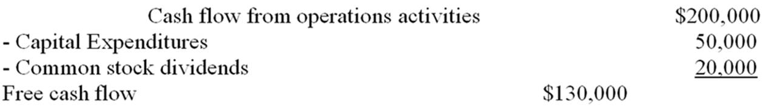
  A. | $150,000
  B. | $270,000
  C. | $180,000
  D. | $130,000

AACSB: Analytic
Blooms: Apply
Difficulty: Intermediate
Learning Objective: 02-04 The statement of cash flows indicates the change in the cash position of the firm.

111. | With respect to Finance in Action: Global, which of the following is NOT true:
  A. | International Accounting Standards and United States GAAP are now in full agreement.
  B. | LIFO is forbidden under International Financial Reporting Standards.
  C. | International Financial Reporting Standards are "rules-based."
  D. | Under United States GAAP the method of depreciating long-term assets is at the discretion of the company's management

AACSB: Analytic
Blooms: Understand
Difficulty: Challenge
Learning Objective: 02-05 Depreciation provides a tax reduction benefit that increases cash flow.

112. | Assuming a tax rate of 40%, depreciation expenses of $500,000 will  Tax savings from depreciation = Depreciation × tax rate = $500,000 × .40 = $200,000
  A. | reduce income by $200,000.
  B. | reduce taxes by $200,000.
  C. | reduce taxes by $500,000.
  D. | have no effect on income or taxes, since depreciation is not a cash expense.

AACSB: Analytic
Blooms: Apply
Difficulty: Basic
Learning Objective: 02-05 Depreciation provides a tax reduction benefit that increases cash flow.

113. | Assuming a tax rate of 40%, the after-tax cost of interest expense of $1,000,000 is  After tax cost of interest = Interest × (1 - tax rate) = $1,000,000 × .60 = $600,000
  A. | $1,000,000
  B. | $140,000
  C. | $600,000
  D. | $400,000

AACSB: Analytic
Blooms: Apply
Difficulty: Basic
Learning Objective: 02-04 The statement of cash flows indicates the change in the cash position of the firm.

114. | Assuming a tax rate of 30%, the after-tax cost of a $100,000 dividend payment is  Dividends are not tax deductible.
  A. | $100,000
  B. | $70,000
  C. | $30,000
  D. | None of the options

AACSB: Analytic
Blooms: Apply
Difficulty: Intermediate
Learning Objective: 02-04 The statement of cash flows indicates the change in the cash position of the firm.

115. | Farah Snack Co. has earnings after taxes of $150,000. Interest expense for the year was $20,000; preferred dividends paid were $20,000; and common dividends paid were $30,000. Taxes were $22,500. The firm has 100,000 shares of common stock outstanding. Earnings per share on the common stock was  Earnings after taxes - Preferred stock dividends = Earnings available to common  $150,000 - $20,000 = $130,000 EAC  Earnings per share = Earnings available to common/number of shares outstanding  $130,000/100,000 = $1.30
  A. | $1.30.
  B. | $1.10.
  C. | $0.75.
  D. | $0.80.

AACSB: Analytic
Blooms: Apply
Difficulty: Challenge
Learning Objective: 02-01 The income statement measures profitability.

116. | Gerry Co. has a gross profit of $1,200,000 and $400,000 in depreciation expense. Selling and administrative expense is $250,000. Given that the tax rate is 40 percent, compute the cash flow for Gerry Co.  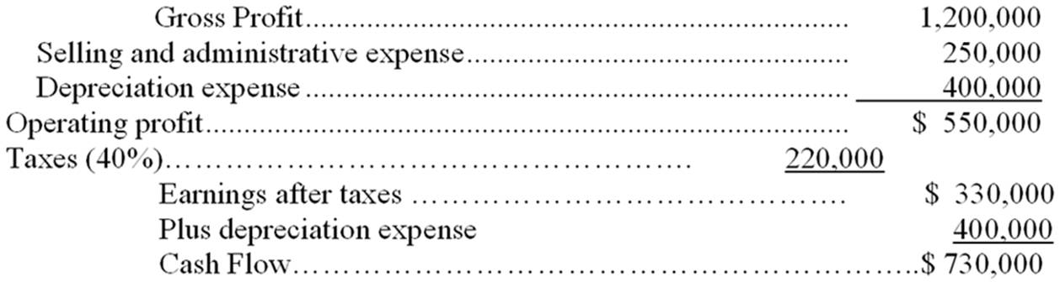
  A. | $730,000
  B. | $550,000
  C. | $330,000
  D. | None of the options

AACSB: Analytic
Blooms: Apply
Difficulty: Challenge
Learning Objective: 02-04 The statement of cash flows indicates the change in the cash position of the firm.
Learning Objective: 02-05 Depreciation provides a tax reduction benefit that increases cash flow.

117. | Hoover Inc. has current assets of $350,000 and fixed assets of $650,000. Current liabilities are $100,000 and long-term liabilities are $250,000. There is $120,000 in preferred stock outstanding and the firm has issued 10,000 shares of common stock. Compute book value (net worth) per share  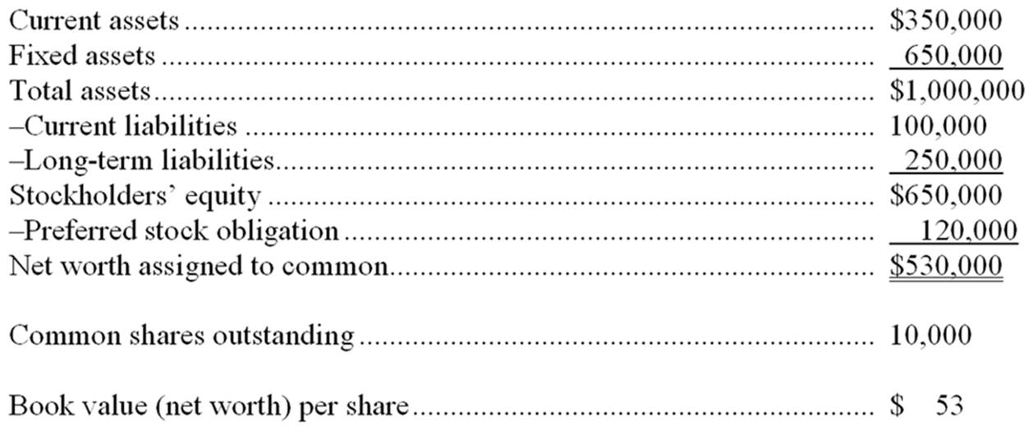
  A. | $84.00.
  B. | $53.00.
  C. | $75.00.
  D. | None of the options.

AACSB: Analytic
Blooms: Apply
Difficulty: Challenge
Learning Objective: 02-03 The balance sheet shows assets and the financing of those assets with debt and equity.

118. | The best indication of the operational efficiency of management is
  A. | net income.
  B. | earnings per share.
  C. | earnings before interest and taxes (EBIT).
  D. | gross profit.

AACSB: Analytic
Blooms: Understand
Difficulty: Challenge
Learning Objective: 02-01 The income statement measures profitability.

119. | Which of the following would indicate an accurate statement of cash flows?
  A. | Net cash flow is equal to marketable securities balance
  B. | Net cash flows from financing activities are equal to the change in stockholder's equity
  C. | Net cash flow is equal to the ending cash balance
  D. | Net cash flow is equal to the change in the cash balance

AACSB: Analytic
Blooms: Analyze
Difficulty: Intermediate
Learning Objective: 02-04 The statement of cash flows indicates the change in the cash position of the firm.

120. | An increase of $100,000 in inventory would result in a(n)
  A. | Decrease of net cash flow.
  B. | Increase in net cash flow.
  C. | Decrease in marketable securities.
  D. | Increase in bonds payable.

AACSB: Analytic
Blooms: Analyze
Difficulty: Intermediate
Learning Objective: 02-04 The statement of cash flows indicates the change in the cash position of the firm.

121. | Compute the net increase or decrease in cash flows if Star Corporation had $250,000 in net income, $30,000 in depreciation expense, a decrease of $20,000 in A/R and an increase in bonds payable of $50,000.  Change in cash flow = Net income + Depreciation + Decrease in A/R + Increase in bonds = $250,000 + $30,000 + $20,000 + $50,000 = $350,000.
  A. | $370,000
  B. | $350,000
  C. | $280,000
  D. | $310,000

AACSB: Analytic
Blooms: Apply
Difficulty: Intermediate
Learning Objective: 02-04 The statement of cash flows indicates the change in the cash position of the firm.

122. | One of the primary factors evaluated when a company is pursuing a leveraged buyout is
  A. | Net cash flow.
  B. | Free cash flow.
  C. | Cash flow from financing activities.
  D. | Cash flow from investing activities.

AACSB: Analytic
Blooms: Understand
Difficulty: Intermediate
Learning Objective: 02-04 The statement of cash flows indicates the change in the cash position of the firm.

123. | Backdating of options is
  A. | A fair method to award top-performing employees.
  B. | Illegal.
  C. | Not to be reported unless a gain is provided to an employee.
  D. | Considered a gift by tax law.

AACSB: Ethics
Blooms: Understand
Difficulty: Intermediate
Learning Objective: 02-04 The statement of cash flows indicates the change in the cash position of the firm.

Matching Questions
124. | Match the following with the questions below:
  1. cash flow from financing | All the assets of the firm minus the liabilities and preferred stock. | 3
  2. marketable securities | A financial statement that indicates what the firm owns or possesses, and how these assets are financed in the form of liabilities or ownership interest. | 6
  3. net worth or book value | Changes accrual-based information from the income statement and balance sheet to cash-based information. | 17
  4. depreciation | The relative convertibility of short-term assets into cash. | 13
  5. cash flows from operations | The levy expressed as a percentage that applies to each new dollar of taxable income. | 9
  6. balance sheet | The multiplier applied to earnings per share to determine the current value of the firm's stock. | 14
  7. free cash flow | The income available to common stockholders divided by the number of common shares outstanding. | 8
  8. earnings per share | A financial statement that measures the profitability of the firm over a period of time. | 15
  9. marginal corporate tax rate | Temporary investments of excess cash. | 2
  10. notes payable | Represents the net cash flow that results from changes in the amount of a firm's long-term assets. | 11
  11. cash flows from investing | The total ownership position of preferred and common stockholders. | 16
  12. historical cost accounting | Traditional method of accounting using original costs minus depreciation. | 12
  13. liquidity | Represents the net cash flow that results from a firm's production and sales activities. | 5
  14. P/E ratio | Short-term signed obligations to banks or other creditors. | 10
  15. income statement | Cash flow that is generated (or reduced) from the sale or repurchase of securities, the payment of cash dividends, and borrowings or repayment of debt. | 1
  16. stockholders' equity | The allocation of the initial cost of an asset over its useful life. | 4
  17. statement of cash flows | Cash flow from operations minus capital expenditures minus dividend payments. | 7

AACSB: Reflective Thinking
Blooms: Remember
Difficulty: Intermediate
Learning Objective: 02-01 The income statement measures profitability.
Learning Objective: 02-02 The price-earnings ratio indicates the relative valuation of earnings.
Learning Objective: 02-03 The balance sheet shows assets and the financing of those assets with debt and equity.
Learning Objective: 02-04 The statement of cash flows indicates the change in the cash position of the firm.
Learning Objective: 02-05 Depreciation provides a tax reduction benefit that increases cash flow.

Essay Questions
125. | The following is the December 31, 2010 balance sheet for the Epics Corporation.  Sales for 2010 were $3,000,000, with the cost of goods sold being 60% of sales. Depreciation expense was 10% of the gross plant and equipment at the beginning of the year. Interest expense was 9% on the notes payable and 11% on the bonds payable. Selling and administrative expenses were $200,000 and the firm's tax rate is 40%. Prepare an income statement.  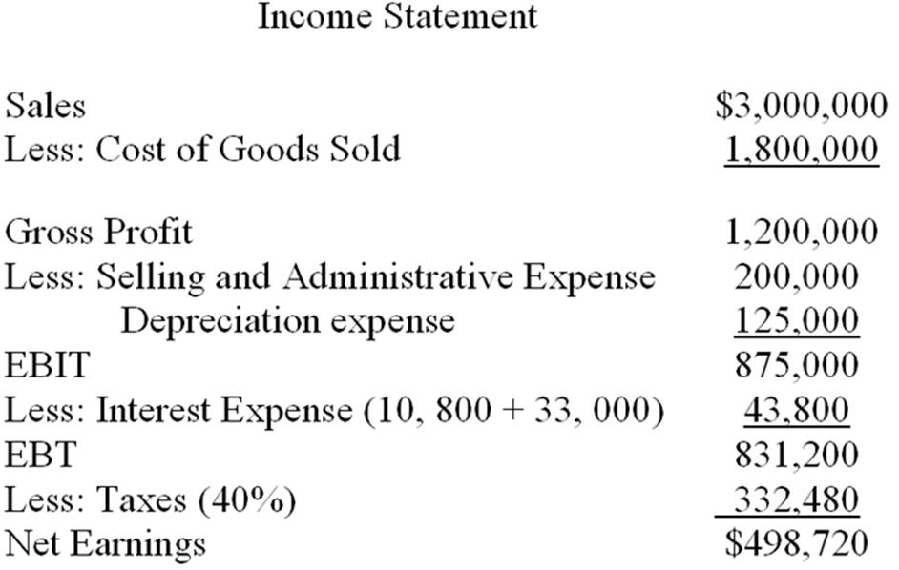

AACSB: Analytic
Blooms: Apply
Difficulty: Intermediate
Learning Objective: 02-01 The income statement measures profitability.
Learning Objective: 02-03 The balance sheet shows assets and the financing of those assets with debt and equity.

126. | Given the financial information for the A.E. Neuman Corporation:  (a) Prepare a statement of cash flows for the year ended December 31, 2010.  (b) What is the dividend payout ratio for 2010?  (c) If we increased the dividend payout ratio to 100%, what would happen to retained earnings at year end 2010?  A.E. Neuman Corporation - Year-end Balance Sheets  LIABILITIES AND STOCKHOLDERS EQUITY  (a)  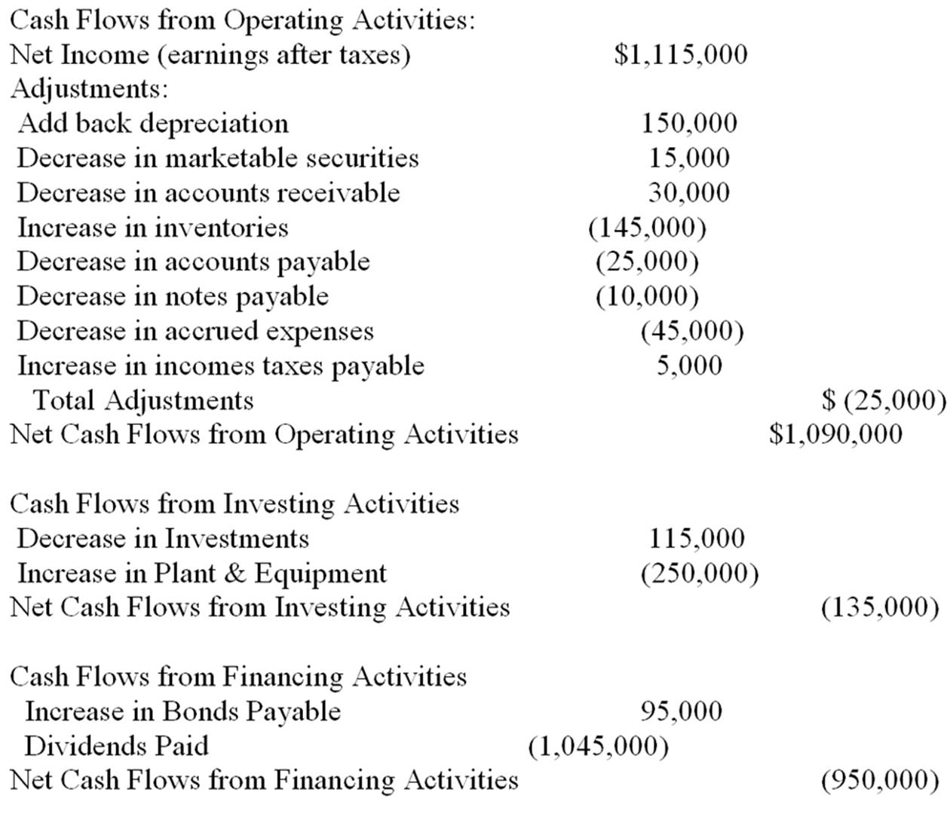  (b)  (c) The 2010 value for retained earnings would decrease by $70,000 to $400,000. In addition, assets would have to decrease by $70,000 or other liabilities would have to increase by the same amount. Clearly, dividend payouts of this magnitude are very unhealthy for this company's cash flow, particularly since the firm appears to be borrowing funds while expanding their Fixed Asset Base. Companies must have accumulated profits AND liquidity in order to pay dividends.

AACSB: Analytic
Blooms: Apply
Difficulty: Challenge
Learning Objective: 02-04 The statement of cash flows indicates the change in the cash position of the firm.

127. | Assume the company has issued 15,000 bonds with a coupon rate of 10% and a face value of $1,000 per bond, and the company has a marginal tax rate of 40%. Calculate the annual after-tax cost of the interest expense.  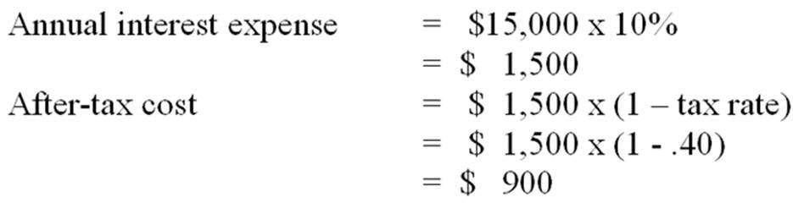

AACSB: Analytic
Blooms: Apply
Difficulty: Intermediate
Learning Objective: 02-01 The income statement measures profitability.
Learning Objective: 02-04 The statement of cash flows indicates the change in the cash position of the firm.

128. | ElectroWizard Company produces a popular video game called Destructo, which sells for $65. Last year ElectroWizard sold 100,000 Destructo games, each of which costs $10 to produce. ElectroWizard incurred selling and administrative expenses of $200,000 and a depreciation expense of $100,000. In addition, ElectroWizard has a $1,000,000 loan outstanding at 8%. Their tax rate is 40%. There are 400,000 common shares outstanding.  Prepare an income statement for ElectroWizard in good form (include EPS).  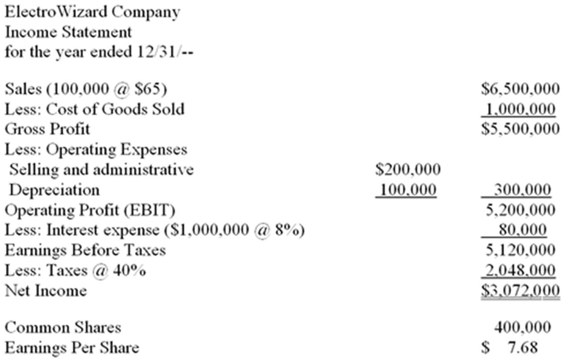

AACSB: Analytic
Blooms: Apply
Difficulty: Intermediate
Learning Objective: 02-01 The income statement measures profitability.

129. | Identify each of the following as increasing (+) or decreasing (-) cash flows from operating activities (0), investment activities (I), or financing activities (F). (EXAMPLE: The sale of plant and equipment would increase cash flows from investing activities, and the correct answer would be +I).  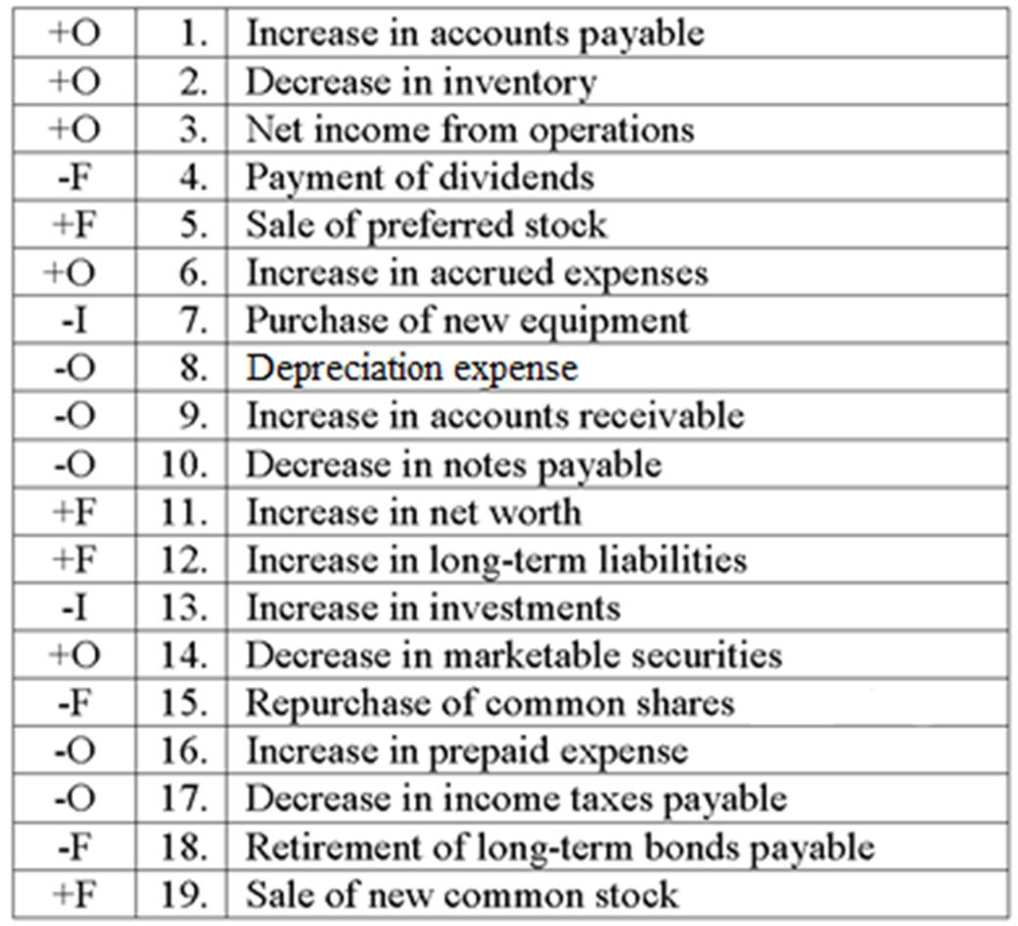

AACSB: Analytic
Blooms: Analyze
Difficulty: Intermediate
Learning Objective: 02-04 The statement of cash flows indicates the change in the cash position of the firm.

