CHAPTER 2

Overview of Business Processes

SUGGESTED ANSWERS TO DISCUSSION QUESTIONS

2.1 Table 2-1 lists some of the documents used in the revenue, expenditure, and human resources cycle. What kinds of input or output documents or forms would you find in the production (or conversion) cycle?

Students will not know the names of the documents but they should be able to identify the tasks about which information needs to be gathered. Here are some of those tasks:

- Requests for items to be produced
- Documents to plan production
- Schedule of items to be produced
- List of items produced, including quantity and quality
- Form to allocate costs to products
- Form to collect time spent on production jobs
- Form requesting raw materials for production process
- Documents showing how much raw materials are on hand
- Documents showing how much raw materials went into production
- List of production processes
- List of items needed to produce each product
- Documents to control movement of goods from one location to another

2.2 With respect to the data processing cycle, explain the phrase “garbage in, garbage out.” How can you prevent this from happening?

When garbage, defined as errors, is allowed into a system that error is processed and the resultant erroneous (garbage) data stored. The stored data at some point will become output. Thus, the phrase garbage in, garbage out. Data errors are even more problematic in ERP systems because the error can affect many more applications than an error in a non-integrated database.

Companies go to great lengths to make sure that errors are not entered into a system. To prevent data input errors:

- Data captured on source documents and keyed into the system are edited by the computer to detect and correct errors and critical data is sometimes double keyed.
- Companies use turnaround documents to avoid the keying process.
- Companies use source data automation devices to capture data electronically to avoid manual data entry with its attendant errors.
- Well-designed documents and screens improve accuracy and completeness by providing instructions or prompts about what data to collect, grouping logically related pieces of information close together, using check off boxes or pull-down menus to present the available options, and using appropriate shading and borders to clearly separate data items.
- Data input screens are preformatted to list all the data the user needs to enter.
- Prenumbered source documents are used or the system automatically assigns a sequential number to each new transaction. This simplifies verifying that all transactions have been recorded and that none of the documents has been misplaced.
- The system is programmed to make sure company policies are followed, such as approving or verifying a transaction. For example, the system can be programmed to check a customer’s credit limit and payment history, as well as inventory status, before confirming a sale to a customer.

2.3 What kinds of documents are most likely to be turnaround documents? Do an internet search to find the answer and to find example turnaround documents.

Documents that are commonly used as turnaround documents include the following:

- Utility bills
- Meter cards for collecting readings from gas meters, photocopiers, water meters etc
- Subscription renewal notices
- Inventory stock cards
- Invoices
- Checks (banks encode account info on the bottom of checks)
- Annual emissions inventory forms (http://www.deq.state.ok.us/aqdnew/Emissions/TurnAroundDocs.htm)
- Adult Literary Information and Evaluation System forms (http://www.lacnyc.org/ALIES/tech_support/manual/Section4Chapter2.pdf)

Students will find many other turnaround documents.

Here are some URLs for turnaround document definitions and examples:
http://en.wikipedia.org/wiki/Turnaround_document
http://www.pcmag.com/encyclopedia_term/0,2542,t=turnaround+document&i=53248,00.asp
http://www.answers.com/topic/turnaround-document-1

Here are some turnaround document images (1 long URL):
http://images.google.com/images?q=turnaround+document&oe=utf-8&rls=org.mozilla:en-US:official&client=firefox-a&um=1&ie=UTF-8&ei=N7yBSpbAF4KiswO39JnwCA&sa=X&oi=image_result_group&ct=title&resnum=4

2.4 The data processing cycle in Figure 2-1 is an example of a basic process found throughout nature. Relate the basic input/process/store/output model to the functions of the human body.

There are a number of ways to relate the input/process/store/output model to the human body. Here are a few of them

- Brain. We read, see, hear, and feel things. We process that input in order to understand what it is and how it relates to us. We store that data in our brains and then process it again in order to produce solve problems, make decisions, etc., which represent output.
- Stomach. We take food in as input. It is processed to produce energy to fuel all bodily functions. If we eat more food than the body needs at any one time it is stored as fat. The output is walking, talking, thinking – all functions fueled by the energy produced. Human waste is also an output of that process.

Students will come up with other examples of how the input/process/store/output model applies to the human body

2.5 Some individuals argue that accountants should focus on producing financial statements and leave the design and production of managerial reports to information systems specialists. What are the advantages and disadvantages of following this advice? To what extent should accountants be involved in producing reports that include more than just financial measures of performance? Why?

There are no advantages to accountants focusing only on financial information. Both the accountant and the organization would suffer if this occurred. Moreover, it would be very costly to have two systems rather than one that captures and processes operational facts at the same time as it captures and reports financial facts.

The main disadvantage of this is that accountants would ignore much relevant information about the organization’s activities. To the extent that such nonfinancial information (e.g., market share, customer satisfaction, measures of quality, etc.) is important to management, the value of the accounting function would decline. Moreover, accountants have been trained in how to design systems to maximize the reliability of the information produced. If relevant information is not produced by the AIS, there is danger that the information may be unreliable because the people responsible for its production have not been trained in, or adequately aware of, the potential threats to reliability and the best measures for dealing with those threats.
SUGGESTED ANSWERS TO THE PROBLEMS

2.1 The chart of accounts must be tailored to an organization’s specific needs. Discuss how the chart of accounts for the following organizations would differ from the one presented for S&S in Table 2-2.

Some of the changes in the chart of accounts for each type of entity include the following:

a. University
- No equity or summary drawing accounts. Instead, have a fund balances section for each type of fund.
- Several types of funds, with a separate chart of accounts for each. The current fund is used for operating expenses, but not capital expenditures. Loan funds are used to account for scholarships and loans. Endowment funds are used to account for resources obtained from specific donors, generally with the objective that principal be preserved and that income be used for a specific purpose. Plant funds are used for major capital expenditures. Most fund categories would be further divided into restricted and unrestricted categories.
- Unlikely to have Notes Receivable, but may have Accounts Receivable for students who pay tuition in installment payments.
- Tuition and fees would be one source of revenue. Others include gifts, investment income, sales of services, and, for public universities, state appropriations.
- Student loans are an asset; student deposits are a liability.

b. Bank
- Loans to customers would be an asset, some current others noncurrent, depending upon the length of the loan.
- No inventory
- Customer accounts would be liabilities.
- Classification of revenue would be among loans, investments, service charges, etc.
- No cost of goods sold.

c. Government Unit
- No equity or summary drawing accounts. Instead, have fund balances.
- Balance sheet shows two major categories: (1) assets and (2) liabilities and fund equity.
- Separate chart of accounts for each fund (general fund, special revenue fund, capital projects fund, and debt service fund).
- Revenue and expenditure accounts would be grouped by purpose (e.g., police, highways, sanitation, education, etc.).
- Encumbrance accounts
- Revenues would include taxes, licenses and permits, fines, and charges for specific services.
- Taxes receivable as a separate category due to importance.
- No cost of goods sold.

d. Manufacturing Company
- Several types of inventory accounts (raw materials, work-in-process, and finished goods).
- Additional digits to code revenues and expenses by products and to code assets/liabilities by divisions.

e. Expansion of S&S
- Additional digits to code:
- Revenues and expenses by products and by stores
- Assets/liabilities by stores.

2.2 Design a chart of accounts for SDC. Explain how you structured the chart of accounts to meet the company’s needs and operating characteristics. Keep total account code length to a minimum, while still satisfying all of Mace’s desires.
(Adapted from the CMA Exam)

A six-digit code (represented by letters ABCDEF) is sufficient to meet SDC’s needs:

A This digit identifies the 4 divisions plus the corporate office. One digit can accommodate up to 9 different divisions, assuming that no division would be zero. Thus, the number of divisions would have to more than double before the chart of accounts would have to be revised.

B This digit represents major account types (asset, liability, equity, revenue, expense). There are only 6 categories, so one digit is sufficient.

C This digit represents the major classification within account type:

- For balance sheet accounts, this represents specific sub-categories (current assets, plant and equipment, etc.), as only six categories are needed.

- For expense and revenue accounts, this digit represents the product group, as again there are only five products plus general costs.

D This digit represents specific accounts or cost centers:

- For balance sheet accounts, this is the control account; one digit is adequate because the problem says no more than 10 categories.

- For expense accounts, this is the cost center; one digit is adequate because the problem indicates no more than 6 cost centers.

EF These two digits represent the subsidiary accounts and natural expense categories:

- For expense accounts, these represent the 56 natural expense categories and variances for each cost center.

- For the balance sheet, these two digits accommodate up to 100 subsidiary accounts.
2.3 An audit trail enables a person to trace a source document to its ultimate effect on the financial statements or work back from amounts in the financial statements to source documents. Describe in detail the audit trail for the following:

a. The audit trail for inventory purchases includes linking purchase requisitions, purchase orders, and receiving reports to vendor invoices for payment. All these documents would be linked to the check or EFT transaction used to pay for an invoice and recorded in the Cash Disbursements Journal. In addition, these documents would all be linked to the journal entry made to record that purchase. There would be a general ledger account number at the bottom of each column in the journal. The journal reference would appear in the General Ledger, Inventory Ledger, and Accounts Payable ledger.

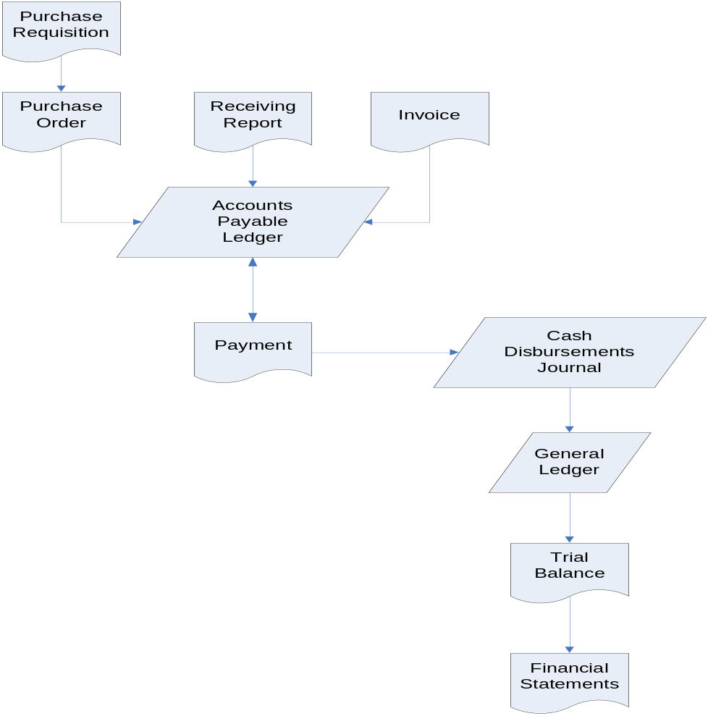
b. The audit trail for the sale of inventory links the customer order, sales order, and shipping document to the sales invoice. These documents are linked to the journal entry recording the sale of that merchandise. The invoice would also be linked to the cash received from the customer and to the journal entry to record that receipt.

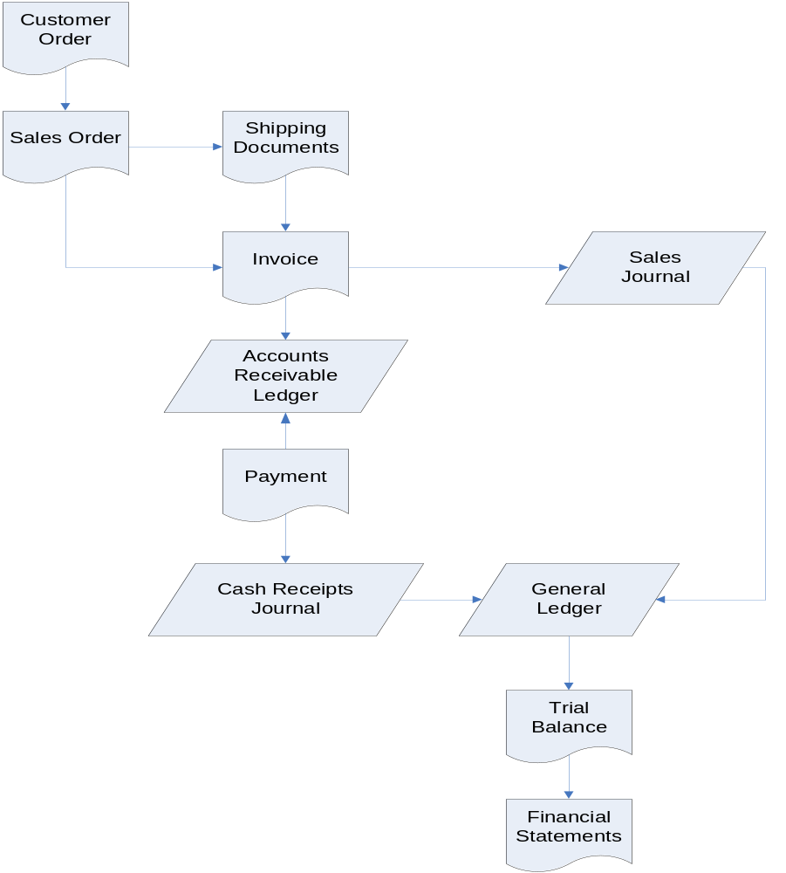

c. The audit trail for employee payroll links records of employee activity (time cards, time sheets, etc.) to paychecks and to the journal entry to record payment of payroll. In a manufacturing company, there would also be links to the job-time tickets used to allocate labor costs to specific products or processes.

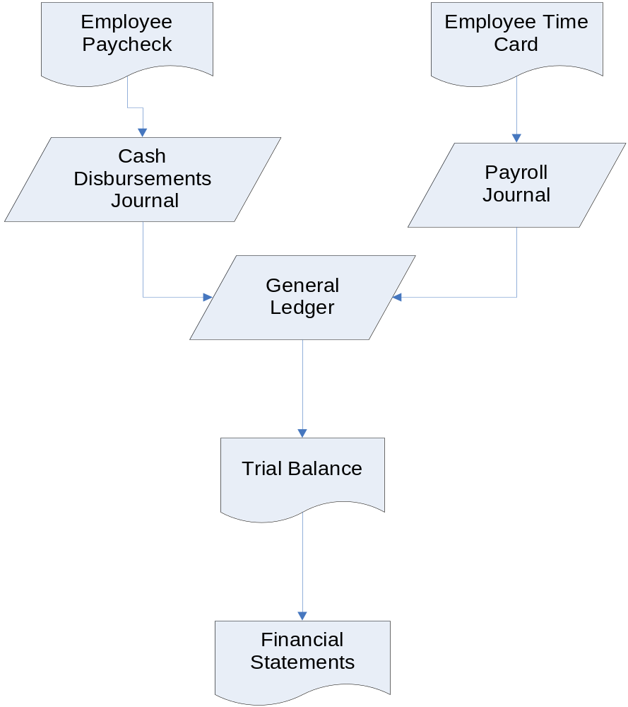

2.4 Your nursery sells various types and sizes of trees, bedding plants, vegetable plants, and shrubs. It also sells fertilizer and potting soil. Design a coding scheme for your nursery.

Grading depends upon the instructor’s judgment about the quality of the coding scheme. The coding scheme should be either a group or block coding. In addition, the student’s solutions should provide sufficient detail in order to determine whether the solution represents a group or block coding scheme.

An example block code is as follows (under each major heading the student would list the specific products offered for sale, such as 701 – Fuji apple tree). Four digits instead of three would allow the nursery to list more products for sale.

100 Flowers - Annual
200 Flowers – Perennial
300 Vegetables
400 Fruits
500 Shrubs
600 Trees- Flowering
700 Trees – Fruit and Nut

If the nursery had four locations, a group code could be used with the first digit indicating the location (2 location digits would allow for more growth). Other digits could be added to the group code to indicate other ways of identifying products.

2.5 Match the following terms with their definitions

TERM | DEFINITION
_10_ a. data processing | - Contains summary-level data for every asset, liability, equity, revenue, and expense account
_23_ b. source documents | 2. Items are numbered consecutively to account for all items; missing items cause a gap in the numerical sequence
_7_ c. turnaround documents | 3. Path of a transaction through a data processing system from point of origin to final output, or backwards from final output to point of origin
_16_ d. source data automation | 4. List of general ledger account numbers; allows transaction data to be coded, classified, and entered into proper accounts; facilitates preparation of financial statements and reports
_1_ e. general ledger | 5. Contents of a specific field, such as “George” in a name field
_13_ f. subsidiary ledger | 6. Portion of a data record that contains the data value for a particular attribute, like a cell in a spreadsheet
_26_ g. control account | 7. Company data sent to an external party and then returned to the system as input
_21_ h. coding | 8. Used to record infrequent or non-routine transactions
_2__ i. sequence code | 9. Characteristics of interest that need to be stored
_25_ j. block code | 10. The steps a company must follow to efficiently and effectively process data about its transactions
_19_ k. group code | 11. Something about which information is stored
_22_ l. mnemonic code | 12. Stores cumulative information about an organization; like a ledger in a manual AIS.
__4_ m. chart of accounts | 13. Contains detailed data for any general ledger account with many individual subaccounts
__8_ n. general journal | 14. Contains records of individual business transactions that occur during a specific time period
_17_ o. specialized journal | 15. Updating each transaction as it occurs
__3_ p. audit trail | 16. Devices that capture transaction data in machine-readable form at the time and place of their origin
_11_ q. entity | 17. Used to record large numbers of repetitive transactions
__9_ r. attribute | 18. Set of interrelated, centrally coordinated files
__6_ s. field | 19. Two or more subgroups of digits are used to code items
_24_ t. record | 20. Updating done periodically, such as daily
__5_ u. data value | 21. Systematic assignment of numbers or letters to items to classify and organize them
_12_ v. master file | 22. Letters and numbers, derived from the item description, are interspersed to identify items; usually easy to memorize
_14_ w. transaction file | 23. Initial record of a transaction that takes place; usually recorded on preprinted forms or formattted screens
_18_ x. database | 24. Fields containing data about entity attributes; like a row in a spreadsheet
_20_ y. batch processing | 25. Sets of numbers are reserved for specific categories of data
_15_ z. online, real-time processing | 26. The general ledger account corresponding to a subsidiary ledger, where the sum of all subsidiary ledger entries should equal the amount in the general ledger account

2.6 For each of the following scenarios identify which data processing method (batch or online, real-time) would be the most appropriate.

Some students will respond that all can and ought to be done with online-real time processing. While all can certainly be done that way, batch processing does have its advantages (cheaper, more efficient, etc.). In making the decision between batch and online-real time processing, designers must consider the need for current and accurate data. Batch processing is often used for data that does not need frequent updating and naturally occurs or is processed at fixed times. For example, while employee check in and checkout times may be gathered in real time, payroll is usually only processed at a fixed interval such as weekly, biweekly, or monthly.

a. Make an airline reservation | online-real time
b. Register for a university course | online-real time
c. Prepare biweekly payroll checks | batch
d. Process an order through an e-commerce Web site | online-real time
e. Prepare a daily bank deposit | batch
f. Preparation of customer bills by a local utility | batch
g. Accumulate daily costs from a production run of a single automobile part | batch
h. Identify the replacement drill bit size for a bit broken during a recent production run | on-line real time

2.7 After viewing the Web sites, and based on your reading of the chapter, write a 2 page paper that describes how an ERP can connect and integrate the revenue, expenditure, human resources/payroll, and financing cycles of a business.

Student solutions will vary depending on the demonstrations they observe. However, the demonstrations should give the students a more concrete and visual understanding of what an ERP system is and does. Student solutions should at least discuss how an ERP could integrate all of the various cycle activities of a business into one integrated system.

  - Which of the following actions update a master file and which would be stored as a record in a transaction file?

- Update customer address change – Master file
- Update unit pricing information – Master file
- Record daily sales – Transaction file
- Record payroll checks – Transaction file
- Change employee pay rates – Master file
- Record production run variances – Transaction file
- Record Sales Commissions – Transaction file
- Change employee office location – Master file
- Update accounts payable balance – Master file
- Change customer credit limit – Master file
- Change vendor payment discount terms – Master file
- Record purchases – Transaction file
  - You were hired to assist Ashton Fleming in designing an accounting system for S&S. Ashton has developed a list of the journals, ledgers, reports, and documents that he thinks S&S needs (see Table 2-6). He asks you to complete the following tasks:

No single answer exists with this case. Indeed, solutions will vary depending upon student ingenuity and creativity. Student answers can be compared to examples of these documents found in chapters 12, 13, and 15.

a. Specify what data you think should be collected on each of the following four documents: sales invoice, purchase order, receiving report, employee time card

A sample invoice is presented in the Revenue Cycle chapter. A sample purchase order is presented in the Expenditure Cycle chapter. A sample receiving report also appears in the Expenditure Cycle chapter. Although student designs will vary, each document should contain the following data items:

Sales Invoice
Customer name and address Product code or number
Customer account number Product description
Customer order number Quantity ordered
Salesperson code Quantity shipped
Shipping Address Unit price
Shipper and date shipped Extended price
Terms of sale Taxes, if applicable
Total Amount due

Purchase Order
Ship to address Item numbers ordered
Bill to address Payment terms
Purchasing agent number Shipping instructions
Quantity of parts ordered Supplier name or number
Prices of parts ordered Date of purchase
Taxes, if any Total amount of purchase

Receiving Report
Vendor name Vendor number
Vendor address Date received
Shipper Receiving clerk number
Quantity received Part number received
Description/quality remarks Purchase order number
Inspected by

Employee Time Card
Employee name Total regular hours
Employee number Time in/ Time out
Pay period Total overtime hours
Department number Approved by
Employee signature

b. Design a report to manage inventory
The report to manage inventory should contain the following information:

Preferred vendor

Product number

Description

Reorder point

Quantity on Hand

Quantity Available

Vendor performance history

Quantity on order

Lead time

- Design a report to assist in managing credit sales and cash collections.
The report to manage credit sales and cash collections should include:

Credit sales per period

Cash collections per period

Aging of accounts receivable

Customers by geographic region

Uncollectible accounts per period

- Visit a local office supply store and identify what types of journals, ledgers, and blank forms for various documents (sales invoices, purchase orders, etc.) are available. Describe how easily they could be adapted to meet S&S’s needs.

The answers to this will vary depending upon the types of documents carried in the office supplies stores visited by the students.

A fruitful topic for class discussion, or a possible additional case assignment, is to compare the design of paper documents to the data entry screen layouts used in various popular accounting packages.

SUGGESTED ANSWERS TO THE CASES

2.1 Bar Harbor Blueberry Farm

Data from Case

Date | Supplier Invoice | Supplier Name | Supplier Address | Amount
March 7 | AJ34 | Bud’s Soil Prep, Inc. | PO Box 34 | $2,067.85
March 11 | 14568 | Osto Farmers Supply | 45 Main | $ 67.50
March 14 | 893V | Whalers Fertilizer, Inc. | Route 34 | $5,000.00
March 21 | 14699 | Osto Farmers Supply | 45 Main | $3,450.37
March 21 | 10102 | IFM Package Wholesale | 587 Longview | $4,005.00
March 24 | 10145 | IFM Package Wholesale | 587 Longview | $ 267.88

Purchases Journal
Page 1

Date | Supplier | Supplier Invoice | Account Number | Post Ref | Amount
March 7 | Bud’s Soil Prep, Inc. | AJ34 | 23 | √ | $2,067.85
March 11 | Osto Farmers Supply | 14568 | 24 | √ | $ 67.50
March 14 | Whalers Fertilizer, Inc. | 893V | 36 | √ | $5,000.00
March 21 | Osto Farmers Supply | 14699 | 24 | √ | $3,450.37
March 21 | IFM Package Wholesale | 10102 | 38 | √ | $4,005.00
March 24 | IFM Package Wholesale | 10145 | 38 | √ | $ 267.88
March 31 | TOTAL |  |  |  | 14,858.60

General Ledger

Accounts Payable Account Number: 300

Date | Description | Post Ref | Debit | Credit | Balance
March 1 | Balance Forward |  |  |  | $18,735.55
March 31 |  | √ |  | 14,858.60 | 33,594.15

Purchases Account Number: 605

Date | Description | Post Ref | Debit | Credit | Balance
March 1 | Balance Forward |  |  |  | $54,688.49
March 31 |  | √ | 14,858.60 |  | 69,547.09

Account Payable Subsidiary Ledger

Account No: 23 |  | Bud’s Soil Prep, Inc. |  | PO Box 34 |  | Terms: 2/10, Net 30
Date | Description |  | Debit |  | Credit |  | Balance
March 1 | Balance Forward |  |  |  |  |  | 0.00
March 7 | Mulch |  |  |  | 2,067.85 |  | 2,067.85

Account No: 24 |  | Osto Farmers Supply |  | 45 Main |  | Terms: 2/10, Net 30
Date | Description |  | Debit |  | Credit |  | Balance
March 1 | Balance Forward |  |  |  |  |  | 0.00
Mar 11 | Seedling Heat Mat |  |  |  | 67.50 |  | 67.50
Mar 21 | Medium Portable Greenhouse |  |  |  | 3,450.37 |  | 3,517,87

Account No: 36 |  | Whalers Fertilizer, Inc. |  | Route 34 |  | Terms: 2/10, Net 30
Date | Description |  | Debit |  | Credit |  | Balance
March 1 | Balance Forward |  |  |  |  |  | 0.00
March 14 | Premium Leaf-Blend Fertilizer |  |  |  | 5,000.00 |  | 5,000.00

Account No: 38 |  | IFM Package Wholesale |  | 587 Longview |  | Terms: 2/10, Net 30
Date | Description |  | Debit |  | Credit |  | Balance
March 1 | Balance Forward |  |  |  |  |  | 0.00
Mar 21 | Peat Pots |  |  |  | 4,005.00 |  | 4,005.00
Mar 24 | Labels |  |  |  | 267.88 |  | 4,272.88

