Chapter 02
Financial Statements, Taxes, and Cash Flow

Multiple Choice Questions
1. | Which one of the following is the financial statement that shows the accounting value of a firm's equity as of a particular date?
  A. | income statement
  B. | creditor's statement
  C. | balance sheet
  D. | statement of cash flows
  E. | dividend statement

2. | Net working capital is defined as:
  A. | total liabilities minus shareholders' equity.
  B. | current liabilities minus shareholders' equity.
  C. | fixed assets minus long-term liabilities.
  D. | total assets minus total liabilities.
  E. | current assets minus current liabilities.

3. | The common set of standards and procedures by which audited financial statements are prepared is known as the:
  A. | matching principle.
  B. | cash flow identity.
  C. | Generally Accepted Accounting Principles.
  D. | Financial Accounting Reporting Principles.
  E. | Standard Accounting Value Guidelines.

4. | Which one of the following is the financial statement that summarizes a firm's revenue and expenses over a period of time?
  A. | income statement
  B. | balance sheet
  C. | statement of cash flows
  D. | tax reconciliation statement
  E. | market value report

5. | Noncash items refer to:
  A. | accrued expenses.
  B. | inventory items purchased using credit.
  C. | the ownership of intangible assets such as patents.
  D. | expenses which do not directly affect cash flows.
  E. | sales which are made using store credit.

6. | The percentage of the next dollar you earn that must be paid in taxes is referred to as the _____ tax rate.
  A. | mean
  B. | residual
  C. | total
  D. | average
  E. | marginal

7. | The _____ tax rate is equal to total taxes divided by total taxable income.
  A. | deductible
  B. | residual
  C. | total
  D. | average
  E. | marginal

8. | The cash flow of a firm which is available for distribution to the firm's creditors and stockholders is called the:
  A. | operating cash flow.
  B. | net capital spending.
  C. | net working capital.
  D. | cash flow from assets.
  E. | cash flow to stockholders.

9. | Which term relates to the cash flow which results from a firm's ongoing, normal business activities?
  A. | operating cash flow
  B. | capital spending
  C. | net working capital
  D. | cash flow from assets
  E. | cash flow to creditors

10. | Cash flow from assets is also known as the firm's:
  A. | capital structure.
  B. | equity structure.
  C. | hidden cash flow.
  D. | free cash flow.
  E. | historical cash flow.

11. | The cash flow related to interest payments less any net new borrowing is called the:
  A. | operating cash flow.
  B. | capital spending cash flow.
  C. | net working capital.
  D. | cash flow from assets.
  E. | cash flow to creditors.

12. | Cash flow to stockholders is defined as:
  A. | the total amount of interest and dividends paid during the past year.
  B. | the change in total equity over the past year.
  C. | cash flow from assets plus the cash flow to creditors.
  D. | operating cash flow minus the cash flow to creditors.
  E. | dividend payments less net new equity raised.

13. | Which one of the following is classified as an intangible fixed asset?
  A. | accounts receivable
  B. | production equipment
  C. | building
  D. | trademark
  E. | inventory

14. | Which of the following are current assets?  I. patent  II. inventory  III. accounts payable  IV. cash
  A. | I and III only
  B. | II and IV only
  C. | I, II, and IV only
  D. | I, II and IV only
  E. | II, III, and IV only

15. | Which one of the following is included in a firm's market value but yet is excluded from the firm's accounting value?
  A. | real estate investment
  B. | good reputation of the company
  C. | equipment owned by the firm
  D. | money due from a customer
  E. | an item held by the firm for future sale

16. | Which of the following are included in current liabilities?  I. note payable to a supplier in eight months  II. amount due from a customer next month  III. account payable to a supplier that is due next week  IV. loan payable to the bank in fourteen months
  A. | I and III only
  B. | II and III only
  C. | I, II, and III only
  D. | I, III, and IV only
  E. | I, II, III, and IV

17. | Which one of the following will increase the value of a firm's net working capital?
  A. | using cash to pay a supplier
  B. | depreciating an asset
  C. | collecting an accounts receivable
  D. | purchasing inventory on credit
  E. | selling inventory at a profit

18. | Which one of the following statements concerning net working capital is correct?
  A. | Net working capital increases when inventory is purchased with cash.
  B. | Net working capital must be a positive value.
  C. | Total assets must increase if net working capital increases.
  D. | A decrease in the cash balance may or may not decrease net working capital.
  E. | Net working capital is the amount of cash a firm currently has available for spending.

19. | Which one of the following statements concerning net working capital is correct?
  A. | The lower the value of net working capital the greater the ability of a firm to meet its current obligations.
  B. | An increase in net working capital must also increase current assets.
  C. | Net working capital increases when inventory is sold for cash at a profit.
  D. | Firms with equal amounts of net working capital are also equally liquid.
  E. | Net working capital is a part of the operating cash flow.

20. | Which one of the following accounts is the most liquid?
  A. | inventory
  B. | building
  C. | accounts receivable
  D. | equipment
  E. | land

21. | Which one of the following represents the most liquid asset?
  A. | $100 account receivable that is discounted and collected for $96 today
  B. | $100 of inventory which is sold today on credit for $103
  C. | $100 of inventory which is discounted and sold for $97 cash today
  D. | $100 of inventory that is sold today for $100 cash
  E. | $100 accounts receivable that will be collected in full next week

22. | Which one of the following statements related to liquidity is correct?
  A. | Liquid assets tend to earn a high rate of return.
  B. | Liquid assets are valuable to a firm.
  C. | Liquid assets are defined as assets that can be sold quickly regardless of the price obtained.
  D. | Inventory is more liquid than accounts receivable because inventory is tangible.
  E. | Any asset that can be sold within the next year is considered liquid.

23. | Shareholders' equity:
  A. | increases in value anytime total assets increases.
  B. | is equal to total assets plus total liabilities.
  C. | decreases whenever new shares of stock are issued.
  D. | includes long-term debt, preferred stock, and common stock.
  E. | represents the residual value of a firm.

24. | The higher the degree of financial leverage employed by a firm, the:
  A. | higher the probability that the firm will encounter financial distress.
  B. | lower the amount of debt incurred.
  C. | less debt a firm has per dollar of total assets.
  D. | higher the number of outstanding shares of stock.
  E. | lower the balance in accounts payable.

25. | The book value of a firm is:
  A. | equivalent to the firm's market value provided that the firm has some fixed assets.
  B. | based on historical cost.
  C. | generally greater than the market value when fixed assets are included.
  D. | more of a financial than an accounting valuation.
  E. | adjusted to the market value whenever the market value exceeds the stated book value.

26. | Which of the following is (are) included in the market value of a firm but are excluded from the firm's book value?  I. value of management skills  II. value of a copyright  III. value of the firm's reputation  IV. value of employee's experience
  A. | I only
  B. | II only
  C. | III and IV only
  D. | I, II, and III only
  E. | I, III, and IV only

27. | You recently purchased a grocery store. At the time of the purchase, the store's market value equaled its book value. The purchase included the building, the fixtures, and the inventory. Which one of the following is most apt to cause the market value of this store to be lower than the book value?
  A. | a sudden and unexpected increase in inflation
  B. | the replacement of old inventory items with more desirable products
  C. | improvements to the surrounding area by other store owners
  D. | construction of a new restricted access highway located between the store and the surrounding residential areas
  E. | addition of a stop light at the main entrance to the store's parking lot

28. | Which one of the following is true according to Generally Accepted Accounting Principles?
  A. | Depreciation may or may not be recorded at management's discretion.
  B. | Income is recorded based on the matching principle.
  C. | Costs are recorded based on the realization principle.
  D. | Depreciation is recorded based on the recognition principle.
  E. | Costs of goods sold are recorded based on the matching principle.

29. | Which one of these is most apt to be a fixed cost?
  A. | raw materials
  B. | manufacturing wages
  C. | management bonuses
  D. | office salaries
  E. | shipping and freight

30. | Which one of the following costs is most apt to be a fixed cost?
  A. | production labor cost
  B. | depreciation
  C. | raw materials
  D. | utilities
  E. | sales commissions

31. | Which of the following are expenses for accounting purposes but are not operating cash flows for financial purposes?  I. interest expense  II. taxes  III. costs of goods sold  IV. depreciation
  A. | IV only
  B. | II and IV only
  C. | I and III only
  D. | I and IV only
  E. | I, II, and IV only

32. | Which one of the following statements related to an income statement is correct? Assume accrual accounting is used.
  A. | The addition to retained earnings is equal to net income plus dividends paid.
  B. | Credit sales are recorded on the income statement when the cash from the sale is collected.
  C. | The labor costs for producing a product are expensed when the product is sold.
  D. | Interest is a non-cash expense.
  E. | Depreciation increases the marginal tax rate.

33. | Which one of the following statements related to taxes is correct?
  A. | The marginal tax rate must be equal to or lower than the average tax rate for a firm.
  B. | The tax for a firm is computed by multiplying the firm's current marginal tax rate times the taxable income.
  C. | Additional income is taxed at a firm's average tax rate.
  D. | Given the corporate tax structure in 2012, the highest marginal tax rate is equal to the highest average tax rate.
  E. | The marginal tax rate for a firm can be either higher than or the same as the average tax rate.

34. | As of 2012, which one of the following statements concerning corporate income taxes is correct?
  A. | The largest corporations have an average tax rate of 39 percent.
  B. | The lowest marginal rate is 25 percent.
  C. | A firm's tax is computed on an incremental basis.
  D. | A firm's marginal tax rate will generally be lower than its average tax rate once the firm's income exceeds $50,000.
  E. | When analyzing a new project, the average tax rate should be used.

35. | Depreciation:
  A. | reduces both taxes and net income.
  B. | increases the net fixed assets as shown on the balance sheet.
  C. | reduces both the net fixed assets and the costs of a firm.
  D. | is a noncash expense which increases the net income.
  E. | decreases net fixed assets, net income, and operating cash flows.

36. | Which one of the following statements related to an income statement is correct?
  A. | Interest expense increases the amount of tax due.
  B. | Depreciation does not affect taxes since it is a non-cash expense.
  C. | Net income is distributed to dividends and paid-in surplus.
  D. | Taxes reduce both net income and operating cash flow.
  E. | Interest expense is included in operating cash flow.

37. | Which one of the following statements is correct concerning a corporation with taxable income of $125,000?
  A. | Net income minus dividends paid will equal the ending retained earnings for the year.
  B. | An increase in depreciation will increase the operating cash flow.
  C. | Net income divided by the number of shares outstanding will equal the dividends per share.
  D. | Interest paid will be included in both net income and operating cash flow.
  E. | An increase in the tax rate will increase both net income and operating cash flow.

38. | Which one of the following will increase the cash flow from assets, all else equal?
  A. | decrease in cash flow to stockholders
  B. | decrease in operating cash flow
  C. | increase in the change in net working capital
  D. | decrease in cash flow to creditors
  E. | decrease in net capital spending

39. | For a tax-paying firm, an increase in _____ will cause the cash flow from assets to increase.
  A. | depreciation
  B. | net capital spending
  C. | change in net working capital
  D. | taxes
  E. | production costs

40. | Which one of the following must be true if a firm had a negative cash flow from assets?
  A. | The firm borrowed money.
  B. | The firm acquired new fixed assets.
  C. | The firm had a net loss for the period.
  D. | The firm utilized outside funding.
  E. | Newly issued shares of stock were sold.

41. | An increase in the depreciation expense will do which of the following?  I. increase net income  II. decrease net income  III. increase the cash flow from assets  IV. decrease the cash flow from assets
  A. | I only
  B. | II only
  C. | I and III only
  D. | II and III only
  E. | II and IV only

42. | Which one of the following is NOT included in cash flow from assets?
  A. | accounts payable
  B. | inventory
  C. | sales
  D. | interest expense
  E. | cash account

43. | Net capital spending:
  A. | is equal to ending net fixed assets minus beginning net fixed assets.
  B. | is equal to zero if the decrease in the net fixed assets is equal to the depreciation expense.
  C. | reflects the net changes in total assets over a stated period of time.
  D. | is equivalent to the cash flow from assets minus the operating cash flow minus the change in net working capital.
  E. | is equal to the net change in the current accounts.

44. | Which one of the following statements related to the cash flow to creditors is correct?
  A. | If the cash flow to creditors is positive then the firm must have borrowed more money than it repaid.
  B. | If the cash flow to creditors is negative then the firm must have a negative cash flow from assets.
  C. | A positive cash flow to creditors represents a net cash outflow from the firm.
  D. | A positive cash flow to creditors means that a firm has increased its long-term debt.
  E. | If the cash flow to creditors is zero, then a firm has no long-term debt.

45. | A positive cash flow to stockholders indicates which one of the following with certainty?
  A. | The dividends paid exceeded the net new equity raised.
  B. | The amount of the sale of common stock exceeded the amount of dividends paid.
  C. | No dividends were distributed but new shares of stock were sold.
  D. | Both the cash flow to assets and the cash flow to creditors must be negative.
  E. | Both the cash flow to assets and the cash flow to creditors must be positive.

46. | A firm has $520 in inventory, $1,860 in fixed assets, $190 in accounts receivables, $210 in accounts payable, and $70 in cash. What is the amount of the current assets?
  A. | $710
  B. | $780
  C. | $990
  D. | $2,430
  E. | $2,640

47. | A firm has net working capital of $640. Long-term debt is $4,180, total assets are $6,230, and fixed assets are $3,910. What is the amount of the total liabilities?
  A. | $2,050
  B. | $2,690
  C. | $4,130
  D. | $5,590
  E. | $5,860

48. | A firm has common stock of $6,200, paid-in surplus of $9,100, total liabilities of $8,400, current assets of $5,900, and fixed assets of $21,200. What is the amount of the shareholders' equity?
  A. | $6,900
  B. | $15,300
  C. | $18,700
  D. | $23,700
  E. | $35,500

49. | Your firm has total assets of $4,900, fixed assets of $3,200, long-term debt of $2,900, and short-term debt of $1,400. What is the amount of net working capital?
  A. | -$100
  B. | $300
  C. | $600
  D. | $1,700
  E. | $1,800

50. | Bonner Collision has shareholders' equity of $141,800. The firm owes a total of $126,000 of which 60 percent is payable within the next year. The firm net fixed assets of $161,900. What is the amount of the net working capital?
  A. | $25,300
  B. | $30,300
  C. | $75,600
  D. | $86,300
  E. | $111,500

51. | Four years ago, Velvet Purses purchased a mailing machine at a cost of $176,000. This equipment is currently valued at $64,500 on today's balance sheet but could actually be sold for $58,900. This is the only fixed asset the firm owns. Net working capital is $57,200 and long-term debt is $111,300. What is the book value of shareholders' equity?
  A. | $4,800
  B. | $7,700
  C. | $10,400
  D. | $222,600
  E. | $233,000

52. | Jake owns The Corner Market which he is trying to sell so that he can retire and travel. The Corner Market owns the building in which it is located. This building was built at a cost of $647,000 and is currently appraised at $819,000. The counters and fixtures originally cost $148,000 and are currently valued at $65,000. The inventory is valued on the balance sheet at $319,000 and has a retail market value equal to 1.2 times its cost. Jake expects the store to collect 98 percent of the $21,700 in accounts receivable. The firm has $26,800 in cash and has total debt of $414,700. What is the market value of this firm?
  A. | $857,634
  B. | $900,166
  C. | $919,000
  D. | $1,314,866
  E. | $1,333,700

53. | Jensen Enterprises paid $1,300 in dividends and $920 in interest this past year. Common stock increased by $1,200 and retained earnings decreased by $310. What is the net income for the year?
  A. | -$210
  B. | $990
  C. | $1,610
  D. | $1,910
  E. | $2,190

54. | Andre's Bakery has sales of $687,000 with costs of $492,000. Interest expense is $26,000 and depreciation is $42,000. The tax rate is 35 percent. What is the net income?
  A. | $42,750
  B. | $44,450
  C. | $82,550
  D. | $86,450
  E. | $124,550

55. | Kaylor Equipment Rental paid $75 in dividends and $511 in interest expense. The addition to retained earnings is $418 and net new equity is $500. The tax rate is 35 percent. Sales are $15,900 and depreciation is $680. What are the earnings before interest and taxes?
  A. | $589.46
  B. | $1,269.46
  C. | $1,331.54
  D. | $1,951.54
  E. | $1,949.46

56. | Given the tax rates as shown, what is the average tax rate for a firm with taxable income of $311,360?  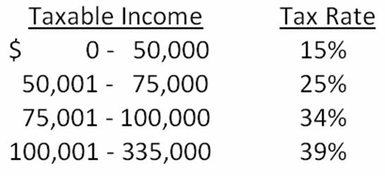
  A. | 28.25 percent
  B. | 31.09 percent
  C. | 33.62 percent
  D. | 35.48 percent
  E. | 39.00 percent

57. | The tax rates are as shown. Nevada Mining currently has taxable income of $97,800. How much additional tax will the firm owe if taxable income increases by $21,000?  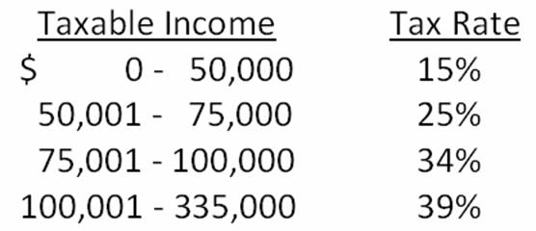
  A. | $8,080
  B. | $8,130
  C. | $8,155
  D. | $8,170
  E. | $8,190

58. | Winston Industries had sales of $843,800 and costs of $609,900. The firm paid $38,200 in interest and $18,000 in dividends. It also increased retained earnings by $62,138 for the year. The depreciation was $76,400. What is the average tax rate?
  A. | 32.83 percent
  B. | 33.33 percent
  C. | 38.17 percent
  D. | 43.39 percent
  E. | 48.87 percent

59. | Crandall Oil has total sales of $1,349,800 and costs of $903,500. Depreciation is $42,700 and the tax rate is 34 percent. The firm does not have any interest expense. What is the operating cash flow?
  A. | $129,152
  B. | $171,852
  C. | $179,924
  D. | $281,417
  E. | $309,076

60. | Nielsen Auto Parts had beginning net fixed assets of $218,470 and ending net fixed assets of $209,411. During the year, assets with a combined book value of $6,943 were sold. Depreciation for the year was $42,822. What is the amount of net capital spending?
  A. | $33,763
  B. | $40,706
  C. | $58,218
  D. | $65,161
  E. | $67,408

61. | At the beginning of the year, a firm had current assets of $121,306 and current liabilities of $124,509. At the end of the year, the current assets were $122,418 and the current liabilities were $103,718. What is the change in net working capital?
  A. | -$19,679
  B. | -$11,503
  C. | -$9,387
  D. | $1,809
  E. | $21,903

62. | At the beginning of the year, the long-term debt of a firm was $72,918 and total debt was $138,407. At the end of the year, long-term debt was $68,219 and total debt was $145,838. The interest paid was $6,430. What is the amount of the cash flow to creditors?
  A. | -$18,348
  B. | -$1,001
  C. | $11,129
  D. | $13,861
  E. | $19,172

63. | Adelson's Electric had beginning long-term debt of $42,511 and ending long-term debt of $48,919. The beginning and ending total debt balances were $84,652 and $78,613, respectively. The interest paid was $4,767. What is the amount of the cash flow to creditors?
  A. | -$1,641
  B. | -$1,272
  C. | $1,272
  D. | $7,418
  E. | $11,175

64. | The Daily News had net income of $121,600 of which 40 percent was distributed to the shareholders as dividends. During the year, the company sold $75,000 worth of common stock. What is the cash flow to stockholders?
  A. | -$75,000
  B. | -$26,360
  C. | -$2,040
  D. | $123,640
  E. | $147,960

65. | The Lakeside Inn had operating cash flow of $48,450. Depreciation was $6,700 and interest paid was $2,480. A net total of $2,620 was paid on long-term debt. The firm spent $24,000 on fixed assets and decreased net working capital by $1,330. What is the amount of the cash flow to stockholders?
  A. | $5,100
  B. | $7,830
  C. | $18,020
  D. | $19,998
  E. | $20,680

66. | 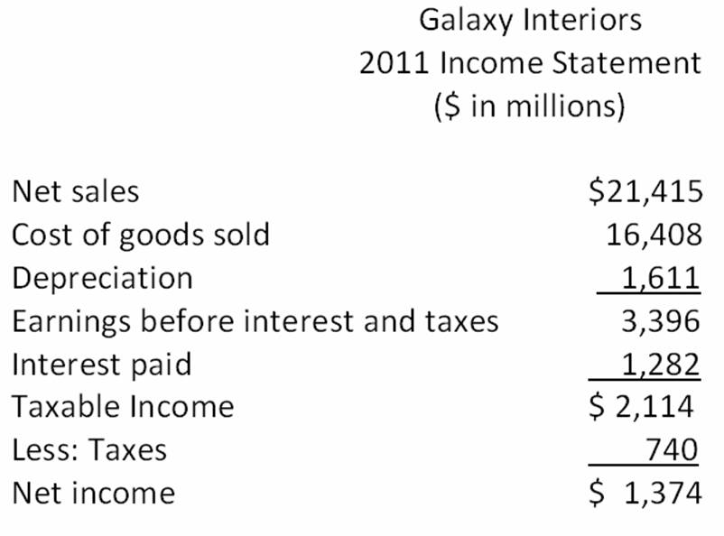  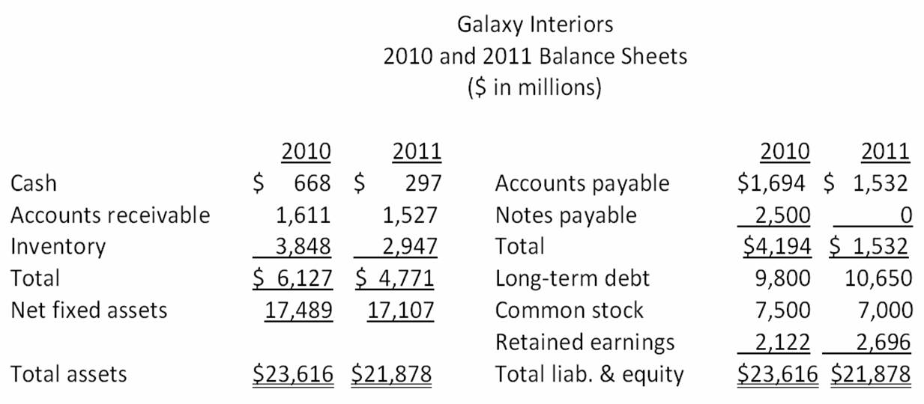  What is the change in the net working capital from 2010 to 2011?
  A. | -$1,194
  B. | $1,306
  C. | $1,887
  D. | $4,780
  E. | $5,172

67. | 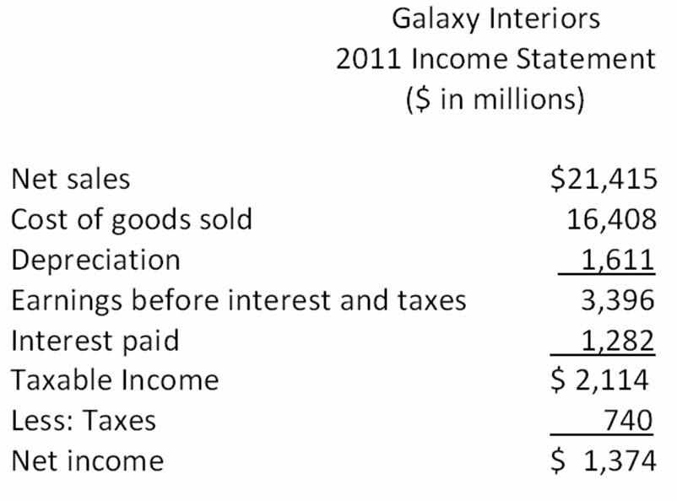  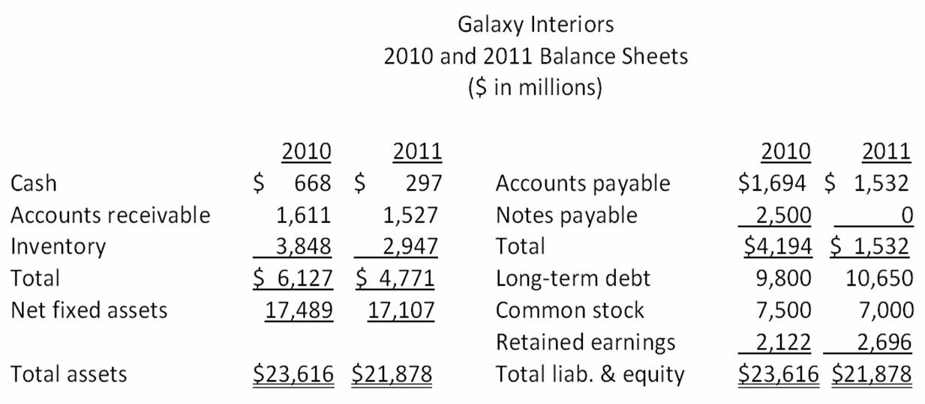  What is the amount of the noncash expenses for 2011?
  A. | $740
  B. | $1,282
  C. | $1,333
  D. | $1,611
  E. | $2,351

68. | 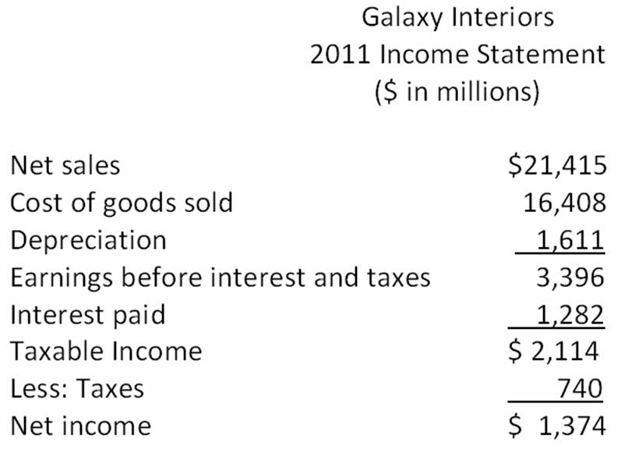  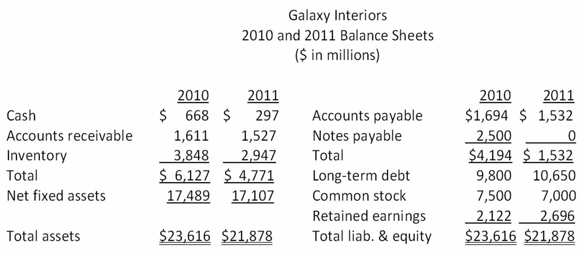  What is the amount of the net capital spending for 2011?
  A. | -$382
  B. | $1,229
  C. | $1,804
  D. | $2,375
  E. | $2,516

69. | What is the operating cash flow for 2011?
  A. | $2,114
  B. | $2,900
  C. | $2,985
  D. | $3,536
  E. | $4,267

70. | What is the cash flow from assets for 2011?
  A. | $1,732
  B. | $2,247
  C. | $2,961
  D. | $3,915
  E. | $4,267

71. | 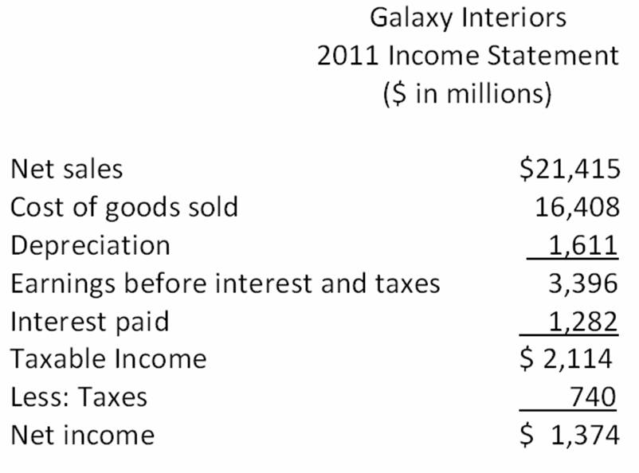  What is the amount of net new borrowing for 2011?
  A. | -$1,812
  B. | $-1,738
  C. | $240
  D. | $662
  E. | $850

72. | 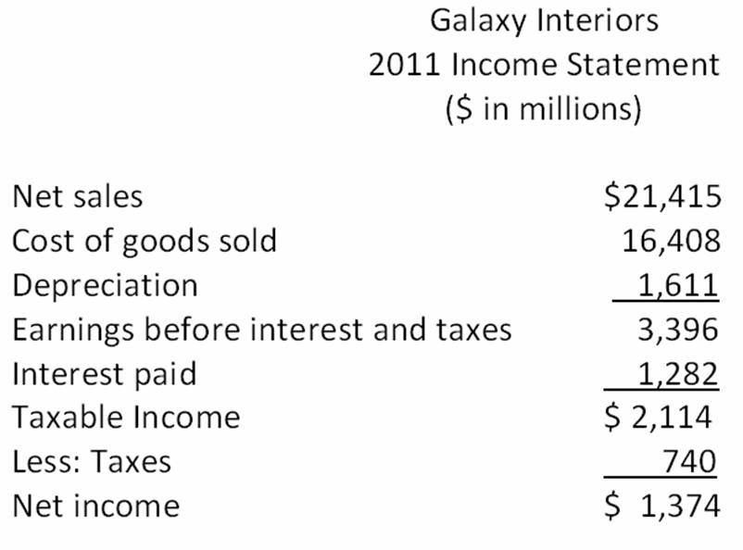  What is the cash flow to creditors for 2011?
  A. | -$353
  B. | -$210
  C. | $300
  D. | $432
  E. | $527

73. | 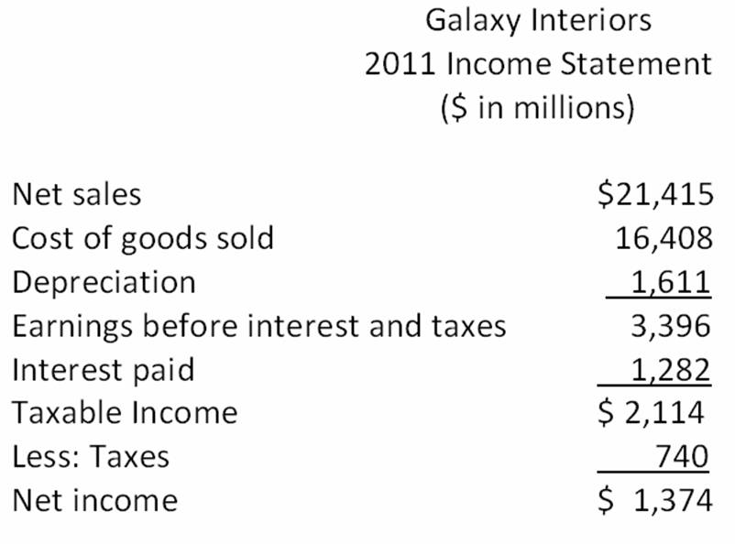  What is the amount of dividends paid in 2011?
  A. | $0
  B. | $574
  C. | $800
  D. | $2,013
  E. | $2,174

74. | What is the cash flow to stockholders for 2011?
  A. | -$500
  B. | -$800
  C. | $500
  D. | $1,300
  E. | $2,100

75. | 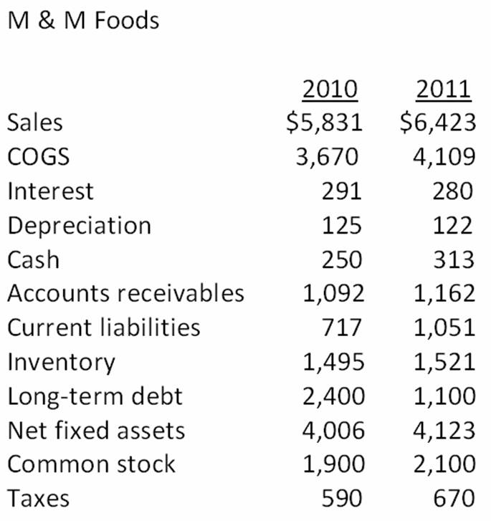  What is the net working capital for 2011?
  A. | -$175
  B. | $338
  C. | $1,262
  D. | $1,945
  E. | $4,941

76. | 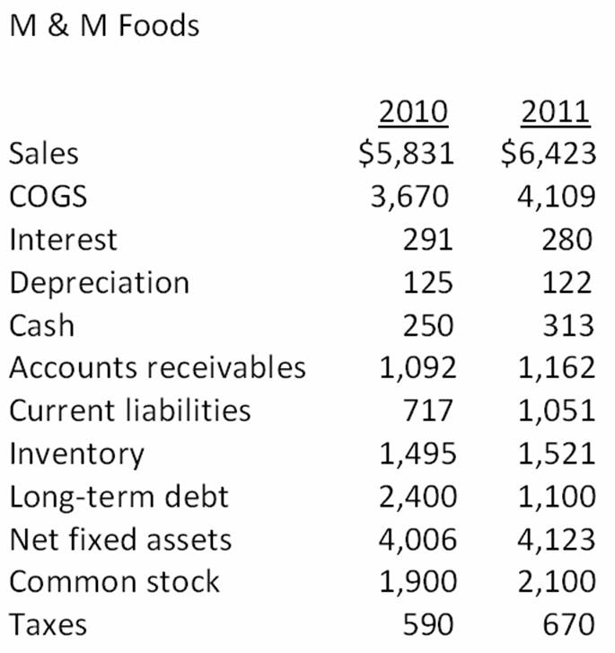  What is the change in net working capital from 2010 to 2011?
  A. | -$175
  B. | -$70
  C. | $125
  D. | $240
  E. | $315

77. | 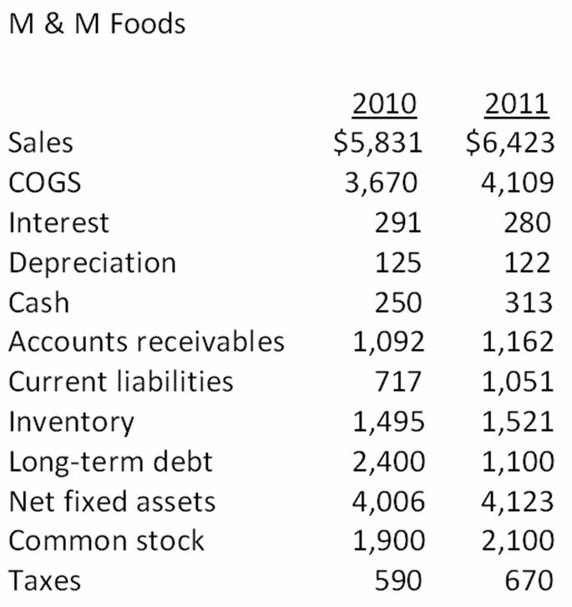  What is the net capital spending for 2011?
  A. | $117
  B. | $239
  C. | $257
  D. | $338
  E. | $421

78. | What is the operating cash flow for 2011?
  A. | $1,226
  B. | $1,367
  C. | $1,644
  D. | $1,766
  E. | $1,823

79. | What is the cash flow from assets for 2011?
  A. | $1,230
  B. | $1,580
  C. | $1,770
  D. | $1,810
  E. | $1,980

80. | 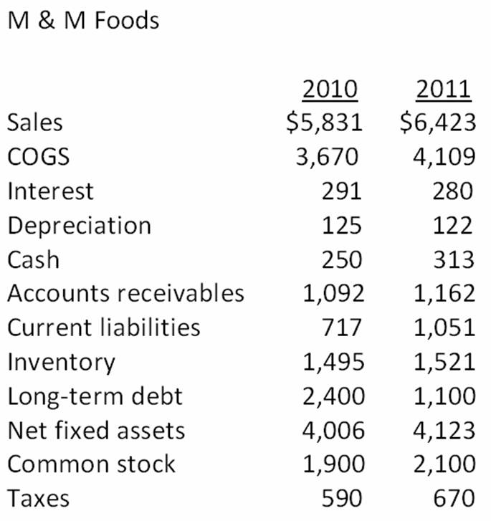  What is net new borrowing for 2011?
  A. | -$1,300
  B. | -$1,020
  C. | $880
  D. | $1,020
  E. | $1,300

81. | What is the cash flow to creditors for 2011?
  A. | -$1,020
  B. | -$1,100
  C. | $280
  D. | $1,580
  E. | $1,760

82. | What is the cash flow to stockholders for 2011?
  A. | $0
  B. | $133
  C. | $268
  D. | $1,709
  E. | $1,515

83. | 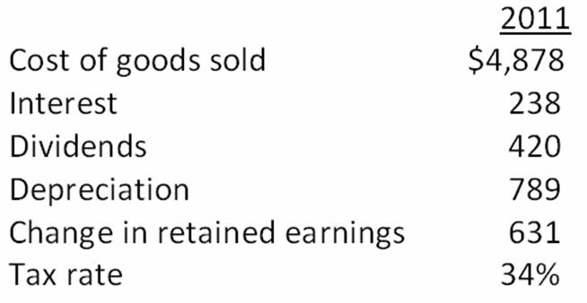  What is the taxable income for 2011?
  A. | $1,051.00
  B. | $1,367.78
  C. | $1,592.42
  D. | $2,776.41
  E. | $3,091.18

84. | 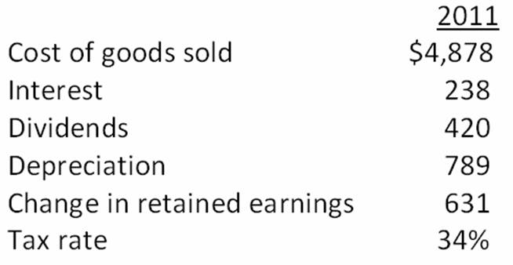  What is the operating cash flow for 2011?
  A. | $2,078.00
  B. | $2,122.42
  C. | $2,462.58
  D. | $2,662.00
  E. | $2,741.42

85. | Beach Front Industries has sales of $546,000, costs of $295,000, depreciation expense of $37,000, interest expense of $15,000, and a tax rate of 32 percent. The firm paid $59,000 in cash dividends. What is the addition to retained earnings?
  A. | $76,320
  B. | $81,700
  C. | $95,200
  D. | $103,460
  E. | $121,680

86. | The Widget Co. purchased new machinery three years ago for $4 million. The machinery can be sold to the Roman Co. today for $2 million. The Widget Co.'s current balance sheet shows net fixed assets of $2,500,000, current liabilities of $1,375,000, and net working capital of $725,000. If all the current assets were liquidated today, the company would receive $1.9 million in cash. The book value of the Widget Co.'s assets today is _____ and the market value of those assets is _____.
  A. | $4,600,000; $3,900,000
  B. | $4,600,000; $3,125,000
  C. | $5,000,000; $3,125,000
  D. | $5,000,000; $3,900,000
  E. | $6,500,000; $3,900,000

87. | Boyer Enterprises had $200,000 in 2011 taxable income. What is the firm's average tax rate based on the rates shown in the following table?  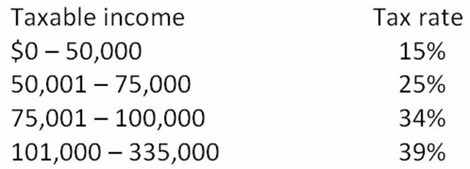
  A. | 28.25 percent
  B. | 30.63 percent
  C. | 32.48 percent
  D. | 36.50 percent
  E. | 39.00 percent

88. | Webster World has sales of $12,900, costs of $5,800, depreciation expense of $1,100, and interest expense of $700. What is the operating cash flow if the tax rate is 32 percent?
  A. | $4,704
  B. | $5,749
  C. | $5,404
  D. | $7,036
  E. | $7,100

89. | The Blue Bonnet's 2010 balance sheet showed net fixed assets of $2.2 million, and the 2011 balance sheet showed net fixed assets of $2.6 million. The company's income statement showed a depreciation expense of $900,000. What was the amount of the net capital spending for 2011?
  A. | -$500,000
  B. | $400,000
  C. | $1,300,000
  D. | $1,700,000
  E. | $1,800,000

90. | The 2010 balance sheet of Global Tours showed current assets of $1,360 and current liabilities of $940. The 2011 balance sheet showed current assets of $1,640 and current liabilities of $1,140. What was the change in net working capital for 2011?
  A. | $80
  B. | $170
  C. | $190
  D. | $880
  E. | $920

91. | The 2010 balance sheet of The Beach Shoppe showed long-term debt of $2.1 million, and the 2011 balance sheet showed long-term debt of $2.3 million. The 2011 income statement showed an interest expense of $250,000. What was the cash flow to creditors for 2011?
  A. | -$200,000
  B. | -$150,000
  C. | $50,000
  D. | $200,000
  E. | $450,000

92. | The 2010 balance sheet of The Sports Store showed $800,000 in the common stock account and $6.7 million in the additional paid-in surplus account. The 2011 balance sheet showed $872,000 and $8 million in the same two accounts, respectively. The company paid out $600,000 in cash dividends during 2011. What is the cash flow to stockholders for 2011?
  A. | -$1,372,000
  B. | -$772,000
  C. | -$628,000
  D. | $372,000
  E. | $1,972,000

93. | Suppose you are given the following information for Bayside Bakery: sales = $30,000; costs = $15,000; addition to retained earnings = $4,221; dividends paid = $469; interest expense = $1,300; tax rate = 30 percent. What is the amount of the depreciation expense?
  A. | $4,820
  B. | $5,500
  C. | $7,000
  D. | $8,180
  E. | $9,500

94. | Dee Dee's Marina is obligated to pay its creditors $6,400 today. The firm's assets have a current market value of $5,900. What is the current market value of the shareholders' equity?
  A. | -$600
  B. | -$500
  C. | $0
  D. | $500
  E. | $600

95. | During 2011, RIT Corp. had sales of $565,600. Costs of goods sold, administrative and selling expenses, and depreciation expenses were $476,000, $58,800, and $58,800, respectively. In addition, the company had an interest expense of $112,000 and a tax rate of 32 percent. What is the operating cash flow for 2009? Ignore any tax loss carry-back or carry-forward provisions.
  A. | $17,920
  B. | $21,840
  C. | $30,800
  D. | $52,600
  E. | $77,840

Essay Questions
96. | Assume you are the financial officer of a major firm. The president of the firm has just stated that she wishes to reduce the firm's investment in current assets since those assets provide little, if any, return to the firm. How would you respond to this statement?

97. | As long as a firm maintains a positive cash balance, why is it essential to review the firm's cash flows?

98. | The managers of a firm wish to expand the firm's operations and are trying to determine the amount of debt financing the firm should obtain versus the amount of equity financing that should be raised. The managers have asked you to explain the effects that both of these forms of financing would have on the cash flows of the firm. Write a short response to this request.

99. | Discuss the difference between book values and market values and explain which one is more important to the financial manager and why.

100. | Assume you are a credit manager in charge of approving commercial loans to business firms. Identify three aspects of a firm's cash flows you would review and explain the type of information you hope to gain from reviewing each of those five aspects.

Chapter 02 Financial Statements, Taxes, and Cash Flow Answer Key

Multiple Choice Questions
1. | Which one of the following is the financial statement that shows the accounting value of a firm's equity as of a particular date?  Refer to section 2.1
  A. | income statement
  B. | creditor's statement
  C. | balance sheet
  D. | statement of cash flows
  E. | dividend statement

AACSB: Analytic
Blooms: Remember
Difficulty: 1 Easy
Learning Objective: 02-01 The difference between accounting value (or "book" value) and market value.
Section: 2.1
Topic: Balance sheet

2. | Net working capital is defined as:  Refer to section 2.1
  A. | total liabilities minus shareholders' equity.
  B. | current liabilities minus shareholders' equity.
  C. | fixed assets minus long-term liabilities.
  D. | total assets minus total liabilities.
  E. | current assets minus current liabilities.

AACSB: Analytic
Blooms: Remember
Difficulty: 1 Easy
Learning Objective: 02-01 The difference between accounting value (or "book" value) and market value.
Section: 2.1
Topic: Net working capital

3. | The common set of standards and procedures by which audited financial statements are prepared is known as the:  Refer to section 2.1
  A. | matching principle.
  B. | cash flow identity.
  C. | Generally Accepted Accounting Principles.
  D. | Financial Accounting Reporting Principles.
  E. | Standard Accounting Value Guidelines.

AACSB: Analytic
Blooms: Remember
Difficulty: 1 Easy
Learning Objective: 02-01 The difference between accounting value (or "book" value) and market value.
Section: 2.1
Topic: GAAP

4. | Which one of the following is the financial statement that summarizes a firm's revenue and expenses over a period of time?  Refer to section 2.2
  A. | income statement
  B. | balance sheet
  C. | statement of cash flows
  D. | tax reconciliation statement
  E. | market value report

AACSB: Analytic
Blooms: Remember
Difficulty: 1 Easy
Learning Objective: 02-02 The difference between accounting income and cash flow.
Section: 2.2
Topic: Income statement

5. | Noncash items refer to:  Refer to section 2.2
  A. | accrued expenses.
  B. | inventory items purchased using credit.
  C. | the ownership of intangible assets such as patents.
  D. | expenses which do not directly affect cash flows.
  E. | sales which are made using store credit.

AACSB: Analytic
Blooms: Remember
Difficulty: 1 Easy
Learning Objective: 02-02 The difference between accounting income and cash flow.
Section: 2.2
Topic: Noncash items

6. | The percentage of the next dollar you earn that must be paid in taxes is referred to as the _____ tax rate.  Refer to section 2.3
  A. | mean
  B. | residual
  C. | total
  D. | average
  E. | marginal

AACSB: Analytic
Blooms: Remember
Difficulty: 1 Easy
Learning Objective: 02-03 The difference between average and marginal tax rates.
Section: 2.3
Topic: Marginal tax rate

7. | The _____ tax rate is equal to total taxes divided by total taxable income.  Refer to section 2.3
  A. | deductible
  B. | residual
  C. | total
  D. | average
  E. | marginal

AACSB: Analytic
Blooms: Remember
Difficulty: 1 Easy
Learning Objective: 02-03 The difference between average and marginal tax rates.
Section: 2.3
Topic: Average tax rate

8. | The cash flow of a firm which is available for distribution to the firm's creditors and stockholders is called the:  Refer to section 2.4
  A. | operating cash flow.
  B. | net capital spending.
  C. | net working capital.
  D. | cash flow from assets.
  E. | cash flow to stockholders.

AACSB: Analytic
Blooms: Remember
Difficulty: 1 Easy
Learning Objective: 02-04 How to determine a firm's cash flow from its financial statements.
Section: 2.4
Topic: Cash flow from assets

9. | Which term relates to the cash flow which results from a firm's ongoing, normal business activities?  Refer to section 2.4
  A. | operating cash flow
  B. | capital spending
  C. | net working capital
  D. | cash flow from assets
  E. | cash flow to creditors

AACSB: Analytic
Blooms: Remember
Difficulty: 1 Easy
Learning Objective: 02-04 How to determine a firm's cash flow from its financial statements.
Section: 2.4
Topic: Operating cash flow

10. | Cash flow from assets is also known as the firm's:  Refer to section 2.4
  A. | capital structure.
  B. | equity structure.
  C. | hidden cash flow.
  D. | free cash flow.
  E. | historical cash flow.

AACSB: Analytic
Blooms: Remember
Difficulty: 1 Easy
Learning Objective: 02-04 How to determine a firm's cash flow from its financial statements.
Section: 2.4
Topic: Free cash flow

11. | The cash flow related to interest payments less any net new borrowing is called the:  Refer to section 2.4
  A. | operating cash flow.
  B. | capital spending cash flow.
  C. | net working capital.
  D. | cash flow from assets.
  E. | cash flow to creditors.

AACSB: Analytic
Blooms: Remember
Difficulty: 1 Easy
Learning Objective: 02-04 How to determine a firm's cash flow from its financial statements.
Section: 2.4
Topic: Cash flow to creditors

12. | Cash flow to stockholders is defined as:  Refer to section 2.4
  A. | the total amount of interest and dividends paid during the past year.
  B. | the change in total equity over the past year.
  C. | cash flow from assets plus the cash flow to creditors.
  D. | operating cash flow minus the cash flow to creditors.
  E. | dividend payments less net new equity raised.

AACSB: Analytic
Blooms: Remember
Difficulty: 1 Easy
Learning Objective: 02-04 How to determine a firm's cash flow from its financial statements.
Section: 2.4
Topic: Cash flow to stockholders

13. | Which one of the following is classified as an intangible fixed asset?  Refer to section 2.1
  A. | accounts receivable
  B. | production equipment
  C. | building
  D. | trademark
  E. | inventory

AACSB: Analytic
Blooms: Remember
Difficulty: 1 Easy
Learning Objective: 02-01 The difference between accounting value (or "book" value) and market value.
Section: 2.1
Topic: Intangible fixed asset

14. | Which of the following are current assets?  I. patent  II. inventory  III. accounts payable  IV. cash  Refer to section 2.1
  A. | I and III only
  B. | II and IV only
  C. | I, II, and IV only
  D. | I, II and IV only
  E. | II, III, and IV only

AACSB: Analytic
Blooms: Remember
Difficulty: 1 Easy
Learning Objective: 02-01 The difference between accounting value (or "book" value) and market value.
Section: 2.1
Topic: Current assets

15. | Which one of the following is included in a firm's market value but yet is excluded from the firm's accounting value?  Refer to section 2.1
  A. | real estate investment
  B. | good reputation of the company
  C. | equipment owned by the firm
  D. | money due from a customer
  E. | an item held by the firm for future sale

AACSB: Analytic
Blooms: Understand
Difficulty: 1 Easy
Learning Objective: 02-01 The difference between accounting value (or "book" value) and market value.
Section: 2.1
Topic: Market value

16. | Which of the following are included in current liabilities?  I. note payable to a supplier in eight months  II. amount due from a customer next month  III. account payable to a supplier that is due next week  IV. loan payable to the bank in fourteen months  Refer to section 2.1
  A. | I and III only
  B. | II and III only
  C. | I, II, and III only
  D. | I, III, and IV only
  E. | I, II, III, and IV

AACSB: Analytic
Blooms: Remember
Difficulty: 1 Easy
Learning Objective: 02-01 The difference between accounting value (or "book" value) and market value.
Section: 2.1
Topic: Current liabilities

17. | Which one of the following will increase the value of a firm's net working capital?  Refer to section 2.1
  A. | using cash to pay a supplier
  B. | depreciating an asset
  C. | collecting an accounts receivable
  D. | purchasing inventory on credit
  E. | selling inventory at a profit

AACSB: Analytic
Blooms: Understand
Difficulty: 2 Medium
Learning Objective: 02-01 The difference between accounting value (or "book" value) and market value.
Section: 2.1
Topic: Net working capital

18. | Which one of the following statements concerning net working capital is correct?  Refer to section 2.1
  A. | Net working capital increases when inventory is purchased with cash.
  B. | Net working capital must be a positive value.
  C. | Total assets must increase if net working capital increases.
  D. | A decrease in the cash balance may or may not decrease net working capital.
  E. | Net working capital is the amount of cash a firm currently has available for spending.

AACSB: Analytic
Blooms: Apply
Difficulty: 2 Medium
Learning Objective: 02-01 The difference between accounting value (or "book" value) and market value.
Section: 2.1
Topic: Net working capital

19. | Which one of the following statements concerning net working capital is correct?  Refer to section 2.1
  A. | The lower the value of net working capital the greater the ability of a firm to meet its current obligations.
  B. | An increase in net working capital must also increase current assets.
  C. | Net working capital increases when inventory is sold for cash at a profit.
  D. | Firms with equal amounts of net working capital are also equally liquid.
  E. | Net working capital is a part of the operating cash flow.

AACSB: Analytic
Blooms: Understand
Difficulty: 2 Medium
Learning Objective: 02-01 The difference between accounting value (or "book" value) and market value.
Section: 2.1
Topic: Net working capital

20. | Which one of the following accounts is the most liquid?  Refer to section 2.1
  A. | inventory
  B. | building
  C. | accounts receivable
  D. | equipment
  E. | land

AACSB: Analytic
Blooms: Remember
Difficulty: 1 Easy
Learning Objective: 02-01 The difference between accounting value (or "book" value) and market value.
Section: 2.1
Topic: Liquidity

21. | Which one of the following represents the most liquid asset?  Refer to section 2.1
  A. | $100 account receivable that is discounted and collected for $96 today
  B. | $100 of inventory which is sold today on credit for $103
  C. | $100 of inventory which is discounted and sold for $97 cash today
  D. | $100 of inventory that is sold today for $100 cash
  E. | $100 accounts receivable that will be collected in full next week

AACSB: Analytic
Blooms: Understand
Difficulty: 2 Medium
Learning Objective: 02-01 The difference between accounting value (or "book" value) and market value.
Section: 2.1
Topic: Liquidity

22. | Which one of the following statements related to liquidity is correct?  Refer to section 2.1
  A. | Liquid assets tend to earn a high rate of return.
  B. | Liquid assets are valuable to a firm.
  C. | Liquid assets are defined as assets that can be sold quickly regardless of the price obtained.
  D. | Inventory is more liquid than accounts receivable because inventory is tangible.
  E. | Any asset that can be sold within the next year is considered liquid.

AACSB: Analytic
Blooms: Remember
Difficulty: 2 Medium
Learning Objective: 02-01 The difference between accounting value (or "book" value) and market value.
Section: 2.1
Topic: Liquidity

23. | Shareholders' equity:  Refer to section 2.1
  A. | increases in value anytime total assets increases.
  B. | is equal to total assets plus total liabilities.
  C. | decreases whenever new shares of stock are issued.
  D. | includes long-term debt, preferred stock, and common stock.
  E. | represents the residual value of a firm.

AACSB: Analytic
Blooms: Remember
Difficulty: 1 Easy
Learning Objective: 02-01 The difference between accounting value (or "book" value) and market value.
Section: 2.1
Topic: Shareholders' equity

24. | The higher the degree of financial leverage employed by a firm, the:  Refer to section 2.1
  A. | higher the probability that the firm will encounter financial distress.
  B. | lower the amount of debt incurred.
  C. | less debt a firm has per dollar of total assets.
  D. | higher the number of outstanding shares of stock.
  E. | lower the balance in accounts payable.

AACSB: Analytic
Blooms: Understand
Difficulty: 2 Medium
Learning Objective: 02-01 The difference between accounting value (or "book" value) and market value.
Section: 2.1
Topic: Financial leverage

25. | The book value of a firm is:  Refer to section 2.1
  A. | equivalent to the firm's market value provided that the firm has some fixed assets.
  B. | based on historical cost.
  C. | generally greater than the market value when fixed assets are included.
  D. | more of a financial than an accounting valuation.
  E. | adjusted to the market value whenever the market value exceeds the stated book value.

AACSB: Analytic
Blooms: Understand
Difficulty: 1 Easy
Learning Objective: 02-01 The difference between accounting value (or "book" value) and market value.
Section: 2.1
Topic: Book value

26. | Which of the following is (are) included in the market value of a firm but are excluded from the firm's book value?  I. value of management skills  II. value of a copyright  III. value of the firm's reputation  IV. value of employee's experience  Refer to section 2.1
  A. | I only
  B. | II only
  C. | III and IV only
  D. | I, II, and III only
  E. | I, III, and IV only

AACSB: Analytic
Blooms: Remember
Difficulty: 2 Medium
Learning Objective: 02-01 The difference between accounting value (or "book" value) and market value.
Section: 2.1
Topic: Market and book value

27. | You recently purchased a grocery store. At the time of the purchase, the store's market value equaled its book value. The purchase included the building, the fixtures, and the inventory. Which one of the following is most apt to cause the market value of this store to be lower than the book value?  Refer to section 2.1
  A. | a sudden and unexpected increase in inflation
  B. | the replacement of old inventory items with more desirable products
  C. | improvements to the surrounding area by other store owners
  D. | construction of a new restricted access highway located between the store and the surrounding residential areas
  E. | addition of a stop light at the main entrance to the store's parking lot

AACSB: Analytic
Blooms: Understand
Difficulty: 2 Medium
Learning Objective: 02-01 The difference between accounting value (or "book" value) and market value.
Section: 2.1
Topic: Market and book value

28. | Which one of the following is true according to Generally Accepted Accounting Principles?  Refer to section 2.2
  A. | Depreciation may or may not be recorded at management's discretion.
  B. | Income is recorded based on the matching principle.
  C. | Costs are recorded based on the realization principle.
  D. | Depreciation is recorded based on the recognition principle.
  E. | Costs of goods sold are recorded based on the matching principle.

AACSB: Analytic
Blooms: Remember
Difficulty: 1 Easy
Learning Objective: 02-02 The difference between accounting income and cash flow.
Section: 2.2
Topic: GAAP

29. | Which one of these is most apt to be a fixed cost?  Refer to section 2.2
  A. | raw materials
  B. | manufacturing wages
  C. | management bonuses
  D. | office salaries
  E. | shipping and freight

AACSB: Analytic
Blooms: Remember
Difficulty: 1 Easy
Learning Objective: 02-02 The difference between accounting income and cash flow.
Section: 2.2
Topic: Fixed cost

30. | Which one of the following costs is most apt to be a fixed cost?  Refer to section 2.2
  A. | production labor cost
  B. | depreciation
  C. | raw materials
  D. | utilities
  E. | sales commissions

AACSB: Analytic
Blooms: Remember
Difficulty: 1 Easy
Learning Objective: 02-02 The difference between accounting income and cash flow.
Section: 2.2
Topic: Fixed cost

31. | Which of the following are expenses for accounting purposes but are not operating cash flows for financial purposes?  I. interest expense  II. taxes  III. costs of goods sold  IV. depreciation  Refer to sections 2.2 and 2.4
  A. | IV only
  B. | II and IV only
  C. | I and III only
  D. | I and IV only
  E. | I, II, and IV only

AACSB: Analytic
Blooms: Remember
Difficulty: 1 Easy
Learning Objective: 02-02 The difference between accounting income and cash flow.
Learning Objective: 02-04 How to determine a firm's cash flow from its financial statements.
Section: 2.2 and 2.4
Topic: Accounting versus cash flow

32. | Which one of the following statements related to an income statement is correct? Assume accrual accounting is used.  Refer to sections 2.2 and 2.3
  A. | The addition to retained earnings is equal to net income plus dividends paid.
  B. | Credit sales are recorded on the income statement when the cash from the sale is collected.
  C. | The labor costs for producing a product are expensed when the product is sold.
  D. | Interest is a non-cash expense.
  E. | Depreciation increases the marginal tax rate.

AACSB: Analytic
Blooms: Understand
Difficulty: 2 Medium
Learning Objective: 02-02 The difference between accounting income and cash flow.
Learning Objective: 02-03 The difference between average and marginal tax rates.
Section: 2.2 and 2.3
Topic: Income statement

33. | Which one of the following statements related to taxes is correct?  Refer to section 2.3
  A. | The marginal tax rate must be equal to or lower than the average tax rate for a firm.
  B. | The tax for a firm is computed by multiplying the firm's current marginal tax rate times the taxable income.
  C. | Additional income is taxed at a firm's average tax rate.
  D. | Given the corporate tax structure in 2012, the highest marginal tax rate is equal to the highest average tax rate.
  E. | The marginal tax rate for a firm can be either higher than or the same as the average tax rate.

AACSB: Analytic
Blooms: Remember
Difficulty: 2 Medium
Learning Objective: 02-03 The difference between average and marginal tax rates.
Section: 2.3
Topic: Tax rates

34. | As of 2012, which one of the following statements concerning corporate income taxes is correct?  Refer to section 2.3
  A. | The largest corporations have an average tax rate of 39 percent.
  B. | The lowest marginal rate is 25 percent.
  C. | A firm's tax is computed on an incremental basis.
  D. | A firm's marginal tax rate will generally be lower than its average tax rate once the firm's income exceeds $50,000.
  E. | When analyzing a new project, the average tax rate should be used.

AACSB: Analytic
Blooms: Understand
Difficulty: 2 Medium
Learning Objective: 02-03 The difference between average and marginal tax rates.
Section: 2.3
Topic: Taxes

35. | Depreciation:  Refer to sections 2.2 and 2.4
  A. | reduces both taxes and net income.
  B. | increases the net fixed assets as shown on the balance sheet.
  C. | reduces both the net fixed assets and the costs of a firm.
  D. | is a noncash expense which increases the net income.
  E. | decreases net fixed assets, net income, and operating cash flows.

AACSB: Analytic
Blooms: Understand
Difficulty: 2 Medium
Learning Objective: 02-02 The difference between accounting income and cash flow.
Learning Objective: 02-04 How to determine a firm's cash flow from its financial statements.
Section: 2.2 and 2.4
Topic: Depreciation

36. | Which one of the following statements related to an income statement is correct?  Refer to sections 2.2 and 2.4
  A. | Interest expense increases the amount of tax due.
  B. | Depreciation does not affect taxes since it is a non-cash expense.
  C. | Net income is distributed to dividends and paid-in surplus.
  D. | Taxes reduce both net income and operating cash flow.
  E. | Interest expense is included in operating cash flow.

AACSB: Analytic
Blooms: Understand
Difficulty: 2 Medium
Learning Objective: 02-02 The difference between accounting income and cash flow.
Learning Objective: 02-04 How to determine a firm's cash flow from its financial statements.
Section: 2.2 and 2.4
Topic: Income statement

37. | Which one of the following statements is correct concerning a corporation with taxable income of $125,000?  Refer to sections 2.2 and 2.4
  A. | Net income minus dividends paid will equal the ending retained earnings for the year.
  B. | An increase in depreciation will increase the operating cash flow.
  C. | Net income divided by the number of shares outstanding will equal the dividends per share.
  D. | Interest paid will be included in both net income and operating cash flow.
  E. | An increase in the tax rate will increase both net income and operating cash flow.

AACSB: Analytic
Blooms: Understand
Difficulty: 2 Medium
Learning Objective: 02-02 The difference between accounting income and cash flow.
Learning Objective: 02-04 How to determine a firm's cash flow from its financial statements.
Section: 2.2 and 2.4
Topic: Income statement

38. | Which one of the following will increase the cash flow from assets, all else equal?  Refer to section 2.4
  A. | decrease in cash flow to stockholders
  B. | decrease in operating cash flow
  C. | increase in the change in net working capital
  D. | decrease in cash flow to creditors
  E. | decrease in net capital spending

AACSB: Analytic
Blooms: Understand
Difficulty: 1 Easy
Learning Objective: 02-04 How to determine a firm's cash flow from its financial statements.
Section: 2.4
Topic: Cash flow from assets

39. | For a tax-paying firm, an increase in _____ will cause the cash flow from assets to increase.  Refer to section 2.4
  A. | depreciation
  B. | net capital spending
  C. | change in net working capital
  D. | taxes
  E. | production costs

AACSB: Analytic
Blooms: Understand
Difficulty: 2 Medium
Learning Objective: 02-04 How to determine a firm's cash flow from its financial statements.
Section: 2.4
Topic: Cash flow from assets

40. | Which one of the following must be true if a firm had a negative cash flow from assets?  Refer to section 2.4
  A. | The firm borrowed money.
  B. | The firm acquired new fixed assets.
  C. | The firm had a net loss for the period.
  D. | The firm utilized outside funding.
  E. | Newly issued shares of stock were sold.

AACSB: Analytic
Blooms: Understand
Difficulty: 2 Medium
Learning Objective: 02-04 How to determine a firm's cash flow from its financial statements.
Section: 2.4
Topic: Cash flow from assets

41. | An increase in the depreciation expense will do which of the following?  I. increase net income  II. decrease net income  III. increase the cash flow from assets  IV. decrease the cash flow from assets  Refer to sections 2.2 and 2.4
  A. | I only
  B. | II only
  C. | I and III only
  D. | II and III only
  E. | II and IV only

AACSB: Analytic
Blooms: Understand
Difficulty: 2 Medium
Learning Objective: 02-02 The difference between accounting income and cash flow.
Learning Objective: 02-04 How to determine a firm's cash flow from its financial statements.
Section: 2.2 and 2.4
Topic: Depreciation

42. | Which one of the following is NOT included in cash flow from assets?  Refer to section 2.4
  A. | accounts payable
  B. | inventory
  C. | sales
  D. | interest expense
  E. | cash account

AACSB: Analytic
Blooms: Remember
Difficulty: 1 Easy
Learning Objective: 02-04 How to determine a firm's cash flow from its financial statements.
Section: 2.4
Topic: Cash flow from assets

43. | Net capital spending:  Refer to section 2.4
  A. | is equal to ending net fixed assets minus beginning net fixed assets.
  B. | is equal to zero if the decrease in the net fixed assets is equal to the depreciation expense.
  C. | reflects the net changes in total assets over a stated period of time.
  D. | is equivalent to the cash flow from assets minus the operating cash flow minus the change in net working capital.
  E. | is equal to the net change in the current accounts.

AACSB: Analytic
Blooms: Understand
Difficulty: 1 Easy
Learning Objective: 02-04 How to determine a firm's cash flow from its financial statements.
Section: 2.4
Topic: Net capital spending

44. | Which one of the following statements related to the cash flow to creditors is correct?  Refer to section 2.4
  A. | If the cash flow to creditors is positive then the firm must have borrowed more money than it repaid.
  B. | If the cash flow to creditors is negative then the firm must have a negative cash flow from assets.
  C. | A positive cash flow to creditors represents a net cash outflow from the firm.
  D. | A positive cash flow to creditors means that a firm has increased its long-term debt.
  E. | If the cash flow to creditors is zero, then a firm has no long-term debt.

AACSB: Analytic
Blooms: Understand
Difficulty: 2 Medium
Learning Objective: 02-04 How to determine a firm's cash flow from its financial statements.
Section: 2.4
Topic: Cash flow to creditors

45. | A positive cash flow to stockholders indicates which one of the following with certainty?  Refer to section 2.4
  A. | The dividends paid exceeded the net new equity raised.
  B. | The amount of the sale of common stock exceeded the amount of dividends paid.
  C. | No dividends were distributed but new shares of stock were sold.
  D. | Both the cash flow to assets and the cash flow to creditors must be negative.
  E. | Both the cash flow to assets and the cash flow to creditors must be positive.

AACSB: Analytic
Blooms: Remember
Difficulty: 1 Easy
Learning Objective: 02-04 How to determine a firm's cash flow from its financial statements.
Section: 2.4
Topic: Cash flow to stockholders

46. | A firm has $520 in inventory, $1,860 in fixed assets, $190 in accounts receivables, $210 in accounts payable, and $70 in cash. What is the amount of the current assets?  Current assets = $520 + $190 + $70 = $780
  A. | $710
  B. | $780
  C. | $990
  D. | $2,430
  E. | $2,640

AACSB: Analytic
Blooms: Apply
Difficulty: 1 Easy
Learning Objective: 02-01 The difference between accounting value (or "book" value) and market value.
Section: 2.1
Topic: Current assets

47. | A firm has net working capital of $640. Long-term debt is $4,180, total assets are $6,230, and fixed assets are $3,910. What is the amount of the total liabilities?  Current assets = $6,230 - $3,910 = $2,320  Current liabilities = $2,320 - $640 = $1,680  Total liabilities = $1,680 + $4,180 = $5,860
  A. | $2,050
  B. | $2,690
  C. | $4,130
  D. | $5,590
  E. | $5,860

AACSB: Analytic
Blooms: Create
Difficulty: 2 Medium
Learning Objective: 02-01 The difference between accounting value (or "book" value) and market value.
Section: 2.1
Topic: Net working capital

48. | A firm has common stock of $6,200, paid-in surplus of $9,100, total liabilities of $8,400, current assets of $5,900, and fixed assets of $21,200. What is the amount of the shareholders' equity?  Shareholders' equity = $5,900 + $21,200 - $8,400 = $18,700  (Note: The amount of retained earnings is not provided, so you must use total assets minus total liabilities to derive the correct answer.)
  A. | $6,900
  B. | $15,300
  C. | $18,700
  D. | $23,700
  E. | $35,500

AACSB: Analytic
Blooms: Analyze
Difficulty: 2 Medium
Learning Objective: 02-01 The difference between accounting value (or "book" value) and market value.
Section: 2.1
Topic: Shareholders' equity

49. | Your firm has total assets of $4,900, fixed assets of $3,200, long-term debt of $2,900, and short-term debt of $1,400. What is the amount of net working capital?  Net working capital = $4,900 - $3,200 - $1,400 = $300
  A. | -$100
  B. | $300
  C. | $600
  D. | $1,700
  E. | $1,800

AACSB: Analytic
Blooms: Analyze
Difficulty: 1 Easy
Learning Objective: 02-01 The difference between accounting value (or "book" value) and market value.
Section: 2.1
Topic: Net working capital

50. | Bonner Collision has shareholders' equity of $141,800. The firm owes a total of $126,000 of which 60 percent is payable within the next year. The firm net fixed assets of $161,900. What is the amount of the net working capital?  Current liabilities = .60 × $126,000 = $75,600  Total assets = $141,800 + $126,000 = $267,800  Current assets = $267,800 - $161,900 = $105,900  Net working capital = $105,900 - $75,600 = $30,300
  A. | $25,300
  B. | $30,300
  C. | $75,600
  D. | $86,300
  E. | $111,500

AACSB: Analytic
Blooms: Analyze
Difficulty: 2 Medium
Learning Objective: 02-01 The difference between accounting value (or "book" value) and market value.
Section: 2. 1
Topic: Net working capital

51. | Four years ago, Velvet Purses purchased a mailing machine at a cost of $176,000. This equipment is currently valued at $64,500 on today's balance sheet but could actually be sold for $58,900. This is the only fixed asset the firm owns. Net working capital is $57,200 and long-term debt is $111,300. What is the book value of shareholders' equity?  Book value of shareholders' equity = $64,500 + $57,200 - $111,300 = $10,400
  A. | $4,800
  B. | $7,700
  C. | $10,400
  D. | $222,600
  E. | $233,000

AACSB: Analytic
Blooms: Apply
Difficulty: 1 Easy
Learning Objective: 02-01 The difference between accounting value (or "book" value) and market value.
Section: 2.1
Topic: Book value

52. | Jake owns The Corner Market which he is trying to sell so that he can retire and travel. The Corner Market owns the building in which it is located. This building was built at a cost of $647,000 and is currently appraised at $819,000. The counters and fixtures originally cost $148,000 and are currently valued at $65,000. The inventory is valued on the balance sheet at $319,000 and has a retail market value equal to 1.2 times its cost. Jake expects the store to collect 98 percent of the $21,700 in accounts receivable. The firm has $26,800 in cash and has total debt of $414,700. What is the market value of this firm?  Market value of firm = $819,000 + $65,000 + 1.2($319,000) + .98($21,700) + $26,800 - $414,700 = $900,166
  A. | $857,634
  B. | $900,166
  C. | $919,000
  D. | $1,314,866
  E. | $1,333,700

AACSB: Analytic
Blooms: Apply
Difficulty: 1 Easy
Learning Objective: 02-01 The difference between accounting value (or "book" value) and market value.
Section: 2.1
Topic: Market value

53. | Jensen Enterprises paid $1,300 in dividends and $920 in interest this past year. Common stock increased by $1,200 and retained earnings decreased by $310. What is the net income for the year?  Net income = $1,300 + (-$310) = $990
  A. | -$210
  B. | $990
  C. | $1,610
  D. | $1,910
  E. | $2,190

AACSB: Analytic
Blooms: Apply
Difficulty: 1 Easy
Learning Objective: 02-02 The difference between accounting income and cash flow.
Section: 2.2
Topic: Net income

54. | Andre's Bakery has sales of $687,000 with costs of $492,000. Interest expense is $26,000 and depreciation is $42,000. The tax rate is 35 percent. What is the net income?  Net income = ($687,000 - $492,000 - $26,000 - $42,000) (1 - .35) = $82,550
  A. | $42,750
  B. | $44,450
  C. | $82,550
  D. | $86,450
  E. | $124,550

AACSB: Analytic
Blooms: Apply
Difficulty: 1 Easy
Learning Objective: 02-02 The difference between accounting income and cash flow.
Section: 2. 2
Topic: Net income

55. | Kaylor Equipment Rental paid $75 in dividends and $511 in interest expense. The addition to retained earnings is $418 and net new equity is $500. The tax rate is 35 percent. Sales are $15,900 and depreciation is $680. What are the earnings before interest and taxes?  Net income = $75 + $418 = $493  Taxable income = $493/(1 - .35) = $758.46  Earnings before interest and taxes = $758.46 + $511 = $1,269.46
  A. | $589.46
  B. | $1,269.46
  C. | $1,331.54
  D. | $1,951.54
  E. | $1,949.46

AACSB: Analytic
Blooms: Apply
Difficulty: 2 Medium
Learning Objective: 02-02 The difference between accounting income and cash flow.
Section: 2.2
Topic: EBIT

56. | Given the tax rates as shown, what is the average tax rate for a firm with taxable income of $311,360?  Tax = .15($50,000) + .25($25,000) + .34($25,000) + .39($211,360) = $104,680.40  Average tax rate = $104,680.40/$311,360 = 33.62 percent
  A. | 28.25 percent
  B. | 31.09 percent
  C. | 33.62 percent
  D. | 35.48 percent
  E. | 39.00 percent

AACSB: Analytic
Blooms: Apply
Difficulty: 1 Easy
Learning Objective: 02-03 The difference between average and marginal tax rates.
Section: 2.3
Topic: Average tax rate

57. | The tax rates are as shown. Nevada Mining currently has taxable income of $97,800. How much additional tax will the firm owe if taxable income increases by $21,000?  Additional tax = .34($100,000 - $97,800) + .39($97,800 + $21,000 - $100,000) = $8,080
  A. | $8,080
  B. | $8,130
  C. | $8,155
  D. | $8,170
  E. | $8,190

AACSB: Analytic
Blooms: Apply
Difficulty: 1 Easy
Learning Objective: 02-03 The difference between average and marginal tax rates.
Section: 2.3
Topic: Marginal tax

58. | Winston Industries had sales of $843,800 and costs of $609,900. The firm paid $38,200 in interest and $18,000 in dividends. It also increased retained earnings by $62,138 for the year. The depreciation was $76,400. What is the average tax rate?  Earnings before taxes = $843,800 - $609,900 - $76,400 - $38,200 = $119,300  Net income = $18,000 + $62,138 = $80,138  Taxes = $119,300 - $80,138 = $39,162  Tax rate = $39,162/$119,300 = 32.83 percent
  A. | 32.83 percent
  B. | 33.33 percent
  C. | 38.17 percent
  D. | 43.39 percent
  E. | 48.87 percent

AACSB: Analytic
Blooms: Analyze
Difficulty: 2 Medium
Learning Objective: 02-03 The difference between average and marginal tax rates.
Section: 2.3
Topic: Average tax rate

59. | Crandall Oil has total sales of $1,349,800 and costs of $903,500. Depreciation is $42,700 and the tax rate is 34 percent. The firm does not have any interest expense. What is the operating cash flow?  Earnings before interest and taxes = $1,349,800 - $903,500 - $42,700 = $403,600  Tax = $403,600 × .34 = $137,224  Operating cash flow = $403,600 + $42,700 - $137,224 = $309,076
  A. | $129,152
  B. | $171,852
  C. | $179,924
  D. | $281,417
  E. | $309,076

AACSB: Analytic
Blooms: Apply
Difficulty: 1 Easy
Learning Objective: 02-04 How to determine a firm's cash flow from its financial statements.
Section: 2. 4
Topic: OCF

60. | Nielsen Auto Parts had beginning net fixed assets of $218,470 and ending net fixed assets of $209,411. During the year, assets with a combined book value of $6,943 were sold. Depreciation for the year was $42,822. What is the amount of net capital spending?  Net capital spending = $209,411 - $218,470 + $42,822 = $33,763
  A. | $33,763
  B. | $40,706
  C. | $58,218
  D. | $65,161
  E. | $67,408

AACSB: Analytic
Blooms: Apply
Difficulty: 1 Easy
Learning Objective: 02-04 How to determine a firm's cash flow from its financial statements.
Section: 2.4
Topic: Net capital spending

61. | At the beginning of the year, a firm had current assets of $121,306 and current liabilities of $124,509. At the end of the year, the current assets were $122,418 and the current liabilities were $103,718. What is the change in net working capital?  Change in net working capital = ($122,418 - $103,718) - ($121,306 - $124,509) = $21,903
  A. | -$19,679
  B. | -$11,503
  C. | -$9,387
  D. | $1,809
  E. | $21,903

AACSB: Analytic
Blooms: Apply
Difficulty: 1 Easy
Learning Objective: 02-04 How to determine a firm's cash flow from its financial statements.
Section: 2.4
Topic: Change in net working capital

62. | At the beginning of the year, the long-term debt of a firm was $72,918 and total debt was $138,407. At the end of the year, long-term debt was $68,219 and total debt was $145,838. The interest paid was $6,430. What is the amount of the cash flow to creditors?  Cash flow to creditors = $6,430 - ($68,219 - $72,918) = $11,129
  A. | -$18,348
  B. | -$1,001
  C. | $11,129
  D. | $13,861
  E. | $19,172

AACSB: Analytic
Blooms: Apply
Difficulty: 1 Easy
Learning Objective: 02-04 How to determine a firm's cash flow from its financial statements.
Section: 2.4
Topic: Cash flow to creditors

63. | Adelson's Electric had beginning long-term debt of $42,511 and ending long-term debt of $48,919. The beginning and ending total debt balances were $84,652 and $78,613, respectively. The interest paid was $4,767. What is the amount of the cash flow to creditors?  Cash flow to creditors = $4,767 - ($48,919 - $42,511) = -$1,641
  A. | -$1,641
  B. | -$1,272
  C. | $1,272
  D. | $7,418
  E. | $11,175

AACSB: Analytic
Blooms: Apply
Difficulty: 1 Easy
Learning Objective: 02-04 How to determine a firm's cash flow from its financial statements.
Section: 2.4
Topic: Cash flow to creditors

64. | The Daily News had net income of $121,600 of which 40 percent was distributed to the shareholders as dividends. During the year, the company sold $75,000 worth of common stock. What is the cash flow to stockholders?  Cash flow to stockholders = .40($121,600) - $75,000 = -$26,360
  A. | -$75,000
  B. | -$26,360
  C. | -$2,040
  D. | $123,640
  E. | $147,960

AACSB: Analytic
Blooms: Apply
Difficulty: 1 Easy
Learning Objective: 02-04 How to determine a firm's cash flow from its financial statements.
Section: 2.4
Topic: Cash flow to stockholders

65. | The Lakeside Inn had operating cash flow of $48,450. Depreciation was $6,700 and interest paid was $2,480. A net total of $2,620 was paid on long-term debt. The firm spent $24,000 on fixed assets and decreased net working capital by $1,330. What is the amount of the cash flow to stockholders?  Cash flow from assets = $48,450 - (-$1,330) - $24,000 = $25,780  Cash flow to creditors = $2,480 - (-$2,620) = $5,100  Cash flow to stockholders = $25,780 - $5,100 = $20,680
  A. | $5,100
  B. | $7,830
  C. | $18,020
  D. | $19,998
  E. | $20,680

AACSB: Analytic
Blooms: Analyze
Difficulty: 2 Medium
Learning Objective: 02-04 How to determine a firm's cash flow from its financial statements.
Section: 2.4
Topic: Cash flow to stockholders

66. | What is the change in the net working capital from 2010 to 2011?  Change in net working capital = ($4,771 - $1,532) - ($6,127 - $4,194) = $1,306
  A. | -$1,194
  B. | $1,306
  C. | $1,887
  D. | $4,780
  E. | $5,172

AACSB: Analytic
Blooms: Apply
Difficulty: 1 Easy
Learning Objective: 02-04 How to determine a firm's cash flow from its financial statements.
Section: 2.4
Topic: Net working capital

67. | What is the amount of the noncash expenses for 2011?  The noncash expense is the depreciation in the amount of $1,611.
  A. | $740
  B. | $1,282
  C. | $1,333
  D. | $1,611
  E. | $2,351

AACSB: Analytic
Blooms: Remember
Difficulty: 1 Easy
Learning Objective: 02-02 The difference between accounting income and cash flow.
Section: 2.2
Topic: Noncash expense

68. | What is the amount of the net capital spending for 2011?  Net capital spending = $17,107 - $17,489 + $1,611 = $1,229
  A. | -$382
  B. | $1,229
  C. | $1,804
  D. | $2,375
  E. | $2,516

AACSB: Analytic
Blooms: Apply
Difficulty: 1 Easy
Learning Objective: 02-04 How to determine a firm's cash flow from its financial statements.
Section: 2.4
Topic: Net capital spending

69. | What is the operating cash flow for 2011?  Operating cash flow = $3,396 + $1,611 - $740 = $4,267
  A. | $2,114
  B. | $2,900
  C. | $2,985
  D. | $3,536
  E. | $4,267

AACSB: Analytic
Blooms: Apply
Difficulty: 1 Easy
Learning Objective: 02-04 How to determine a firm's cash flow from its financial statements.
Section: 2.4
Topic: Operating cash flow

70. | What is the cash flow from assets for 2011?  Change in net working capital = ($4,771 - $1,532) - ($6,127 - $4,194) = $1,306  Net capital spending = $17,107 - $17,489 + $1,611 = $1,229  Operating cash flow = $3,396 + $1,611 - $740 = $4,267  Cash flow from assets = $4,267 - $1,229 - $1,306 = $1,732
  A. | $1,732
  B. | $2,247
  C. | $2,961
  D. | $3,915
  E. | $4,267

AACSB: Analytic
Blooms: Analyze
Difficulty: 2 Medium
Learning Objective: 02-04 How to determine a firm's cash flow from its financial statements.
Section: 2.4
Topic: Cash flow from assets

71. | What is the amount of net new borrowing for 2011?  Net new borrowing = $10,650 - $9,800 = $850
  A. | -$1,812
  B. | $-1,738
  C. | $240
  D. | $662
  E. | $850

AACSB: Analytic
Blooms: Apply
Difficulty: 1 Easy
Learning Objective: 02-04 How to determine a firm's cash flow from its financial statements.
Section: 2. 4
Topic: Net new borrowing

72. | What is the cash flow to creditors for 2011?  Cash flow to creditors = $1,282 - ($10,650 - $9,800) = $432
  A. | -$353
  B. | -$210
  C. | $300
  D. | $432
  E. | $527

AACSB: Analytic
Blooms: Apply
Difficulty: 1 Easy
Learning Objective: 02-04 How to determine a firm's cash flow from its financial statements.
Section: 2. 4
Topic: Cash flow to creditors

73. | What is the amount of dividends paid in 2011?  Dividends paid = $1,374 - ($2,696 - $2,122) = $800
  A. | $0
  B. | $574
  C. | $800
  D. | $2,013
  E. | $2,174

AACSB: Analytic
Blooms: Apply
Difficulty: 1 Easy
Learning Objective: 02-02 The difference between accounting income and cash flow.
Section: 2.2
Topic: Dividends paid

74. | What is the cash flow to stockholders for 2011?  Cash flow to stockholders = [$1,374 - ($2,696 - $2,122)] - ($7,000 - $7,500) = $1,300
  A. | -$500
  B. | -$800
  C. | $500
  D. | $1,300
  E. | $2,100

AACSB: Analytic
Blooms: Analyze
Difficulty: 2 Medium
Learning Objective: 02-04 How to determine a firm's cash flow from its financial statements.
Section: 2.4
Topic: Cash flow to stockholders

75. | What is the net working capital for 2011?  Net working capital = $313 + $1,162 + $1,521 - $1,051 = $1,945
  A. | -$175
  B. | $338
  C. | $1,262
  D. | $1,945
  E. | $4,941

AACSB: Analytic
Blooms: Apply
Difficulty: 1 Easy
Learning Objective: 02-01 The difference between accounting value (or "book" value) and market value.
Section: 2.1
Topic: Net working capital

76. | What is the change in net working capital from 2010 to 2011?  Change in net working capital = ($313 + $1,162 + $1,521 - $1,051) - ($250 + $1,092 + $1,495 - $717) = -$175
  A. | -$175
  B. | -$70
  C. | $125
  D. | $240
  E. | $315

AACSB: Analytic
Blooms: Analyze
Difficulty: 2 Medium
Learning Objective: 02-04 How to determine a firm's cash flow from its financial statements.
Section: 2.4
Topic: Change in net working capital

77. | What is the net capital spending for 2011?  Net capital spending = $4,123 - $4,006 + $122 = $239
  A. | $117
  B. | $239
  C. | $257
  D. | $338
  E. | $421

AACSB: Analytic
Blooms: Apply
Difficulty: 1 Easy
Learning Objective: 02-04 How to determine a firm's cash flow from its financial statements.
Section: 2.4
Topic: Net capital spending

78. | What is the operating cash flow for 2011?  Operating cash flow = ($6,423 - $4,109 - $122) + $122 - $670 = $1,644
  A. | $1,226
  B. | $1,367
  C. | $1,644
  D. | $1,766
  E. | $1,823

AACSB: Analytic
Blooms: Analyze
Difficulty: 2 Medium
Learning Objective: 02-04 How to determine a firm's cash flow from its financial statements.
Section: 2.4
Topic: Operating cash flow

79. | What is the cash flow from assets for 2011?  Operating cash flow = ($6,423 - $4,109 - $122) + $122 - $670 = $1,644  Net capital spending = $4,123 - $4,006 + $122 = $239  Change in net working capital = ($313 + $1,162 + $1,521 - $1,051) - ($250 + $1,092 + $1,495 - $717) = -$175  Cash flow from assets = $1,644 - $239 - (-$175) = $1,580
  A. | $1,230
  B. | $1,580
  C. | $1,770
  D. | $1,810
  E. | $1,980

AACSB: Analytic
Blooms: Analyze
Difficulty: 2 Medium
Learning Objective: 02-04 How to determine a firm's cash flow from its financial statements.
Section: 2.4
Topic: Cash flow from assets

80. | What is net new borrowing for 2011?  Net new borrowing = $1,100 - $2,400 = -$1,300
  A. | -$1,300
  B. | -$1,020
  C. | $880
  D. | $1,020
  E. | $1,300

AACSB: Analytic
Blooms: Apply
Difficulty: 1 Easy
Learning Objective: 02-04 How to determine a firm's cash flow from its financial statements.
Section: 2.4
Topic: Net new borrowing

81. | What is the cash flow to creditors for 2011?  Net new borrowing = $1,100 - $2,400= -$1,300  Cash flow to creditors = 280 - (-$1,300) = $1,580
  A. | -$1,020
  B. | -$1,100
  C. | $280
  D. | $1,580
  E. | $1,760

AACSB: Analytic
Blooms: Analyze
Difficulty: 2 Medium
Learning Objective: 02-04 How to determine a firm's cash flow from its financial statements.
Section: 2.4
Topic: Cash flow to creditors

82. | What is the cash flow to stockholders for 2011?  Operating cash flow = ($6,423 - $4,109 - $122) + $122 - $670 = $1,644  Net capital spending = $4,123 - $4,006 + $122 = $239  Change in net working capital = ($313 + $1,162 + $1,521 - $1,051) - ($250 + $1,092 + $1,495 - $717) = -$175  Cash flow from assets = $1,644 - $239 - (-$175) = $1,580  Net new borrowing = $1,100 - $2,400= -$1,300  Cash flow to creditors = 280 - (-$1,300) = $1,580  Cash flow to stockholders = $1,580 - $1,580 = $0
  A. | $0
  B. | $133
  C. | $268
  D. | $1,709
  E. | $1,515

AACSB: Analytic
Blooms: Create
Difficulty: 3 Hard
Learning Objective: 02-04 How to determine a firm's cash flow from its financial statements.
Section: 2.4
Topic: Cash flow to stockholders

83. | What is the taxable income for 2011?  Net income = $420 + $631 = $1,051  Taxable income = $1,051/(1 - .34) = $1,592.42
  A. | $1,051.00
  B. | $1,367.78
  C. | $1,592.42
  D. | $2,776.41
  E. | $3,091.18

AACSB: Analytic
Blooms: Analyze
Difficulty: 2 Medium
Learning Objective: 02-02 The difference between accounting income and cash flow.
Section: 2.2
Topic: Taxable income

84. | What is the operating cash flow for 2011?  Net income = $420 + $631 = $1,051  Taxable income = $1,051/(1 - .34) = $1,592.42  Earnings before interest and taxes = $1,592.42 + $238 = $1,830.42  Operating cash flow = $1,830.42 + $789 - .34($1,592.42) = $2,078.00
  A. | $2,078.00
  B. | $2,122.42
  C. | $2,462.58
  D. | $2,662.00
  E. | $2,741.42

AACSB: Analytic
Blooms: Create
Difficulty: 2 Medium
Learning Objective: 02-04 How to determine a firm's cash flow from its financial statements.
Section: 2.4
Topic: Operating cash flow

85. | Beach Front Industries has sales of $546,000, costs of $295,000, depreciation expense of $37,000, interest expense of $15,000, and a tax rate of 32 percent. The firm paid $59,000 in cash dividends. What is the addition to retained earnings?  Net income = ($546,000 - $295,000 - $37,000 - $15,000) (1 - .32) = $135,320  Addition to retained earnings = $135,320 - $59,000 = $76,320
  A. | $76,320
  B. | $81,700
  C. | $95,200
  D. | $103,460
  E. | $121,680

AACSB: Analytic
Blooms: Apply
Difficulty: 1 Easy
EOC: 2-3
Learning Objective: 02-02 The difference between accounting income and cash flow.
Section: 2.2
Topic: Addition to retained earnings

86. | The Widget Co. purchased new machinery three years ago for $4 million. The machinery can be sold to the Roman Co. today for $2 million. The Widget Co.'s current balance sheet shows net fixed assets of $2,500,000, current liabilities of $1,375,000, and net working capital of $725,000. If all the current assets were liquidated today, the company would receive $1.9 million in cash. The book value of the Widget Co.'s assets today is _____ and the market value of those assets is _____.  Book value = ($725,000 + $1,375,000) + $2,500,000 = $4,600,000  Market value = $1,900,000 + $2,000,000 = $3,900,000
  A. | $4,600,000; $3,900,000
  B. | $4,600,000; $3,125,000
  C. | $5,000,000; $3,125,000
  D. | $5,000,000; $3,900,000
  E. | $6,500,000; $3,900,000

AACSB: Analytic
Blooms: Apply
Difficulty: 1 Easy
EOC: 2-5
Learning Objective: 02-01 The difference between accounting value (or "book" value) and market value.
Section: 2.1
Topic: Market and book value

87. | Boyer Enterprises had $200,000 in 2011 taxable income. What is the firm's average tax rate based on the rates shown in the following table?  Tax = .15($50,000) + .25($25,000) + .34($25,000) + .39($200,000 - $100,000) = $61,250  Average tax rate = $61,250/$200,000 = 30.63 percent
  A. | 28.25 percent
  B. | 30.63 percent
  C. | 32.48 percent
  D. | 36.50 percent
  E. | 39.00 percent

AACSB: Analytic
Blooms: Apply
Difficulty: 1 Easy
EOC: 2-7
Learning Objective: 02-03 The difference between average and marginal tax rates.
Section: 2.3
Topic: Average tax rate

88. | Webster World has sales of $12,900, costs of $5,800, depreciation expense of $1,100, and interest expense of $700. What is the operating cash flow if the tax rate is 32 percent?  Earnings before interest and taxes = $12,900 - $5,800 - $1,100 = $6,000  Taxable income = $6,000 - $700 = $5,300  Tax = .32($5,300) = $1,696  Operating cash flow = $6,000 + $1,100 - $1,696 = $5,404
  A. | $4,704
  B. | $5,749
  C. | $5,404
  D. | $7,036
  E. | $7,100

AACSB: Analytic
Blooms: Apply
Difficulty: 1 Easy
EOC: 2-8
Learning Objective: 02-04 How to determine a firm's cash flow from its financial statements.
Section: 2.4
Topic: Cash flow to creditors
Topic: Operating cash flow

89. | The Blue Bonnet's 2010 balance sheet showed net fixed assets of $2.2 million, and the 2011 balance sheet showed net fixed assets of $2.6 million. The company's income statement showed a depreciation expense of $900,000. What was the amount of the net capital spending for 2011?  Net capital spending = $2,600,000 - $2,200,000 + $900,000 = $1,300,000
  A. | -$500,000
  B. | $400,000
  C. | $1,300,000
  D. | $1,700,000
  E. | $1,800,000

AACSB: Analytic
Blooms: Apply
Difficulty: 1 Easy
EOC: 2-9
Learning Objective: 02-04 How to determine a firm's cash flow from its financial statements.
Section: 2.4
Topic: Cash flow to creditors
Topic: Net capital spending

90. | The 2010 balance sheet of Global Tours showed current assets of $1,360 and current liabilities of $940. The 2011 balance sheet showed current assets of $1,640 and current liabilities of $1,140. What was the change in net working capital for 2011?  Change in net working capital = ($1,640 - $1,140) - ($1,360 - $940) = $80
  A. | $80
  B. | $170
  C. | $190
  D. | $880
  E. | $920

AACSB: Analytic
Blooms: Apply
Difficulty: 1 Easy
EOC: 2-10
Learning Objective: 02-04 How to determine a firm's cash flow from its financial statements.
Section: 2.4
Topic: Cash flow to creditors
Topic: Net working capital

91. | The 2010 balance sheet of The Beach Shoppe showed long-term debt of $2.1 million, and the 2011 balance sheet showed long-term debt of $2.3 million. The 2011 income statement showed an interest expense of $250,000. What was the cash flow to creditors for 2011?  Cash flow to creditors = $250,000 - ($2,300,000 - $2,100,000) = $50,000
  A. | -$200,000
  B. | -$150,000
  C. | $50,000
  D. | $200,000
  E. | $450,000

AACSB: Analytic
Blooms: Apply
Difficulty: 1 Easy
EOC: 2-11
Learning Objective: 02-04 How to determine a firm's cash flow from its financial statements.
Section: 2.4
Topic: Cash flow to creditors

92. | The 2010 balance sheet of The Sports Store showed $800,000 in the common stock account and $6.7 million in the additional paid-in surplus account. The 2011 balance sheet showed $872,000 and $8 million in the same two accounts, respectively. The company paid out $600,000 in cash dividends during 2011. What is the cash flow to stockholders for 2011?  Cash flow to stockholders = $600,000 - [($872,000 + $8,000,000) - ($800,000 + $6,700,000) = -$772,000
  A. | -$1,372,000
  B. | -$772,000
  C. | -$628,000
  D. | $372,000
  E. | $1,972,000

AACSB: Analytic
Blooms: Apply
Difficulty: 1 Easy
EOC: 2-12
Learning Objective: 02-04 How to determine a firm's cash flow from its financial statements.
Section: 2.4
Topic: Cash flow to stockholders

93. | Suppose you are given the following information for Bayside Bakery: sales = $30,000; costs = $15,000; addition to retained earnings = $4,221; dividends paid = $469; interest expense = $1,300; tax rate = 30 percent. What is the amount of the depreciation expense?  Net income = $469 + $4,221 = $4,690  Earnings before taxes = $4,690/(1 - .30) = $6,700  Earnings before interest and taxes = $6,700 + $1,300 = $8,000  Depreciation = $30,000 - $15,000 - $8,000 = $7,000
  A. | $4,820
  B. | $5,500
  C. | $7,000
  D. | $8,180
  E. | $9,500

AACSB: Analytic
Blooms: Analyze
Difficulty: 2 Medium
EOC: 2-15
Learning Objective: 02-02 The difference between accounting income and cash flow.
Section: 2.2
Topic: Income statement

94. | Dee Dee's Marina is obligated to pay its creditors $6,400 today. The firm's assets have a current market value of $5,900. What is the current market value of the shareholders' equity?  Shareholders' equity = Max [($5,900 - $6,400),0]. Since the market value of equity cannot be negative, the answer is zero.
  A. | -$600
  B. | -$500
  C. | $0
  D. | $500
  E. | $600

AACSB: Analytic
Blooms: Analyze
Difficulty: 2 Medium
EOC: 2-17
Learning Objective: 02-01 The difference between accounting value (or "book" value) and market value.
Section: 2.1
Topic: Shareholders' equity

95. | During 2011, RIT Corp. had sales of $565,600. Costs of goods sold, administrative and selling expenses, and depreciation expenses were $476,000, $58,800, and $58,800, respectively. In addition, the company had an interest expense of $112,000 and a tax rate of 32 percent. What is the operating cash flow for 2009? Ignore any tax loss carry-back or carry-forward provisions.  Earnings before interest and taxes = Net income = $565,600 - $476,000 - $58,800 - $58,800 = -$28,000  Operating cash flow = -$28,000 + $58,800 - $0 = $30,800
  A. | $17,920
  B. | $21,840
  C. | $30,800
  D. | $52,600
  E. | $77,840

AACSB: Analytic
Blooms: Analyze
Difficulty: 2 Medium
EOC: 2-19
Learning Objective: 02-04 How to determine a firm's cash flow from its financial statements.
Section: 2.4
Topic: Cash flow to creditors
Topic: Operating cash flow

Essay Questions
96. | Assume you are the financial officer of a major firm. The president of the firm has just stated that she wishes to reduce the firm's investment in current assets since those assets provide little, if any, return to the firm. How would you respond to this statement?  While it is true that current assets provide a low rate of return, those assets are essential to the firm's liquidity. Should the liquid assets be reduced too low, the firm could face a much greater problem than a low rate of return. That problem would be the inability to meet the firm's financial obligations which could even result in a bankruptcy due to a lack of cash flow.  Feedback: Refer to section 2.1

AACSB: Reflective thinking
Blooms: Apply
Difficulty: 2 Medium
Learning Objective: 02-01 The difference between accounting value (or "book" value) and market value.
Section: 2.1
Topic: Liquidity

97. | As long as a firm maintains a positive cash balance, why is it essential to review the firm's cash flows?  Firms can have positive cash balances because they are using borrowed funds or equity investments. For a firm to be financially healthy over the long-term, it must be able to generate cash internally. Cash flow analysis enables you to determine the sources, and uses, of a firm's cash to evaluate the financial health of the firm and ensure that the firm is generating positive cash flows from its operations.  Feedback: Refer to section 2-4

AACSB: Reflective thinking
Blooms: Analyze
Difficulty: 2 Medium
Learning Objective: 02-04 How to determine a firm's cash flow from its financial statements.
Section: 2-4
Topic: Cash flows

98. | The managers of a firm wish to expand the firm's operations and are trying to determine the amount of debt financing the firm should obtain versus the amount of equity financing that should be raised. The managers have asked you to explain the effects that both of these forms of financing would have on the cash flows of the firm. Write a short response to this request.  Debt financing will require cash outflows for both interest and principal payments. The interest outflow will be partially offset by a decrease in the cash outflow for taxes. Should the firm accept additional debt, the liquidity of the firm might have to be increased to ensure the debt obligations can be met in a timely manner. On the other hand, equity financing does not create any requirement for future cash outflows as equity does not need to be repaid nor are dividends required. However, if dividends are paid, they would not lower the firm's cash outflow for taxes.  Feedback: Refer to section 2.4

AACSB: Reflective thinking
Blooms: Evaluate
Difficulty: 2 Medium
Learning Objective: 02-04 How to determine a firm's cash flow from its financial statements.
Section: 2.4
Topic: Cash flows

99. | Discuss the difference between book values and market values and explain which one is more important to the financial manager and why.  The accounts on the balance sheet are generally carried at historical cost, not market values. Although the book value of the current assets and the liabilities may closely approximate market values, the same cannot be said for the rest of the balance sheet accounts. Market values are more relevant as they reflect today's values whereas the balance sheet reflects historical costs as adjusted by various accounting methods. To determine the current value of a firm, and its worth to the shareholders, financial managers must monitor market values.  Feedback: Refer to section 2.1

AACSB: Reflective thinking
Blooms: Analyze
Difficulty: 2 Medium
Learning Objective: 02-01 The difference between accounting value (or "book" value) and market value.
Section: 2.1
Topic: Book versus market value

100. | Assume you are a credit manager in charge of approving commercial loans to business firms. Identify three aspects of a firm's cash flows you would review and explain the type of information you hope to gain from reviewing each of those five aspects.  Student answers will vary but here are some examples:  1) operating cash flow - Is the firm generating positive cash flow from its current operations?  2) cash flow to creditors - Is the firm currently repaying debt or is it assuming additional debt?  3) net working capital - Is the firm increasing or decreasing its net working capital and what effect, if any, is this having on the firm's liquidity?  4) cash flow to stockholders - Is the firm currently paying any dividends to its shareholders and are those shareholders investing additional capital into the firm?  5) net capital spending - Is the firm currently investing in additional fixed assets?  Feedback: Refer to section 2.4

AACSB: Reflective thinking
Blooms: Evaluate
Difficulty: 2 Medium
Learning Objective: 02-04 How to determine a firm's cash flow from its financial statements.
Section: 2.4
Topic: Cash flows

