Chapter 2
Managerial Accounting and Cost Concepts
Solutions to Questions

2-1 The three major elements of product costs in a manufacturing company are direct materials, direct labor, and manufacturing overhead.
2-2
a. Direct materials are an integral part of a finished product and their costs can be conveniently traced to it.
b. Indirect materials are generally small items of material such as glue and nails. They may be an integral part of a finished product but their costs can be traced to the product only at great cost or inconvenience.
c. Direct labor consists of labor costs that can be easily traced to particular products. Direct labor is also called “touch labor.”
d. Indirect labor consists of the labor costs of janitors, supervisors, materials handlers, and other factory workers that cannot be conveniently traced to particular products. These labor costs are incurred to support production, but the workers involved do not directly work on the product.
e. Manufacturing overhead includes all manufacturing costs except direct materials and direct labor. Consequently, manufacturing overhead includes indirect materials and indirect labor as well as other manufacturing costs.
2-3 A product cost is any cost involved in purchasing or manufacturing goods. In the case of manufactured goods, these costs consist of direct materials, direct labor, and manufacturing overhead. A period cost is a cost that is taken directly to the income statement as an expense in the period in which it is incurred.
2-4
- Variable cost: The variable cost per unit is constant, but total variable cost changes in direct proportion to changes in volume.
- Fixed cost: The total fixed cost is constant within the relevant range. The average fixed cost per unit varies inversely with changes in volume.
- Mixed cost: A mixed cost contains both variable and fixed cost elements.
2-5
- Unit fixed costs decrease as volume increases.
- Unit variable costs remain constant as volume increases.
- Total fixed costs remain constant as volume increases.
- Total variable costs increase as volume increases.
2-6
- Cost behavior: Cost behavior refers to the way in which costs change in response to changes in a measure of activity such as sales volume, production volume, or orders processed.
- Relevant range: The relevant range is the range of activity within which assumptions about variable and fixed cost behavior are valid.
2-7 An activity base is a measure of whatever causes the incurrence of a variable cost. Examples of activity bases include units produced, units sold, letters typed, beds in a hospital, meals served in a cafe, service calls made, etc.
2-8 The linear assumption is reasonably valid providing that the cost formula is used only within the relevant range.
2-9 A discretionary fixed cost has a fairly short planning horizon—usually a year. Such costs arise from annual decisions by management to spend on certain fixed cost items, such as advertising, research, and management development. A committed fixed cost has a long planning horizon—generally many years. Such costs relate to a company’s investment in facilities, equipment, and basic organization. Once such costs have been incurred, they are “locked in” for many years.
2-10 Yes. As the anticipated level of activity changes, the level of fixed costs needed to support operations may also change. Most fixed costs are adjusted upward and downward in large steps, rather than being absolutely fixed at one level for all ranges of activity.
2-11 The high-low method uses only two points to determine a cost formula. These two points are likely to be less than typical because they represent extremes of activity.
2-12 The formula for a mixed cost is Y = a + bX. In cost analysis, the “a” term represents the fixed cost and the “b” term represents the variable cost per unit of activity.
2-13 The term “least-squares regression” means that the sum of the squares of the deviations from the plotted points on a graph to the regression line is smaller than could be obtained from any other line that could be fitted to the data.
2-14 The contribution approach income statement organizes costs by behavior, first deducting variable expenses to obtain contribution margin, and then deducting fixed expenses to obtain net operating income. The traditional approach organizes costs by function, such as production, selling, and administration. Within a functional area, fixed and variable costs are intermingled.
2-15 The contribution margin is total sales revenue less total variable expenses.
2-16 A differential cost is a cost that differs between alternatives in a decision. An opportunity cost is the potential benefit that is given up when one alternative is selected over another. A sunk cost is a cost that has already been incurred and cannot be altered by any decision taken now or in the future.
2-17 No, differential costs can be either variable or fixed. For example, the alternatives might consist of purchasing one machine rather than another to make a product. The difference between the fixed costs of purchasing the two machines is a differential cost.

The Foundational 15
1. | Direct materials | $ 6.00
 | Direct labor | 3.50
 | Variable manufacturing overhead | 1.50
 | Variable manufacturing cost per unit | $11.00
 | Variable manufacturing cost per unit (a) | $11.00
 | Number of units produced (b) | 10,000
 | Total variable manufacturing cost (a) × (b) |  | $110,000
 | Average fixed manufacturing overhead per unit (c) | $4.00
 | Number of units produced (d) | 10,000
 | Total fixed manufacturing cost (c) × (d) |  | 40,000
 | Total product (manufacturing) cost |  | $150,000

Note: The average fixed manufacturing overhead cost per unit of $4.00 is valid for only one level of activity—10,000 units produced.

2. | Sales commissions | $1.00
 | Variable administrative expense | 0.50
 | Variable selling and administrative per unit | $1.50
 | Variable selling and admin. per unit (a) | $1.50
 | Number of units sold (b) | 10,000
 | Total variable selling and admin. expense  (a) × (b) |  | $15,000
 | Average fixed selling and administrative expense per unit ($3 fixed selling + $2 fixed admin.) (c) | $5.00
 | Number of units sold (d) | 10,000
 | Total fixed selling and administrative expense (c) × (d) |  | 50,000
 | Total period (nonmanufacturing) cost |  | $65,000

Note: The average fixed selling and administrative expense per unit of $5.00 is valid for only one level of activity—10,000 units sold.

The Foundational 15 (continued)
3. | Direct materials | $ 6.00
 | Direct labor | 3.50
 | Variable manufacturing overhead | 1.50
 | Sales commissions | 1.00
 | Variable administrative expense | 0.50
 | Variable cost per unit sold | $12.50
4. | Direct materials | $ 6.00
 | Direct labor | 3.50
 | Variable manufacturing overhead | 1.50
 | Sales commissions | 1.00
 | Variable administrative expense | 0.50
 | Variable cost per unit sold | $12.50
5. | Variable cost per unit sold (a) | $12.50
 | Number of units sold (b) | 8,000
 | Total variable costs (a) × (b) | $100,000
6. | Variable cost per unit sold (a) | $12.50
 | Number of units sold (b) | 12,500
 | Total variable costs (a) × (b) | $156,250
7. | Total fixed manufacturing cost  (see requirement 1) (a) | $40,000
 | Number of units produced (b) | 8,000
 | Average fixed manufacturing cost per unit produced (a) ÷ (b) | $5.00
8. | Total fixed manufacturing cost  (see requirement 1) (a) | $40,000
 | Number of units produced (b) | 12,500
 | Average fixed manufacturing cost per unit produced (a) ÷ (b) | $3.20
9. | Total fixed manufacturing cost  (see requirement 1) | $40,000

The Foundational 15 (continued)
10. | Total fixed manufacturing cost  (see requirement 1) | $40,000
11. | Variable overhead per unit (a) |  | $1.50
 | Number of units produced (b) |  | 8,000
 | Total variable overhead cost (a) × (b) |  |  |  |  | $12,000
 | Total fixed overhead (see requirement 1) |  |  |  |  | 40,000
 | Total manufacturing overhead cost |  |  |  |  | $52,000
Total manufacturing overhead cost (a) |  |  |  |  | $52,000
Number of units produced (b) |  |  |  |  | 8,000
Manufacturing overhead per unit (a) ÷ (b) |  |  |  |  | $6.50
12. | Variable overhead per unit (a) |  | $1.50
 | Number of units produced (b) |  | 12,500
 | Total variable overhead cost (a) × (b) |  |  |  |  | $18,750
 | Total fixed overhead (see requirement 1) |  |  |  |  | 40,000
 | Total manufacturing overhead cost |  |  |  |  | $58,750
Total manufacturing overhead cost (a) |  |  |  |  | $58,750
Number of units produced (b) |  |  |  |  | 12,500
Manufacturing overhead per unit (a) ÷ (b) |  |  |  |  | $4.70
13. | Selling price per unit |  |  | $22.00
 | Variable cost per unit sold  (see requirement 4) |  |  | 12.50
 | Contribution margin per unit |  |  | $ 9.50

The Foundational 15 (continued)
14. | Direct materials per unit | $6.00
 | Direct labor per unit | 3.50
 | Direct manufacturing cost per unit (a) | $9.50
 | Number of units produced (b) | 11,000
 | Total direct manufacturing cost (a) × (b) | $104,500
Variable overhead per unit (a) |  | $1.50
Number of units produced (b) |  | 11,000
Total variable overhead cost (a) × (b) |  |  | $16,500
Total fixed overhead (see requirement 1) |  |  | 40,000
Total indirect manufacturing cost |  |  | $56,500
15. | Direct materials per unit | $6.00
 | Direct labor per unit | 3.50
 | Variable manufacturing overhead per unit | 1.50
 | Incremental cost per unit produced | $11.00

Note: Variable selling and administrative expenses are variable with respect to the number of units sold, not the number of units produced.

Exercise 2-1 (15 minutes)

 | Cost | Cost Object | Direct Cost | Indirect Cost
1. | The wages of pediatric nurses | The pediatric department | X
2. | Prescription drugs | A particular patient | X
3. | Heating the hospital | The pediatric department |  | X
4. | The salary of the head of pediatrics | The pediatric department | X
5. | The salary of the head of pediatrics | A particular pediatric patient |  | X
6. | Hospital chaplain’s salary | A particular patient |  | X
7. | Lab tests by outside contractor | A particular patient | X
8. | Lab tests by outside contractor | A particular department | X

Exercise 2-2 (10 minutes)
1. The cost of a hard drive installed in a computer: direct materials.

2. The cost of advertising in the Puget Sound Computer User newspaper: selling.

3. The wages of employees who assemble computers from components: direct labor.

4. Sales commissions paid to the company’s salespeople: selling.

5. The wages of the assembly shop’s supervisor: manufacturing overhead.

6. The wages of the company’s accountant: administrative.

7. Depreciation on equipment used to test assembled computers before release to customers: manufacturing overhead.

8. Rent on the facility in the industrial park: a combination of manufacturing overhead, selling, and administrative. The rent would most likely be prorated on the basis of the amount of space occupied by manufacturing, selling, and administrative operations.

Exercise 2-3 (15 minutes)
 |  | Product Cost | Period Cost
1. | Depreciation on salespersons’ cars |  | X
2. | Rent on equipment used in the factory | X
3. | Lubricants used for machine maintenance | X
4. | Salaries of personnel who work in the finished goods warehouse |  | X
5. | Soap and paper towels used by factory workers at the end of a shift | X
6. | Factory supervisors’ salaries | X
7. | Heat, water, and power consumed in the factory | X
8. | Materials used for boxing products for shipment overseas (units are not normally boxed) |  | X
9. | Advertising costs |  | X
10. | Workers’ compensation insurance for factory employees | X
11. | Depreciation on chairs and tables in the factory lunchroom | X
12. | The wages of the receptionist in the administrative offices |  | X
13. | Cost of leasing the corporate jet used by the company's executives |  | X
14. | The cost of renting rooms at a Florida resort for the annual sales conference |  | X
15. | The cost of packaging the company’s product | X

Exercise 2-4 (15 minutes)
1. |  | Cups of Coffee Served  in a Week
 |  | 2,000 | 2,100 | 2,200
 | Fixed cost | $1,200 | $1,200 | $1,200
 | Variable cost | 440 | 462 | 484
 | Total cost | $1,640 | $1,662 | $1,684
 | Average cost per cup served * | $0.820 | $0.791 | $0.765

* Total cost ÷ cups of coffee served in a week

2. The average cost of a cup of coffee declines as the number of cups of coffee served increases because the fixed cost is spread over more cups of coffee.

Exercise 2-5 (20 minutes)
1. |  | Occupancy-Days | Electrical Costs
 | High activity level (August) | 2,406 | $5,148
 | Low activity level (October) | 124 | 1,588
 | Change | 2,282 | $3,560

Variable cost = Change in cost ÷ Change in activity
= $3,560 ÷ 2,282 occupancy-days
= $1.56 per occupancy-day

 | Total cost (August) | $5,148
 | Variable cost element  ($1.56 per occupancy-day × 2,406 occupancy-days) | 3,753
 | Fixed cost element | $1,395

2. Electrical costs may reflect seasonal factors other than just the variation in occupancy days. For example, common areas such as the reception area must be lighted for longer periods during the winter than in the summer. This will result in seasonal fluctuations in the fixed electrical costs.
Additionally, fixed costs will be affected by the number of days in a month. In other words, costs like the costs of lighting common areas are variable with respect to the number of days in the month, but are fixed with respect to how many rooms are occupied during the month.
Other, less systematic, factors may also affect electrical costs such as the frugality of individual guests. Some guests will turn off lights when they leave a room. Others will not.

Exercise 2-6 (15 minutes)

1. Traditional income statement

Cherokee, Inc.
Traditional Income Statement

Sales ($30 per unit × 20,000 units) |  | $600,000
Cost of goods sold  ($24,000 + $180,000 – $44,000) |  | 160,000
Gross margin |  | 440,000
Selling and administrative expenses:
Selling expenses  (($4 per unit × 20,000 units) + $40,000) | 120,000
Administrative expenses  (($2 per unit × 20,000 units) + $30,000) | 70,000 | 190,000
Net operating income |  | $250,000

2. Contribution format income statement

Cherokee, Inc.
Contribution Format Income Statement

Sales |  | $600,000
Variable expenses:
Cost of goods sold  ($24,000 + $180,000 – $44,000) | $160,000
Selling expenses ($4 per unit × 20,000 units) | 80,000
Administrative expenses  ($2 per unit × 20,000 units) | 40,000 | 280,000
Contribution margin |  | 320,000
Fixed expenses:
Selling expenses | 40,000
Administrative expenses | 30,000 | 70,000
Net operating income |  | $250,000

Exercise 2-7 (15 minutes)
 | Item | Differential Cost | Opportunity Cost | Sunk Cost
1. | Cost of the old X-ray machine |  |  | X
2. | The salary of the head of the Radiology Department
3. | The salary of the head of the Pediatrics Department
4. | Cost of the new color laser printer | X
5. | Rent on the space occupied by Radiology
6. | The cost of maintaining the old machine | X
7. | Benefits from a new DNA analyzer |  | X
8. | Cost of electricity to run the X-ray machines | X

Note: The costs of the salaries of the head of the Radiology Department and Pediatrics Department and the rent on the space occupied by Radiology are neither differential costs, nor opportunity costs, nor sunk costs. These costs do not differ between the alternatives and therefore are irrelevant in the decision, but they are not sunk costs because they occur in the future.

Exercise 2-8 (20 minutes)
1. |  | Kilometers Driven | Total Annual Cost*
 | High level of activity | 105,000 | $11,970
 | Low level of activity | 70,000 | 9,380
 | Change | 35,000 | $ 2,590

* | 105,000 kilometers × $0.114 per kilometer = $11,970
 | 70,000 kilometers × $0.134 per kilometer = $9,380

Variable cost per kilometer:
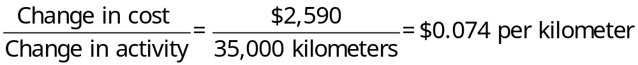
Fixed cost per year:

Total cost at 105,000 kilometers | $11,970
Less variable portion:  105,000 kilometers × $0.074 per kilometer | 7,770
Fixed cost per year | $ 4,200

2. Y = $4,200 + $0.074X

3. | Fixed cost | $ 4,200
 | Variable cost:  80,000 kilometers × $0.074 per kilometer | 5,920
 | Total annual cost | $10,120

Exercise 2-9 (10 minutes)
1. Product costs:

Direct materials | $ 80,000
Direct labor | 42,000
Manufacturing overhead | 19,000
Total product costs | $141,000

2. Period costs:
Selling expenses | $22,000
Administrative expenses | 35,000
Total period costs | $57,000

3. Conversion costs:

Direct labor | $42,000
Manufacturing overhead | 19,000
Total conversion costs | $61,000

4. Prime costs:

Direct materials | $ 80,000
Direct labor | 42,000
Total prime costs | $122,000

Exercise 2-10 (20 minutes)
1. The company’s variable cost per unit is:
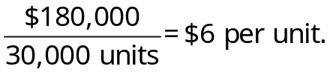
In accordance with the behavior of variable and fixed costs, the completed schedule is:

 | Units produced and sold
 | 30,000 | 40,000 | 50,000
Total costs:
Variable costs | $180,000 | $240,000 | $300,000
Fixed costs | 300,000 | 300,000 | 300,000
Total costs | $480,000 | $540,000 | $600,000
Cost per unit:
Variable cost | $ 6.00 | $ 6.00 | $ 6.00
Fixed cost | 10.00 | 7.50 | 6.00
Total cost per unit | $16.00 | $13.50 | $12.00

2. The company’s income statement in the contribution format is:

Sales (45,000 units × $16 per unit) | $720,000
Variable expenses (45,000 units × $6 per unit) | 270,000
Contribution margin | 450,000
Fixed expense | 300,000
Net operating income | $150,000

Exercise 2-11 (45 minutes)
1. The scattergraph appears below:

Yes, there is an approximately linear relationship between the number of units shipped and the total shipping expense.

Exercise 2-11 (continued)
2. The high-low estimates and cost formula are computed as follows:

 |  | Units Shipped | Shipping Expense
 | High activity level (June) | 8 | $2,700
 | Low activity level (July) | 2 | 1,200
 | Change | 6 | $1,500

Variable cost element:
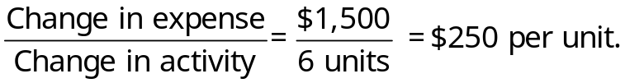
Fixed cost element:

Shipping expense at high activity level | $2,700
Less variable cost element ($250 per unit × 8 units) | 2,000
Total fixed cost | $ 700

The cost formula is $700 per month plus $250 per unit shipped or
Y = $700 + $250X,
where X is the number of units shipped.

The scattergraph on the following page shows the straight line drawn through the high and low data points.

Exercise 2-11 (continued)

3. The high-low estimate of fixed costs is $210.71 lower than the estimate provided by least-squares regression. The high-low estimate of the variable cost per unit is $32.14 higher than the estimate provided by least-squares regression. A straight line that minimized the sum of the squared errors would intersect the Y-axis at $910.71 instead of $700. It would also have a flatter slope because the estimated variable cost per unit is lower than the high-low method.

4. The cost of shipping units is likely to depend on the weight and volume of the units shipped and the distance traveled as well as on the number of units shipped. In addition, higher cost shipping might be necessary to meet a deadline.

Exercise 2-12 (30 minutes)
 |  |  | Product Cost |  |  | Period (Selling
Name of the Cost | Variable Cost | Fixed Cost | Direct Materials | Direct Labor | Manu-facturing Overhead | and Admin) Cost | Oppor-tunity Cost | Sunk Cost
Rental revenue forgone, $30,000 per year |  |  |  |  |  |  | X
Direct materials cost, $80 per unit | X |  | X
Rental cost of warehouse, $500 per month |  | X |  |  |  | X
Rental cost of equipment, $4,000 per month |  | X |  |  | X
Direct labor cost, $60 per unit | X |  |  | X
Depreciation of the annex space, $8,000 per year |  | X |  |  | X |  |  | X
Advertising cost, $50,000 per year |  | X |  |  |  | X
Supervisor's salary, $1,500 per month |  | X |  |  | X
Electricity for machines, $1.20 per unit | X |  |  |  | X
Shipping cost, $9 per unit | X |  |  |  |  | X
Return earned on investments, $3,000 per year |  |  |  |  |  |  | X

Exercise 2-13 (20 minutes)

1. Traditional income statement

The Alpine House, Inc.
Traditional Income Statement

Sales |  | $150,000
Cost of goods sold  ($30,000 + $100,000 – $40,000) |  | 90,000
Gross margin |  | 60,000
Selling and administrative expenses:
Selling expenses (($50 per unit × 200 pairs of skis*) + $20,000) | 30,000
Administrative expenses (($10 per unit × 200 pairs of skis) + $20,000) | 22,000 | 52,000
Net operating income |  | $ 8,000

*$150,000 sales ÷ $750 per pair of skis = 200 pairs of skis.

2. Contribution format income statement

The Alpine House, Inc.
Contribution Format Income Statement

Sales |  | $150,000
Variable expenses:
Cost of goods sold  ($30,000 + $100,000 – $40,000) | $90,000
Selling expenses  ($50 per unit × 200 pairs of skis) | 10,000
Administrative expenses  ($10 per unit × 200 pairs of skis) | 2,000 | 102,000
Contribution margin |  | 48,000
Fixed expenses:
Selling expenses | 20,000
Administrative expenses | 20,000 | 40,000
Net operating income |  | $ 8,000

Exercise 2-13 (continued)

2. Since 200 pairs of skis were sold and the contribution margin totaled $48,000 for the quarter, the contribution of each pair of skis toward fixed expenses and profits was $240 ($48,000 ÷ 200 pair of skis = $240 per pair of skis).
Exercise 2-14 (30 minutes)
1. |  | Guest-  Days | Custodial  Supplies  Expense
 | High activity level (July) | 12,000 | $13,500
 | Low activity level (March) | 4,000 | 7,500
 | Change | 8,000 | $ 6,000

Variable cost per guest-day:
Fixed cost per month:

Custodial supplies expense at high activity level | $13,500
Less variable cost element:  12,000 guest-days × $0.75 per guest-day | 9,000
Total fixed cost | $ 4,500

The cost formula is $4,500 per month plus $0.75 per guest-day or
Y = $4,500 + $0.75X

2. Custodial supplies expense for 11,000 guest-days:

Variable cost:  11,000 guest-days × $0.75 per guest-day | $ 8,250
Fixed cost | 4,500
Total cost | $12,750

Exercise 2-14 (continued)
3. The scattergraph appears below.

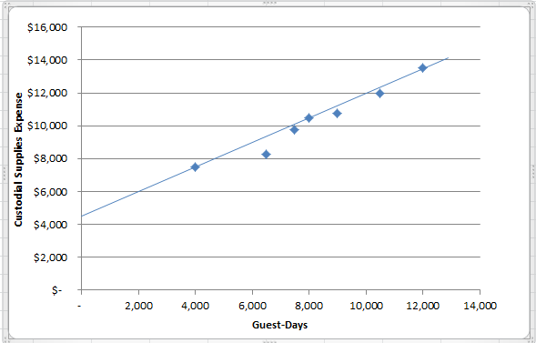

4. The high-low estimate of fixed costs is $526.90 higher than the estimate provided by least-squares regression. The high-low estimate of the variable cost per unit is $0.02 lower than the estimate provided by least-squares regression. A straight line that minimized the sum of the squared errors would intersect the Y-axis at $3,973.10 instead of $4,500. It would also have a steeper slope because the estimated variable cost per unit is higher than the high-low method.

5. Expected custodial supplies expense for 11,000 guest-days:

Variable cost: 11,000 guest-days × $0.77 per day | $ 8,470.00
Fixed cost | 3,973.10
Total cost | $12,443.10

Exercise 2-15 (15 minutes)
 |  |  |  |  | Selling and
 |  | Cost Behavior |  |  | Administrative |  | Product
 | Cost Item | Variable | Fixed |  | Cost |  | Cost
1. | Hamburger buns at a Wendy’s outlet | X |  |  |  |  | X
2. | Advertising by a dental office |  | X |  | X
3. | Apples processed and canned by Del Monte | X |  |  |  |  | X
4. | Shipping canned apples from a Del Monte plant to customers | X |  |  | X
5. | Insurance on a Bausch & Lomb factory producing contact lenses |  | X |  |  |  | X
6. | Insurance on IBM’s corporate headquarters |  | X |  | X
7. | Salary of a supervisor overseeing production of printers at Hewlett-Packard |  | X |  |  |  | X
8. | Commissions paid to automobile salespersons | X |  |  | X
9. | Depreciation of factory lunchroom facilities at a General Electric plant |  | X |  |  |  | X
10. | Steering wheels installed in BMWs | X |  |  |  |  | X

Problem 2-16 (45 minutes)
1. | Cost of goods sold | Variable
 | Advertising expense | Fixed
 | Shipping expense | Mixed
 | Salaries and commissions | Mixed
 | Insurance expense | Fixed
 | Depreciation expense | Fixed

2. Analysis of the mixed expenses:
 |  | Units | Shipping Expense | Salaries and Commissions Expense
High level of activity |  | 5,000 | $38,000 | $90,000
Low level of activity |  | 4,000 | 34,000 | 78,000
Change |  | 1,000 | $ 4,000 | $12,000

Variable cost element:
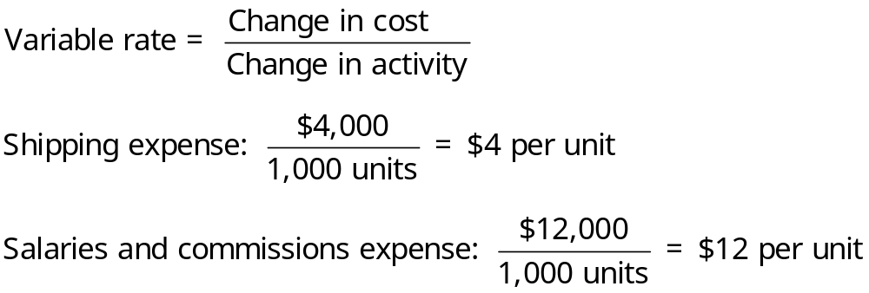
Fixed cost element:

 | Shipping Expense | Salaries and Commissions Expense
Cost at high level of activity | $38,000 | $90,000
Less variable cost element:
5,000 units × $4 per unit | 20,000
5,000 units × $12 per unit |  | 60,000
Fixed cost element | $18,000 | $30,000

Problem 2-16 (continued)
The cost formulas are:
Shipping expense:
$18,000 per month plus $4 per unit
or
Y = $18,000 + $4X
Salaries and commissions expense:
$30,000 per month plus $12 per unit
or
Y = $30,000 + $12X

3.
 | Morrisey & Brown, Ltd.
 | Income Statement
 | For the Month Ended September 30
 | Sales (5,000 units × $100 per unit) |  | $500,000
 | Variable expenses:
 | Cost of goods sold  (5,000 units × $60 per unit) | $300,000
 | Shipping expense  (5,000 units × $4 per unit) | 20,000
 | Salaries and commissions expense  (5,000 units × $12 per unit) | 60,000 | 380,000
 | Contribution margin |  | 120,000
 | Fixed expenses:
 | Advertising expense | 21,000
 | Shipping expense | 18,000
 | Salaries and commissions expense | 30,000
 | Insurance expense | 6,000
 | Depreciation expense | 15,000 | 90,000
 | Net operating income |  | $ 30,000

Problem 2-17 (30 minutes)
1. Maintenance cost at the 75,000 direct labor-hour level of activity can be isolated as follows:

 | Level of Activity
 | 50,000 DLHs | 75,000 DLHs
Total factory overhead cost | $14,250,000 | $17,625,000
Deduct:
Indirect materials @ $100 per DLH* | 5,000,000 | 7,500,000
Rent | 6,000,000 | 6,000,000
Maintenance cost | $ 3,250,000 | $ 4,125,000

* $5,000,000 ÷ 50,000 DLHs = $100 per DLH

2. High-low analysis of maintenance cost:

 | Direct Labor-Hours | Maintenance Cost
High level of activity | 75,000 | $4,125,000
Low level of activity | 50,000 | 3,250,000
Change | 25,000 | $ 875,000

Variable cost element:
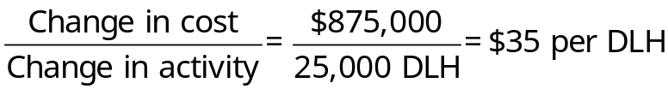
Fixed cost element:

Total cost at the high level of activity | $4,125,000
Less variable cost element  (75,000 DLHs × $35 per DLH) | 2,625,000
Fixed cost element | $1,500,000

Therefore, the cost formula for maintenance is $1,500,000 per year plus $35 per direct labor-hour or
Y = $1,500,000 + $35X
Problem 2-17 (continued)
3. Total factory overhead cost at 70,000 direct labor-hours is:

Indirect materials  (70,000 DLHs × $100 per DLH) |  | $ 7,000,000
Rent |  | 6,000,000
Maintenance:
Variable cost element  (70,000 DLHs × $35 per DLH) | $2,450,000
Fixed cost element | 1,500,000 | 3,950,000
Total factory overhead cost |  | $16,950,000

Problem 2-18 (20 minutes)
 |  | Direct or Indirect Cost of the Meals-On-Wheels Program |  |  | Direct or Indirect Cost of Particular Seniors Served by the Meals-On-Wheels Program |  |  | Variable or Fixed with Respect to the Number of Seniors Served by the Meals-On-Wheels Program
Item | Description | Direct | Indirect |  | Direct | Indirect |  | Variable | Fixed
a. | The cost of leasing the Meals-On-Wheels van | X |  |  |  | X |  |  | X
b. | The cost of incidental supplies such as salt, pepper, napkins, and so on | X |  |  |  | X* |  | X
c. | The cost of gasoline consumed by the Meals-On-Wheels van | X |  |  |  | X |  | X
d. | The rent on the facility that houses Madison Seniors Care Center, including the Meals-On-Wheels program |  | X |  |  | X* |  |  | X
e. | The salary of the part-time manager of the Meals-On-Wheels program | X |  |  |  | X |  |  | X
f. | Depreciation on the kitchen equipment used in the Meals-On-Wheels program | X |  |  |  | X |  |  | X
g. | The hourly wages of the caregiver who drives the van and delivers the meals | X |  |  | X |  |  | X
h. | The costs of complying with health safety regulations in the kitchen | X |  |  |  | X |  |  | X
i. | The costs of mailing letters soliciting donations to the Meals-On-Wheels program | X |  |  |  | X |  |  | X
*These costs could be direct costs of serving particular seniors.

Problem 2-19 (45 minutes)
1. | Marwick’s Pianos, Inc.  Traditional Income Statement  For the Month of August
 | Sales (40 pianos × $3,125 per piano) |  | $125,000
 | Cost of goods sold  (40 pianos × $2,450 per piano) |  | 98,000
 | Gross margin |  | 27,000
 | Selling and administrative expenses:
 | Selling expenses:
 | Advertising | $ 700
 | Sales salaries and commissions  [$950 + (8% × $125,000)] | 10,950
 | Delivery of pianos  (40 pianos × $30 per piano) | 1,200
 | Utilities | 350
 | Depreciation of sales facilities | 800
 | Total selling expenses | 14,000
 | Administrative expenses:
 | Executive salaries | 2,500
 | Insurance | 400
 | Clerical  [$1,000 + (40 pianos × $20 per piano)] | 1,800
 | Depreciation of office equipment | 300
 | Total administrative expenses | 5,000
 | Total selling and administrative expenses |  | 19,000
 | Net operating income |  | $ 8,000
Problem 2-19 (continued)
2. | Marwick’s Pianos, Inc.  Contribution Format Income Statement  For the Month of August
 |  | Total | Per  Piano
 | Sales (40 pianos × $3,125 per piano) | $125,000 | $3,125
 | Variable expenses:
 | Cost of goods sold  (40 pianos × $2,450 per piano) | 98,000 | 2,450
 | Sales commissions (8% × $125,000) | 10,000 | 250
 | Delivery of pianos (40 pianos × $30 per piano) | 1,200 | 30
 | Clerical (40 pianos × $20 per piano) | 800 | 20
 | Total variable expenses | 110,000 | 2,750
 | Contribution margin | 15,000 | $ 375
 | Fixed expenses:
 | Advertising | 700
 | Sales salaries | 950
 | Utilities | 350
 | Depreciation of sales facilities | 800
 | Executive salaries | 2,500
 | Insurance | 400
 | Clerical | 1,000
 | Depreciation of office equipment | 300
 | Total fixed expenses | 7,000
 | Net operating income | $ 8,000

3. Fixed costs remain constant in total but vary on a per unit basis inversely with changes in the activity level. As the activity level increases, for example, the fixed costs will decrease on a per unit basis. Showing fixed costs on a per unit basis on the income statement might mislead management into thinking that the fixed costs behave in the same way as the variable costs. That is, management might be misled into thinking that the per unit fixed costs would be the same regardless of how many pianos were sold during the month. For this reason, fixed costs generally are shown only in totals on a contribution format income statement.

Problem 2-20 (45 minutes)
1. Maintenance cost at the 90,000 machine-hour level of activity can be isolated as follows:

 | Level of Activity
 | 60,000 MHs | 90,000 MHs
Total factory overhead cost | $174,000 | $246,000
Deduct:
Utilities cost @ $0.80 per MH* | 48,000 | 72,000
Supervisory salaries | 21,000 | 21,000
Maintenance cost | $105,000 | $153,000

*$48,000 ÷ 60,000 MHs = $0.80 per MH

2. High-low analysis of maintenance cost:

 | Machine-Hours | Maintenance Cost
High activity level | 90,000 | $153,000
Low activity level | 60,000 | 105,000
Change | 30,000 | $ 48,000

Variable rate:

Total fixed cost:

Total maintenance cost at the high activity level | $153,000
Less variable cost element  (90,000 MHs × $1.60 per MH) | 144,000
Fixed cost element | $ 9,000

Therefore, the cost formula for maintenance is $9,000 per month plus $1.60 per machine-hour or
Y = $9,000 + $1.60X.
Problem 2-20 (continued)
3. |  | Variable Cost per Machine-Hour | Fixed Cost
 | Utilities cost | $0.80
 | Supervisory salaries cost |  | $21,000
 | Maintenance cost | 1.60 | 9,000
 | Total overhead cost | $2.40 | $30,000

Thus, the cost formula would be: Y = $30,000 + $2.40X.

4. Total overhead cost at an activity level of 75,000 machine-hours:

Fixed costs | $ 30,000
Variable costs: 75,000 MHs × $2.40 per MH | 180,000
Total overhead costs | $210,000

Problem 2-21 (30 minutes)
Note to the Instructor: There may be some exceptions to the answers below. The purpose of this problem is to get the student to start thinking about cost behavior and cost purposes; try to avoid lengthy discussions about how a particular cost is classified.

 |  | Variable or | Selling | Administrative | Manufacturing  (Product) Cost
 | Cost Item | Fixed | Cost | Cost | Direct | Indirect
1. | Property taxes, factory | F |  |  |  | X
2. | Boxes used for packaging detergent produced by the company | V |  |  | X
3. | Salespersons’ commissions | V | X
4. | Supervisor’s salary, factory | F |  |  |  | X
5. | Depreciation, executive autos | F |  | X
6. | Wages of workers assembling computers | V |  |  | X
7. | Insurance, finished goods warehouses | F | X
8. | Lubricants for production equipment | V |  |  |  | X
9. | Advertising costs | F | X
10. | Microchips used in producing calculators | V |  |  | X
11. | Shipping costs on merchandise sold | V | X
12. | Magazine subscriptions, factory lunchroom | F |  |  |  | X
13. | Thread in a garment factory | V |  |  |  | X
14. | Billing costs | V | X*
15. | Executive life insurance | F |  | X
Problem 2-21 (continued)
 |  | Variable or | Selling | Administrative | Manufacturing  (Product) Cost
 | Cost Item | Fixed | Cost | Cost | Direct | Indirect
16. | Ink used in textbook production | V |  |  |  | X
17. | Fringe benefits, assembly-line workers | V |  |  | X**
18. | Yarn used in sweater production | V |  |  | X
19. | Wages of receptionist, executive offices | F |  | X

* Could be administrative cost.
** Could be indirect cost.

Problem 2-22 (45 minutes)
1. High-low method:

 |  | Number of  Scans | Utilities Cost
High level of activity |  | 150 | $4,000
Low level of activity |  | 60 | 2,200
Change |  | 90 | $1,800

Fixed cost: | Total cost at high level of activity | $4,000
 | Less variable element:  150 scans × $20 per scan | 3,000
 | Fixed cost element | $1,000

Therefore, the cost formula is: Y = $1,000 + $20X.

2. The scattergraph plot appears as follows:

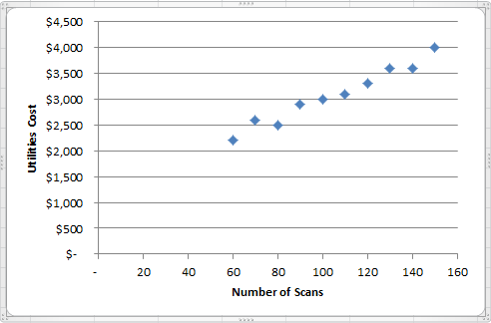

Problem 2-22 (continued)
3. The high-low estimate of fixed costs is $170.90 lower than the estimate provided by least-squares regression. The high-low estimate of the variable cost per unit is $1.82 higher than the estimate provided by least-squares regression. A straight line that minimized the sum of the squared errors would intersect the Y-axis at $1,170.90 instead of $1,000. It would also have a flatter slope because the estimated variable cost per unit is lower than the high-low method.

Problem 2-23 (45 minutes)

1. High-low method:

 | Units  Sold | Shipping Expense
High activity level | 20,000 | $210,000
Low activity level | 10,000 | 119,000
Change | 10,000 | $91,000
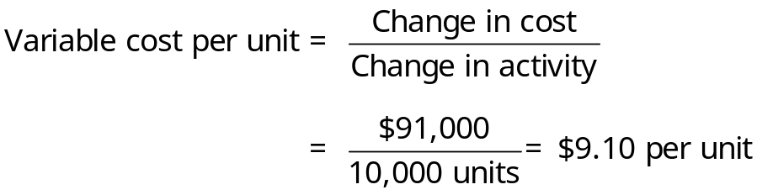
Fixed cost element:
 | Total shipping expense at high activity level | $210,000
 | Less variable element:
 | 20,000 units × $9.10 per unit | 182,000
 | Fixed cost element | $ 28,000

Therefore, the cost formula is: Y = $28,000 + $9.10X.
Problem 2-23 (continued)
2. | Milden Company  Budgeted Contribution Format Income Statement  For the First Quarter, Year 3
 | Sales (12,000 units × $100 per unit) |  | $1,200,000
 | Variable expenses:
 | Cost of goods sold  (12,000 units × $35 unit) | $420,000
 | Sales commission (6% × $1,200,000) | 72,000
 | Shipping expense  (12,000 units × $9.10 per unit) | 109,200
 | Total variable expenses |  | 601,200
 | Contribution margin |  | 598,800
 | Fixed expenses:
 | Advertising expense | 210,000
 | Shipping expense | 28,000
 | Administrative salaries | 145,000
 | Insurance expense | 9,000
 | Depreciation expense | 76,000
 | Total fixed expenses |  | 468,000
 | Net operating income |  | $ 130,800

Problem 2-24 (30 minutes)
1. A cost that is classified as a period cost will be recognized on the income statement as an expense in the current period. A cost that is classified as a product cost will be recognized on the income statement as an expense (i.e., cost of goods sold) only when the associated units of product are sold. If some units are unsold at the end of the period, the costs of those unsold units are treated as assets. Therefore, by reclassifying period costs as product costs, the company is able to carry some costs forward in inventories that would have been treated as current expenses.

2. The discussion below is divided into two parts—Gallant’s actions to postpone expenditures and the actions to reclassify period costs as product costs.

The decision to postpone expenditures is questionable. It is one thing to postpone expenditures due to a cash bind; it is quite another to postpone expenditures in order to hit a profit target. Postponing these expenditures may have the effect of ultimately increasing future costs and reducing future profits. If orders to the company’s suppliers are changed, it may disrupt the suppliers’ operations. The additional costs may be passed on to Gallant’s company and may create ill will and a feeling of mistrust. Postponing maintenance on equipment is particularly questionable. The result may be breakdowns, inefficient and/or unsafe operations, and a shortened life for the machinery.

Gallant’s decision to reclassify period costs is not ethical—assuming that there is no intention of disclosing in the financial reports this reclassification. Such a reclassification would be a violation of the principle of consistency in financial reporting and is a clear attempt to mislead readers of the financial reports. Although some may argue that the overall effect of Gallant’s action will be a “wash”—that is, profits gained in this period will simply be taken from the next period—the trend of earnings will be affected. Hopefully, the auditors would discover any such attempt to manipulate annual earnings and would refuse to issue an unqualified opinion due to the lack of consistency. However, recent accounting scandals may lead to some skepticism about how forceful auditors have been in enforcing tight accounting standards.
Problem 2-25 (45 minutes)
1.
 | Cost Behavior |  | Selling or  Administrative | Product Cost
Cost Item | Variable | Fixed | Cost | Direct | Indirect
Direct labor | $118,000 |  |  | $118,000
Advertising |  | $50,000 | $50,000
Factory supervision |  | 40,000 |  |  | $40,000
Property taxes, factory building |  | 3,500 |  |  | 3,500
Sales commissions | 80,000 |  | 80,000
Insurance, factory |  | 2,500 |  |  | 2,500
Depreciation, administrative office equipment |  | 4,000 | 4,000
Lease cost, factory equipment |  | 12,000 |  |  | 12,000
Indirect materials, factory | 6,000 |  |  |  | 6,000
Depreciation, factory building |  | 10,000 |  |  | 10,000
Administrative office supplies | 3,000 |  | 3,000
Administrative office salaries |  | 60,000 | 60,000
Direct materials used | 94,000 |  |  | 94,000
Utilities, factory | 20,000 |  |  |  | 20,000
Total costs | $321,000 | $182,000 | $197,000 | $212,000 | $94,000

Problem 2-25 (continued)
2. The average product cost for one patio set would be:

Direct | $212,000
Indirect | 94,000
Total | $306,000
$306,000 ÷ 2,000 sets = $153 per set

3. The average product cost per set would increase if the production drops. This is because the fixed costs would be spread over fewer units, causing the average cost per unit to rise.

4. a. Yes, the president may expect a minimum price of $153, which is the average cost to manufacture one set. He might expect a price even higher than this to cover a portion of the administrative costs as well. The brother-in-law probably is thinking of cost as including only direct materials, or, at most, direct materials and direct labor. Direct materials alone would be only $47 per set, and direct materials and direct labor would be only $106.

b. The term is opportunity cost. The full, regular price of a set might be appropriate here, because the company is operating at full capacity, and this is the amount that must be given up (benefit forgone) to sell a set to the brother-in-law.

Case 2-26 (60 minutes)
1. High-low method:
 | Hours | Cost
High level of activity | 25,000 |  | $99,000
Low level of activity | 10,000 |  | 64,500
Change | 15,000 |  | $34,500

Variable element: $34,500 ÷ 15,000 DLH = $2.30 per DLH

Fixed element:
Total cost—25,000 DLH | $99,000
Less variable element:  25,000 DLH × $2.30 per DLH | 57,500
Fixed element | $41,500

Therefore, the cost formula is: Y = $41,500 + $2.30X.

2. The scattergraph is shown below:

Overhead
Costs
$60,000
$65,000
$70,000
$75,000
$80,000
$85,000
$90,000
$95,000
$100,000
8,000
10,000
12,000
14,000
16,000
18,000
20,000
22,000
24,000
26,000
Direct Labor-Hours
Y
X

Case 2-26 (continued)
2. The scattergraph shows that there are two relevant ranges—one below 19,500 DLH and one above 19,500 DLH. The change in equipment lease cost from a fixed fee to an hourly rate causes the slope of the regression line to be steeper above 19,500 DLH, and to be discontinuous between the fixed fee and hourly rate points.
3. The cost formulas computed with the high-low and regression methods are faulty since they are based on the assumption that a single straight line provides the best fit to the data. Creating two data sets related to the two relevant ranges will enable more accurate cost estimates.
4. High-low method:
 | Hours | Cost
High level of activity | 25,000 |  | $99,000
Low level of activity | 20,000 |  | 80,000
Change | 5,000 |  | $19,000

Variable element: $19,000 ÷ 5,000 DLH = $3.80 per DLH

Fixed element:
Total cost—25,000 DLH | $99,000
Less variable element:  25,000 DLH × $3.80 per DLH | 95,000
Fixed element | $4,000

Expected overhead costs when 22,500 machine-hours are used:

Variable cost: 22,500 hours × $3.80 per hour | $85,500
Fixed cost | 4,000
Total cost | $89,500

5. The high-low estimate of fixed costs is $6,090 lower than the estimate provided by least-squares regression. The high-low estimate of the variable cost per machine hour is $0.27 higher than the estimate provided by least-squares regression. A straight line that minimized the sum of the squared errors would intersect the Y-axis at $10,090 instead of $4,000. It would also have a flatter slope because the estimated variable cost per unit is lower than the high-low method.

Case 2-27 (30 minutes)
1. The scattergraph of direct labor cost versus the number of units produced is presented below:

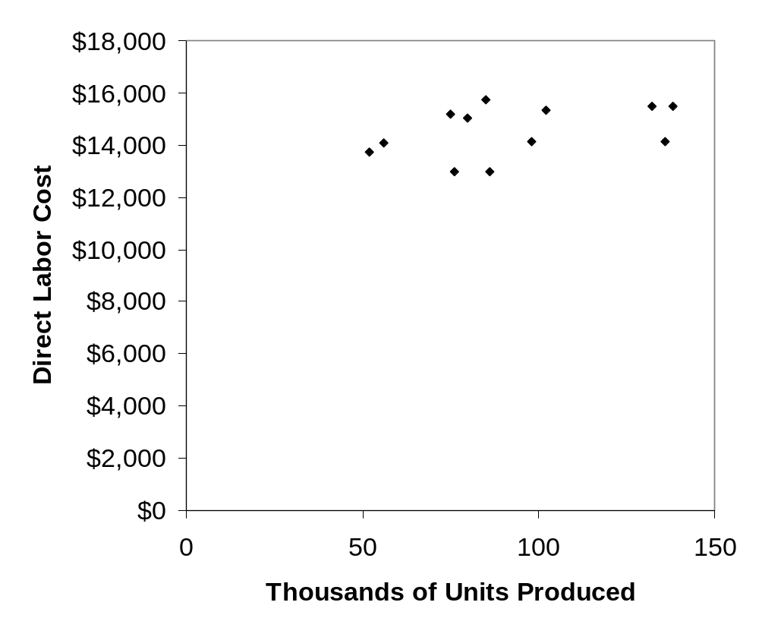
Case 2-27 (continued)
2. The scattergraph of the direct labor cost versus the number of paid days is presented below:

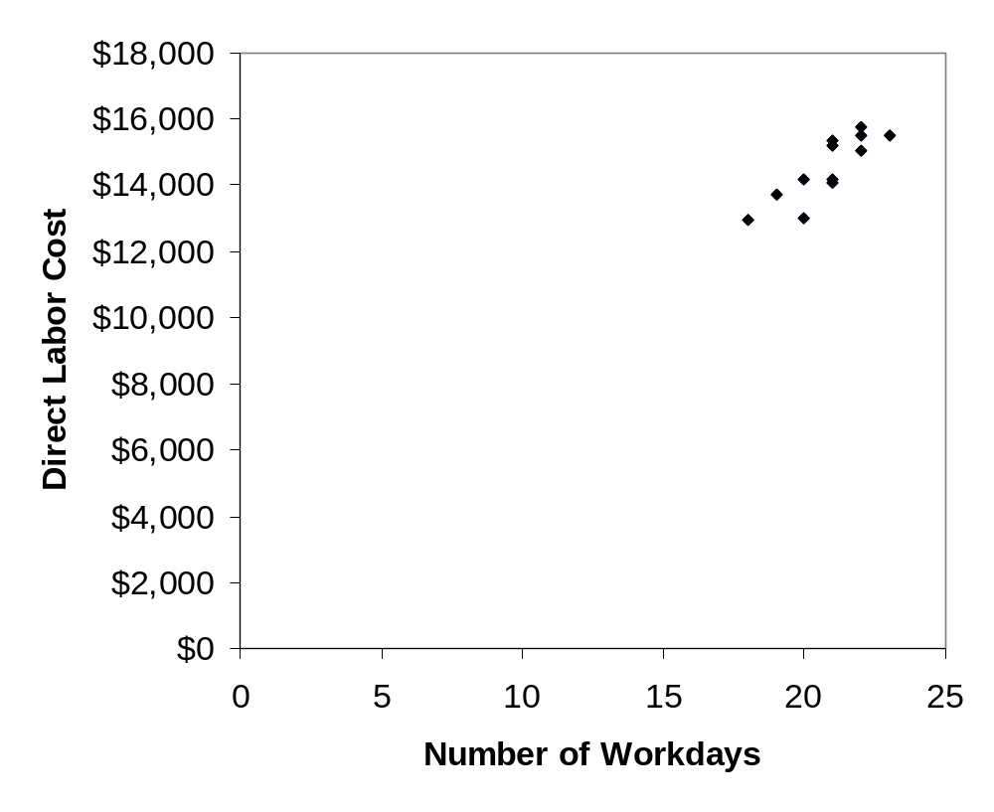
Case 2-27 (continued)
Number of Paid Days
3. The number of paid days should be used as the activity base rather than the number of units produced. The scattergraphs reveal a much stronger relation (i.e., higher correlation) between direct labor costs and number of paid days than between direct labor costs and number of units produced. Variations in the direct labor costs apparently occur because of the number of paid days in the month and have little to do with the number of units that are produced. It appears that the direct labor costs are basically fixed with respect to how many units are produced in a month. This would happen if the direct labor workers are treated as full-time employees who are paid even if there is insufficient work to keep them busy. Moreover, for planning purposes, the company is likely to be able to predict the number of paid days in the month with much greater accuracy than the number of units that will be produced.

Appendix 2A
Least-Squares Regression Computations
Exercise 2A-1 (20 minutes)
1. and 2.

The scattergraph plot and least-squares regression estimates of fixed and variable costs using Microsoft Excel are shown below:

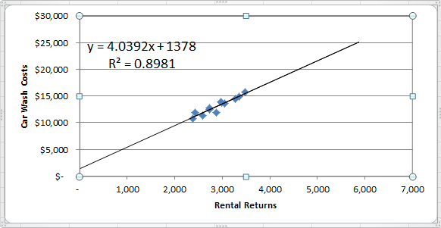

The intercept provides the estimate of the fixed cost element, $1,378 per month, and the slope provides the estimate of the variable cost element, $4.04 per rental return. Expressed as an equation in the form Y = a + bX, the relation between car wash costs and rental returns is
Y = $1,378 + $4.04X
where X is the number of rental returns.
Note that the R² is approximately 0.90, which is quite high, and indicates a strong linear relationship between car wash costs and rental returns.

Exercise 2A-2 (20 minutes)
1. and 2.
The scattergraph plot and regression estimates of fixed and variable costs using Microsoft Excel are shown below:
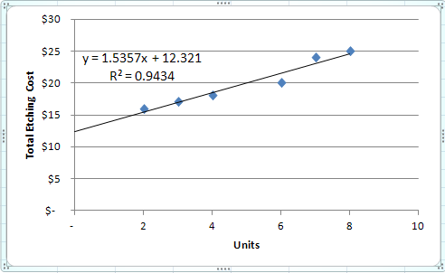

Note that the R² is approximately 0.94, which means that 94% of the variation in etching costs is explained by the number of units etched. This is a very high R² which indicates a very good fit.

The regression equation, in the form Y = a + bX, is as follows (where a is rounded to nearest dollar and b is rounded to the nearest cent):

Y = $12.32 + $1.54X

3. Total expected etching cost if 5 units are processed:

Variable cost: 5 units × $1.54 per unit | $ 7.70
Fixed cost | 12.32
Total expected cost | $20.02

Problem 2A-3 (30 minutes)
1. The scattergraph plot and regression estimates of fixed and variable costs using Microsoft Excel are shown below:
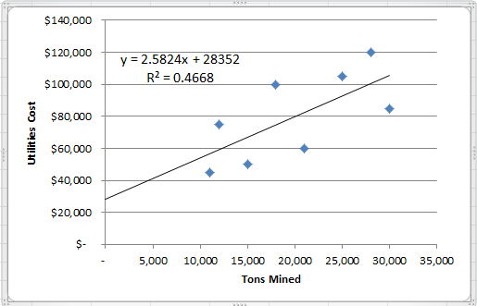

The cost formula, in the form Y = a + bX, using tons mined as the activity base is $28,352 per quarter plus $2.58 per ton mined, or

Y = $28,352 + $2.58X.

Note that the R² is approximately 0.47, which means that only 47% of the variation in utility costs is explained by the number of tons mined.
Problem 2A-3 (continued)
2. The scattergraph plot and regression estimates of fixed and variable costs using Microsoft Excel are shown below:
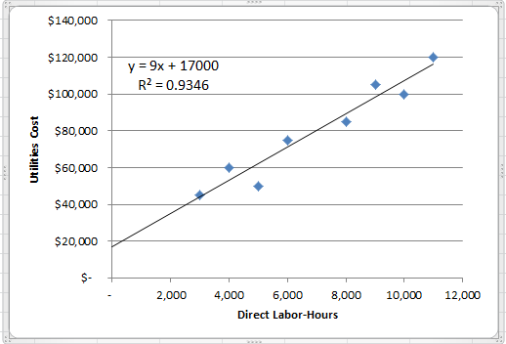

The cost formula, in the form Y = a + bX, using direct labor-hours as the activity base is $17,000 per quarter plus $9.00 per direct labor-hour, or:

Y = $17,000 + $9.00X.

Note that the R² is approximately 0.93, which means that 93% of the variation in utility costs is explained by direct labor-hours. This is a very high R² which is an indication of a very good fit.

3. The company should probably use direct labor-hours as the activity base, since the fit of the regression line to the data is much tighter than it is with tons mined. The R² for the regression using direct labor-hours as the activity base is twice as large as for the regression using tons mined as the activity base. However, managers should look more closely at the costs and try to determine why utilities costs are more closely tied to direct labor-hours than to the number of tons mined.

Problem 2A-4 (30 minutes)
1. and 2.

The scattergraph plot and regression estimates of fixed and variable costs using Microsoft Excel are shown below:

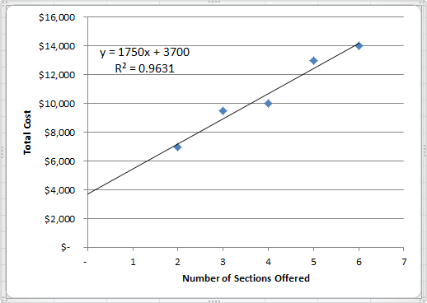

The cost formula, in the form Y = a + bX, using number of sections offered as the activity base is $3,700 per quarter plus $1,750 per section offered, or:

Y = $3,700 + $1,750X.

Note that the R² is approximately 0.96, which means that 96% of the variation in cost is explained by the number of sections. This is a very high R² which indicates a very good fit.

Problem 2A-4 (continued)

3. Expected total cost would be:

Fixed cost | $ 3,700
Variable cost (8 sections × $1,750 per section) | 14,000
Total cost | $17,700

The problem with using the cost formula from (2) to derive total cost is that an activity level of 8 sections may lie outside the relevant range—the range of activity within which the fixed cost is approximately $3,700 per term and the variable cost is approximately $1,750 per section offered. These approximations appear to be reasonably accurate within the range of 2 to 6 sections, but they may be invalid outside this range.

CASE 2A-5 (45 minutes)

1. and 2.

The scattergraph plot and regression estimates of fixed and variable costs using Microsoft Excel are shown below:

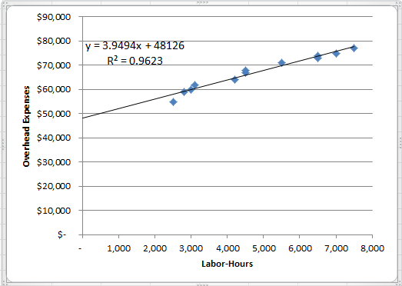

The scattergraph reveals three interesting findings. First, it indicates the relation between overhead expense and labor hours is approximated reasonably well by a straight line. (However, there appears to be a slight downward bend in the plot as the labor-hours increase—evidence of increasing returns to scale. This is a common occurrence in practice. See Noreen & Soderstrom, “Are overhead costs strictly proportional to activity?” Journal of Accounting and Economics, vol. 17, 1994, pp. 255-278.)

Second, the data points are all fairly close to the straight line. This indicates that most of the variation in overhead expenses is explained by labor hours. As a consequence, there probably wouldn’t be much benefit to investigating other possible cost drivers for the overhead expenses.

Third, most of the overhead expense appears to be fixed. Maria should ask herself if this is reasonable. Does the company have large fixed expenses such as rent, depreciation, and salaries?

CASE 2A-5 (continued)

The cost formula, in the form Y = a + bX, using labor-hours as the activity base is $48,126 per month plus $3.95 per labor-hour, or:

Y = $48,126 + $3.95X.

Note that the R² is approximately 0.96, which means that 96% of the variation in cost is explained by labor-hours. This is a very high R² which indicates a very good fit.

3. Using the least-squares regression estimate of the variable overhead cost, the total variable cost per guest is computed as follows:

Food and beverages | $15.00
Labor (0.5 hour @ $10 per hour) | 5.00
Overhead (0.5 hour @ $3.95 per hour) | 1.98
Total variable cost per guest | $21.98

The total contribution from 180 guests paying $31 each is computed as follows:

Sales (180 guests @ $31.00 per guest) | $5,580.00
Variable cost (180 guests @ $21.98 per guest) | 3,956.40
Contribution to profit | $1,623.60

Fixed costs are not included in the above computation because there is no indication that any additional fixed costs would be incurred as a consequence of catering the cocktail party. If additional fixed costs were incurred, they should also be subtracted from revenue.

4. Assuming that no additional fixed costs are incurred as a result of catering the charity event, any price greater than the variable cost per guest of roughly $22 would contribute to profits.
CASE 2A-5 (continued)

5. We would favor bidding slightly less than $30 to get the contract. Any bid above $22 would contribute to profits and a bid at the normal price of $31 is unlikely to land the contract. And apart from the contribution to profit, catering the event would show off the company’s capabilities to potential clients. The danger is that a price that is lower than the normal bid of $31 might set a precedent for the future or it might initiate a price war among caterers. However, the price need not be publicized and the lower price could be justified to future clients because this is a charity event. Another possibility would be for Maria to maintain her normal price but throw in additional services at no cost to the customer. Whether to compete on price or service is a delicate issue that Maria will have to decide after getting to know the personality and preferences of the customer.

Appendix 2B
Cost of Quality
Exercise 2B-1 (10 minutes)
1. Quality of conformance
2. Quality costs
3. Quality circles
4. Prevention costs, appraisal costs
5. Internal failure costs, external failure costs
6. External failure costs
7. Appraisal costs
8. Prevention costs
9. Internal failure costs
10. External failure costs
11. Prevention costs, appraisal costs
12. Quality cost report

Exercise 2B-2 (15 minutes)
1.
 |  | Prevention Cost | Appraisal Cost | Internal Failure Cost | External Failure Cost
a. | Product testing |  | X
b. | Product recalls |  |  |  | X
c. | Rework labor and overhead |  |  | X
d. | Quality circles | X
e. | Downtime caused by defects |  |  | X
f. | Cost of field servicing |  |  |  | X
g. | Inspection of goods |  | X
h. | Quality engineering | X
i. | Warranty repairs |  |  |  | X
j. | Statistical process control | X
k. | Net cost of scrap |  |  | X
l. | Depreciation of test equipment |  | X
m. | Returns and allowances arising from poor quality |  |  |  | X
n. | Disposal of defective products |  |  | X
o. | Technical support to suppliers | X
p. | Systems development | X
q. | Warranty replacements |  |  |  | X
r. | Field testing at customer site |  | X
s. | Product design | X

2. Prevention costs and appraisal costs are incurred in an effort to keep poor quality of conformance from occurring. Internal and external failure costs are incurred because poor quality of conformance has occurred.

Problem 2B-3 (60 minutes)
1. An analysis of the company’s quality cost report is presented below:

 |  | Last Year |  |  |  | This Year
 |  | Amount | Percent* |  |  |  | Amount | Percent*
 | Prevention costs:
 | Machine maintenance | $70 | 1.7 | 10.4 |  |  | $ 120 | 2.5 | 20.3
 | Training suppliers | 0 | 0.0 | 0.0 |  |  | 10 | 0.2 | 1.7
 | Quality circles | 0 | 0.0 | 0.0 |  |  | 20 | 0.4 | 3.4
 | Total prevention costs | 70 | 1.7 | 10.4 |  |  | 150 | 3.1 | 25.4
 | Appraisal costs:
 | Incoming inspection | 20 | 0.5 | 3.0 |  |  | 40 | 0.8 | 6.8
 | Final testing | 80 | 1.9 | 11.9 |  |  | 90 | 1.9 | 15.3
 | Total appraisal costs | 100 | 2.4 | 14.9 |  |  | 130 | 2.7 | 22.0
 | Internal failure costs:
 | Rework | 50 | 1.2 | 7.5 |  |  | 130 | 2.7 | 22.0
 | Scrap | 40 | 1.0 | 6.0 |  |  | 70 | 1.5 | 11.9
 | Total internal failure costs | 90 | 2.1 | 13.4 |  |  | 200 | 4.2 | 33.9
 | External failure costs:
 | Warranty repairs | 90 | 2.1 | 13.4 |  |  | 30 | 0.6 | 5.1
 | Customer returns | 320 | 7.6 | 47.8 |  |  | 80 | 1.7 | 13.6
 | Total external failure costs | 410 | 9.8 | 61.2 |  |  | 110 | 2.3 | 18.6
 | Total quality cost | $670 | 16.0 | 100.0 |  |  | $ 590 | 12.3 | 100.0
 | Total production cost | $4,200 |  |  |  |  | $4,800

* Percentage figures may not add down due to rounding.
Problem 2B-3 (continued)
From the above analysis it would appear that Mercury, Inc.’s program has been successful.

- Total quality costs have declined from 16.0% to 12.3% as a percentage of total production cost. In dollar amount, total quality costs went from $670,000 last year to $590,000 this year.

- External failure costs, those costs signaling customer dissatisfaction, have declined from 9.8% of total production costs to 2.3%. These declines in warranty repairs and customer returns should result in increased sales in the future.

- Appraisal costs have increased from 2.4% to 2.7% of total production cost.

- Internal failure costs have increased from 2.1% to 4.2% of production costs. This increase has probably resulted from the increase in appraisal activities. Defective units are now being spotted more frequently before they are shipped to customers.

- Prevention costs have increased from 1.7% of total production cost to 3.1% and from 10.4% of total quality costs to 25.4%. The $80,000 increase is more than offset by decreases in other quality costs.

2. The initial effect of emphasizing prevention and appraisal was to reduce external failure costs and increase internal failure costs. The increase in appraisal activities resulted in catching more defective units before they were shipped to customers. As a consequence, rework and scrap costs increased. In the future, an increased emphasis on prevention should result in a decrease in internal failure costs. And as defect rates are reduced, resources devoted to appraisal can be reduced.

3. To measure the cost of not implementing the quality program, management could assume that sales and market share would continue to decline and then calculate the lost profit. Or, management might assume that the company will have to cut its prices to hang on to its market share. The impact on profits of lowering prices could be estimated.

Problem 2B-4 (60 minutes)
1. | Florex Company  Quality Cost Report
 |  | Last Year |  |  | This Year
 |  | Amount  (in thousands) | Percent of Sales |  | Amount  (in thousands) | Percent of Sales
 | Prevention costs:
 | Quality engineering | $ 420 | 0.56 |  | $ 570 | 0.76
 | Systems development | 480 | 0.64 |  | 750 | 1.00
 | Statistical process control | 0 | 0.00 |  | 180 | 0.24
 | Total prevention costs | 900 | 1.20 |  | 1,500 | 2.00
 | Appraisal costs
 | Inspection | 750 | 1.00 |  | 900 | 1.20
 | Product testing | 810 | 1.08 |  | 1,200 | 1.60
 | Supplies used in testing | 30 | 0.04 |  | 60 | 0.08
 | Depreciation of testing equipment | 210 | 0.28 |  | 240 | 0.32
 | Total appraisal costs | 1,800 | 2.40 |  | 2,400 | 3.20
 | Internal failure costs:
 | Net cost of scrap | 630 | 0.84 |  | 1,125 | 1.50
 | Rework labor | 1,050 | 1.40 |  | 1,500 | 2.00
 | Disposal of defective products | 720 | 0.96 |  | 975 | 1.30
 | Total internal failure costs | 2,400 | 3.20 |  | 3,600 | 4.80
 | External failure costs:
 | Cost of field servicing | 1,200 | 1.60 |  | 900 | 1.20
 | Warranty repairs | 3,600 | 4.80 |  | 1,050 | 1.40
 | Product recalls | 2,100 | 2.80 |  | 750 | 1.00
 | Total external failure costs | 6,900 | 9.20 |  | 2,700 | 3.60
 | Total quality cost | $12,000 | 16.00 |  | $10,200 | 13.60

Problem 2B-4 (continued)
2.

Problem 2B-4 (continued)
3. The overall impact of the company’s increased emphasis on quality over the past year has been positive in that total quality costs have decreased from 16% of sales to 13.6% of sales. Despite this improvement, the company still has a poor distribution of quality costs. The bulk of the quality costs in both years is traceable to internal and external failure, rather than to prevention and appraisal. Although the distribution of these costs is poor, the trend this year is toward more prevention and appraisal as the company has given more emphasis on quality.

Probably due to the increased spending on prevention and appraisal activities during the past year, internal failure costs have increased by one half, going from $2.4 million to $3.6 million. The reason internal failure costs have gone up is that, through increased appraisal activity, defects are being caught and corrected before products are shipped to customers. Thus, the company is incurring more cost for scrap, rework, and so forth, but it is saving huge amounts in field servicing, warranty repairs, and product recalls. External failure costs have fallen sharply, decreasing from $6.9 million last year to just $2.7 million this year.

If the company continues its emphasis on prevention and appraisal—and particularly on prevention—its total quality costs should continue to decrease in future years. Although internal failure costs are increasing for the moment, these costs should decrease in time as better quality is designed into products. Appraisal costs should also decrease as the need for inspection, testing, and so forth decreases as a result of better engineering and tighter process control.

