Chapter 2
- No. The marginal rate of substitution of beer for pizza (MRS) is 2 for Hamlet and 3 for Ophelia. This violates the necessary condition for a Pareto efficient allocation.
- Although the economy is operating on the production possibilities frontier, the MRT will be less than the MRS because the quota causes the apples market to clear at a price exceeding the marginal cost. We can represent this situation with the following diagram.
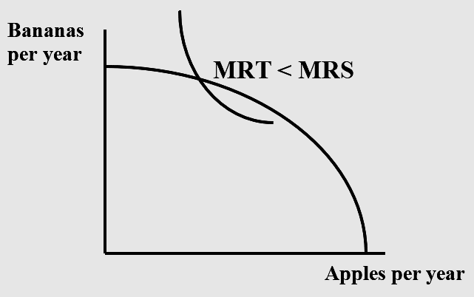
- If individuals are not permitted to substitute apples for bananas by trading or selling, then the MRS of individuals who like apples a lot will exceed the MRS of those liking apples little. If trade were permitted, the first type of individuals would acquire apples from the second type, and consequently the MRS of the first type would decline while the MRS of the second type would rise. This process would continue until the MRS is the same across individuals.

  - The marginal rates of substitution for coffee and for tea are constant for both Hannah and Jose. Hannah would trade ¼ pound of coffee for ⅓ pound of tea to remain equally satisfied. Similarly, Jose would trade ¼ pound of tea for ⅓ pound of coffee to remain equally satisfied. The constant MRS means linear indifference curves
  - Green indifference curves are Jose’s and red indifference curves are Hannah’s.
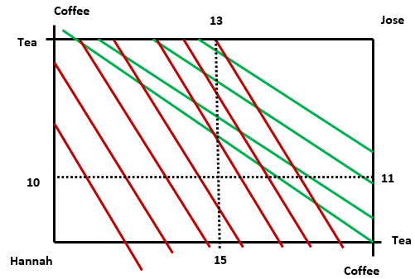

  - The contract curve follows the bottom and right borders of the Edgeworth Box. At any interior point in the box, the parties will find it in their interest to trade until they reach these borders. This is because Hannah would only choose to consume tea once she has consumed all the coffee in the economy. Likewise, Jose would only choose to consume coffee once he has consumed all the tea in the economy.
  - The initial allocation is not Pareto efficient. It is possible to make one better off without making the other worse off.

- If John had one loaf of bread, he would be willing to give up 10 kilos of cheese for an additional loaf of bread. If Marsha had one loaf of bread, she would be willing to give up 5 kilos of cheese for an additional loaf of bread.
- The initial allocation at point a in the Edgeworth box is not Pareto efficient because John is willing to given up 2/3 of a kilo of cheese for an extra loaf of bread while Marsha would be willing to accept 1/3 of a kilo of cheese for a loaf of bread. Marsha should give John some bread in exchange for cheese.
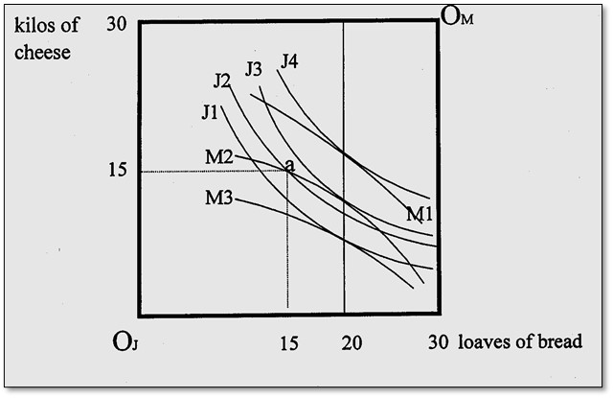
- Along the contract curve:
Since along the contract curve. The contract curve is a vertical line at
- Point a represents an equal allocation of water, but it is not efficient because there is no tangency. Point b is an efficient allocation (but not the only one).
AD: 1) the dashed line is positioned at the halfway point on the horizontal axis.
2) point b is a tangency
If Americans have a higher MRS_{wb} than Canadians, then there are gains for residents of both countries if Canada exports water to the U.S. in exchange for bread.
- The marginal rate of transformation between foreign and domestic movies depends on the ratio of their prices before taxes and subsidies. Because of the wedge created by the taxes and subsidies, the two price ratios are different. Therefore, the marginal rate of substitution and marginal rate of transformation are not equal, and the allocation of resources is inefficient.

a. Social indifference curves are straight lines with slope of –1. As far as society is concerned a “util” to Augustus is equivalent to a “util” to Livia.
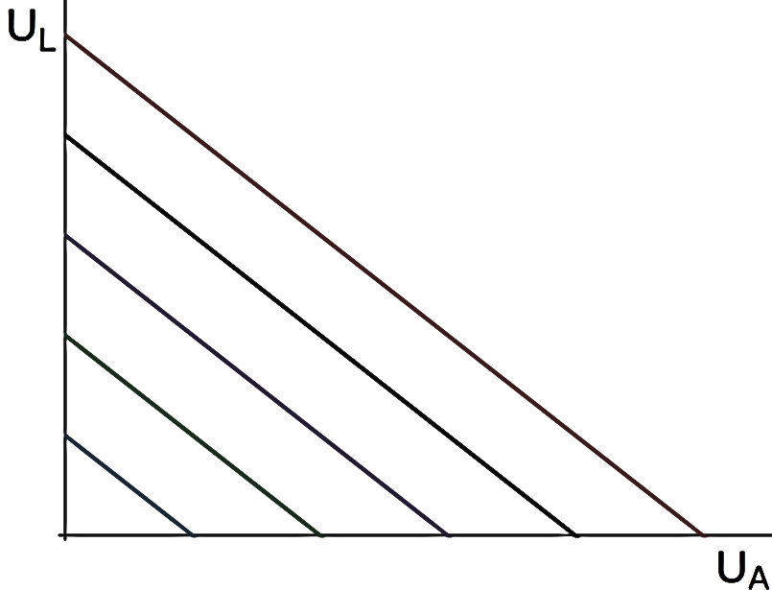
b. Social indifferences are straight lines with slope of –2. This reflects the fact that society values a “util” to Augustus twice as much as a “util” to Livia.
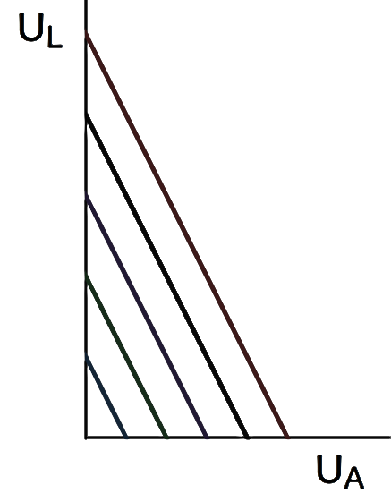
c.
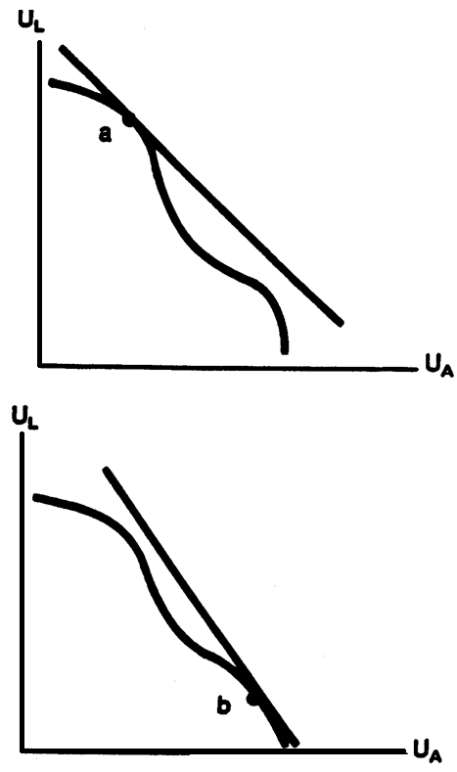
- In this case, the “Edgeworth Box” is actually a line because there is only one good on the island. The set of possible allocations is a straight line, 100 units long. Every allocation is Pareto efficient, because the only way to make one person better off is to make another person worse off. There is no theory in the text to help us decide whether an allocation is fair. Although splitting the peanuts even between the people may be fair, it may not be fair if the calorie “needs” of the people are different. With a social welfare function, we can make assessments on whether redistribution for society as a whole is a good thing.
- Social welfare is maximized when Mark’s marginal utility of income is equal to Judy’s marginal utility of income. Taking the derivative of Mark’s utility function to find his marginal utility function yields MU_{M} = 50/(I_{M}^{1/2}) and taking the derivative of Judy’s utility function yields MU_{J} = 100/(I_{J}^{1/2}). If we set MU_{M} equal to MU_{J}, the condition for maximization becomes I_{J} = 4I_{M} and, since the fixed amount of income is $300, this means that Mark should have $60 and Judy should have $240 if the goal is to maximize social welfare = U_{M} + U_{J}.

  - If the food is evenly distributed between Tang and Wilson, Tang will have 14.14 units of utility and Wilson will have 7.07 units of utility.
  - If the social welfare function is U_{T}+U_{W}, then the marginal utilities of both should be equal to maximize social welfare. Equate MU_{T}=1/(2F_{T}^{1/2}) to MU_{W}=1/(4F_{W}^{1/2}) and substitute F_{T}=400-F_{W}. Therefore, F_{T}=320 and F_{W}=80.
  - If the utility of both Tang and Wilson must be equal, then set U_{T}=U_{W} and substitute F_{T}=400-F_{W} and solve. Therefore, F_{T}=80 and F_{W}=320.

  - False. As shown in the text, equality of the marginal rates of substitution is a necessary, but not sufficient, condition. The MRS for each individual must also equal the MRT.
  - Uncertain. As long as the allocation is an interior solution in the Edgeworth box, the marginal rates of substitution must be equal across individuals. This need not be true, however, at the corners where one consumer has all the goods in the economy.
  - False. A policy that leads to a Pareto improvement results in greater efficiency, but social welfare depends on equity as well as efficiency. A policy that improves efficiency but creates a loss in equity might reduce social welfare.
  - False. Moving to a point on the utility possibilities curve may not result in a Pareto improvement because one party may receive less utility on the curve than they received at the interior point.

  - In this particular insurance market, one would not expect asymmetric information to be much of a problem – the probability of a hurricane is common knowledge. Moral hazard could be an issue – people are more likely to build near a beach if they have hurricane insurance. Still, one would expect the market for hurricane insurance to operate fairly efficiently.
  - There is substantial asymmetric information in the markets for medical insurance for consumers and also malpractice insurance for physicians. For efficient consumption, the price must be equal to the marginal cost, and the effect of insurance may be to reduce the perceived price of medical care consumption. That would lead to consumption above the efficient level. Because of the roles of regulation, insurance, taxes, and the shifting of costs from the uninsured to the insured, there is little reason to expect the market to be efficient.
  - In the stock market, there is good information and thousands of buyers and sellers. We expect, in general, efficient outcomes.
  - From a national standpoint, there is a good deal of competition and information with regards to MP3 players and music. The outcome will likely be efficient for MP3 players and music. However, some firms might exercise some market power through high brand awareness and proprietary downloading systems.
  - The private market allocation is likely inefficient without government intervention. Student loan markets may suffer from asymmetric information – the student knows better than the lender whether he will repay the loan or default on it, a form of adverse selection. Government intervention does not “solve” the adverse selection problem in this case (because participation in the student loan program is not compulsory), but it may create a market that would not exist without intervention.
  - The market for housing is likely to be relatively efficient. Some inefficiencies may exist, such as asymmetric information—the seller knows more about the house than the buyer—and differentiated products. But, the market has developed to mitigate these inefficiencies. For example, a buyer can employ a home inspector to help him understand more about the quality of the home. Also, a large number of homes on the market increases competition.

- It is individualistic. Welfare economics focuses on individual preferences and allocations that maximize utility. If preferences are ill-formed, perhaps due to one of many psychological biases for example, then maximizing those preferences may not be appropriate. There may also be societal goals that are neglected by the framework of welfare economics.
- It focuses on outcomes. Welfare economics focuses on the results of an allocation as the basis for its analysis. It does not distinguish between alternative ways in which any given allocation may be achieved. If the process through which allocations are determined matters — such as whether decisions over allocations by governments are made within a transparent and democratic process — then welfare economics will have little to say.

